Up, Up, & Away!

A Hypermedia Learning Unit

by
Jonathan Brinkerhoff
Krista Glazewski
Carla McAuliffe
and
Matthew Miller
Copyright 1999

Contents of Up, Up, & Away!

Introduction 1

Teaching the Unit 3
Introductory Activities 4
Gathering Resources 7
Balloon Design 10
Winds Around the World 14
Travel Plan 23
Supply List 26
Unit Review and Assessment 29

Assessment Resources 31
Student Progress Reports 32
Final Project Assessment Checklists 35
Student Self-Assessment Form 38
Question Bank 39

Teacher Resources 41
Parental Involvement Letter 42
Presentation Feedback Checklist 44

Student Handouts 45
The Challenge 46
Project Expectations 47
Final Projects and Presentations 48
Unit Introductory Articles 49
Information Sources Record Sheet 52
Balloon Types Record Sheet 53
Route Map Record Sheet 54
Jet Stream Map 55
Travel Plan Record Sheet 56
Supply List Record Sheet 57
Experiment Report Form 58

Introduction to Up, Up, & Away!

Up, Up, & Away! is an interdisciplinary, hypermedia-based learning unit that integrates meteorological concepts with geography and language arts. At the center of this unit is a challenging problem that guides and directs the learning activities. Students are given the task of planning a global circumnavigation via balloon, a feat attempted by a host of teams and accomplished for the first time by the Breitling Orbiter 3 piloted by Swiss psychiatrist Bertrand Piccard and British adventurer Brian Jones on March 3, 1999. To gather information for solving the problem, students navigate through the database of informational multimedia pages about ballooning. The specific unit objectives are:

Unit Objective:

Upon completion of the module, students will be able to:
- Generate a viable route of travel for circumnavigating the Earth via balloon based on global winds as well as geographic and political constraints.
- Design a balloon and present a rationale for its design.
- Generate a supply list and present a rationale for the included items.

Content Objectives:

In the area of meteorology, students will:
- Identify the flow of global atmospheric winds.
- Describe why helium balloons rise.
- Describe why hot air balloons rise.
- Describe how winds are generated.

In the area of geography, students will:
- Identify the major continents and oceans.
- Name at least ten countries of the world.
- Describe the political climate of countries
that impose travel restrictions on balloonists.

In the area of measurement, students will:
- Calculate the total distance traveled in
their proposed route.
- Use an estimated flight speed to calculate
the number of days for the proposed trip.

The Up, Up & Away! Home Page.
The Up, Up & Away! home page (Fig. 1) contains a Challenge for the students and three links—Project, Resources, and Hints.
Project: Selecting the Project button opens a pop-up window which lists the student products to be turned in upon completion of the unit.
Resources: The Resources button links to informational websites related to global ballooning. The informational sites are organized under four headings: Prior Attempts, Weather & Geography, News Articles, and Balloon Design. Beneath these headings are links to web sites containing information relevant to completing the Up, Up & Away! challenge. To facilitate faster download times, the majority of these sites are contained on the Up, Up & Away! CD. This also allows students to access most of the resources from a computer without network access. Those sites requiring network access include the jet stream weather sites, the J. Renee site, the Global Conqueror site, and the NOVA links: “Great Balloon Race Around the World” and “Why Balloons Float.”
Hints: Selecting the Hints button provides access to a variety of student scaffold materials including a glossary of ballooning related terms, three guiding organizers designed to help students unsure of how to proceed in solving the three main aspects of the problem, and an information log for recording where relevant facts are located.

Figure 1.
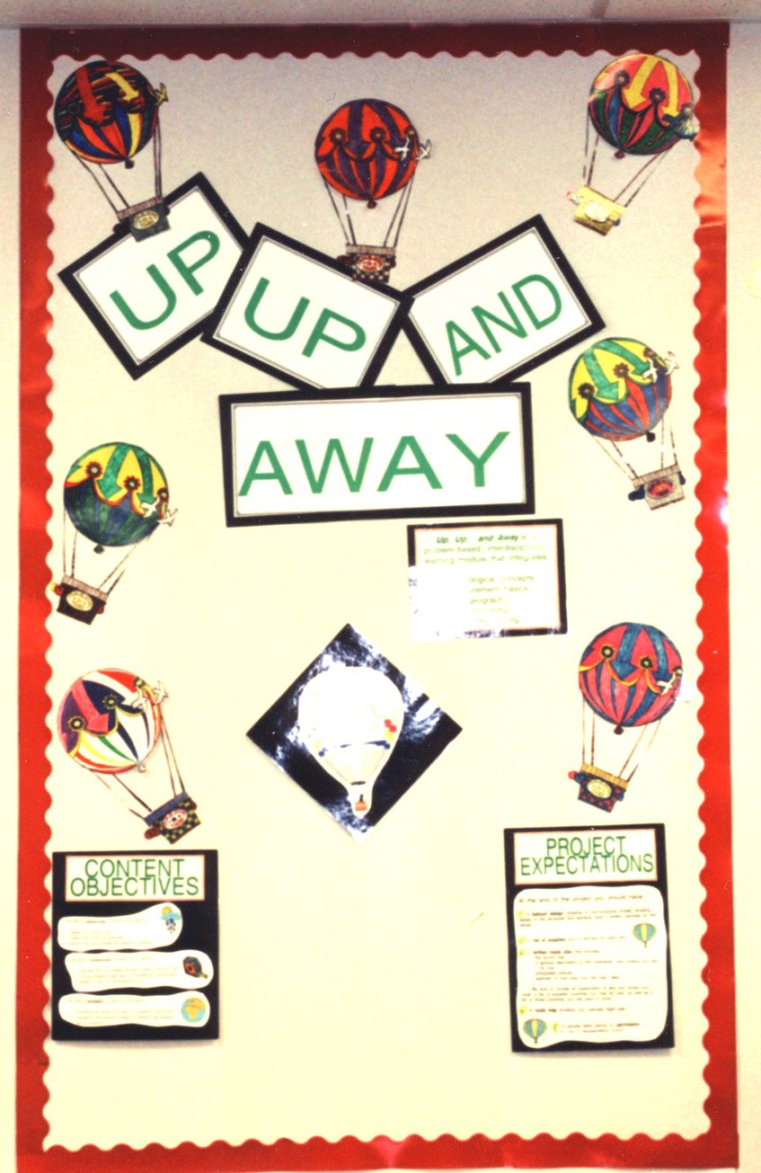
Teaching the Unit.
Figure 2

Setting the Stage: Student interest in the unit may be promoted through creation of an Up, Up & Away! bulletin board (Fig. 2). Additionally, trade books relating to balloons and ballooning, as well as atlases, may be assembled in a reading center.

Parental Involvement: Parental involvement may be promoted by sending home a parental involvement letter. A sample letter is provided on page 42 of this manual. This sample letter, as well as any other forms, may be edited as desired.

Teacher Guidance: There are two approaches to teaching Up, Up & Away!. The first, a true problem-based learning approach, introduces students to the challenge, project expectations, and program interface before releasing them to work with minimal supervision. For students less familiar with problem-based learning, greater success may be achieved by dividing the unit into lessons that all students complete simultaneously with teacher guidance as described in the teacher’s manual.

Grouping: The design of Up, Up, & Away! lends itself to the utilization of cooperative learning groups, especially if computers and/or supplies are limited. It is recommended that teachers assign students to cooperative group roles such as group facilitator, recorder, and computer operator and rotate those roles to insure equal accountability and access to the computer.

Progress Reports: Student feedback regarding progress toward achieving each of the unit’s enabling objectives may be provided through use of the progress reports found on page 32 of this manual. Additionally, the student information record sheets (Balloon Types, Route Map, Travel Plan, and Supply List found on pages 53 through 57 of this manual) may be collected and assessed for student progress.

Final Presentations: Consider having students create a display of their final Up, Up & Away! projects and present them to the class (Fig. 3). Presentation guidelines are provided on page 48 of this manual.

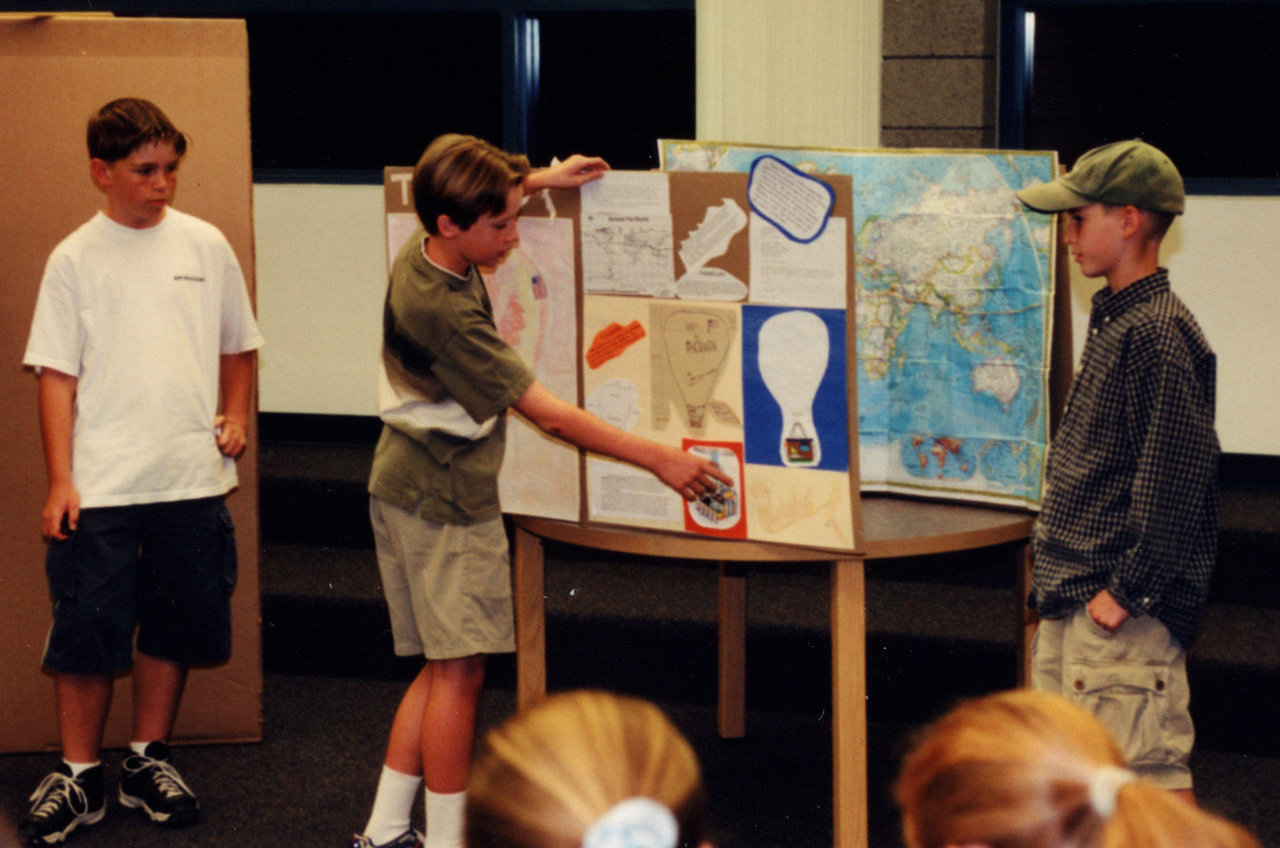
Technology Integration Option: Have students present their final projects using presentation software such as PowerPoint or HyperStudio.
Figure 3

Content Accountability: To assess individual student content knowledge associated with this unit, a question bank of possible assessment questions is provided on page 39 of this manual.

Student Self-Assessment: Students may gain valuable insight into their role as learners by assessing their own performance. A self-assessment form is provided on page 38 of this manual.
Introductory Activities

Note:
Novice computer users may be distracted by the computer interface, such that maintaining student focus during the unit introduction is difficult. Consider allowing students time to explore the interface prior to beginning the lesson, or conducting the introductory readings from paper copies. Paper copies of The Challenge, introductory articles, and the Information Sources record sheet are provided in the Student Handouts section of this manual, beginning on page 45.

Introduce the problem.

- Read The Challenge with the class (Up, Up & Away! Home page).
- The Challenge:

After attending last year’s Thunderbird Balloon Festival, you decide you would like to be the first American to fly a balloon nonstop around the world. Flying a balloon around the world nonstop has only been accomplished once before and no American has ever done it, although several have tried. What do you need to do to make this dream come true?

Introduce the interface and provide students with background information on the problem.

- Direct students to the Up, Up & Away! Resources Page.

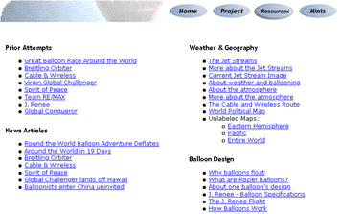
.
- Under the News Articles heading, click on the link to open the newspaper article, “Round-the-World Balloon Adventure Deflates”.
- Have students read the article one section at a time. Engage students with questions such as the following:
- When did this flight take place?
- Where did the balloonists ditch their balloon?
- Why did the attempt fail?
The Crash
- How tall was the balloon? How high is the ceiling of our classroom? How many times the height of our class was the balloon?
- Can you imagine bouncing across the ocean for miles? What might the men have been thinking?
- How long were they in the water?
Failed Attempts
- How many attempts have the three men made to fly a balloon around the world? How would you describe the desire these three men have?
- How many miles did the flight cover?
Weather & Politics
- How many weather related words can you find in this article?
- How fast was the balloon traveling before it was sucked into a low pressure system? What’s the difference in speed between 200 and 16 miles per hour?
- Which countries refused to let the balloon travel through their air space?
- What are the things that prevented the flight from succeeding?
- Was their enthusiasm diminished by their failure?

- Under the News Articles heading, click on the link to open the newspaper article, “Around the World in 19 Days”.
- Have students read the article one section at a time. Engage students with questions such as the following:
- What’s the date of the article?
- What’s the difference in altitude between the flight described in the first article and the flight described in this one?
- Where did they hope to land?
- How much did they win?
- Why is Piccard and Jones’ accomplishment important?
The Dangers
- Name two dangers long distance balloonists face.
- What can balloonists do to keep from getting shot down?
- How do you think the deaths of the Americans in 1995 affected other balloonists?

Navigating
- What is the name of the winds balloonists use to fly around the world?
- How does a balloon “change lanes”?
- Who helps the pilots navigate the balloon? In what ways are these people important?
The Cost
- How much did the Breitling balloon cost?
- Why do you think Piccard and Jones made this flight? Do you think it was for the money?
- What things have we learned about meeting the challenge from these two articles?

- If desired, additional articles under the News Articles heading may be read and discussed.
- Direct students to the Project button. Read the project expectations with the class and answer questions as needed.
- Project Expectations:

At the end of the project you should have:
- a balloon design (drawing or model - the model does not need to be functional) showing details of the envelope and gondola, plus a written rationale for the design.
- a list of supplies and a rationale for each item.
- a written travel plan that includes the launch site, a description of the continents and oceans you’ll fly over, your anticipated altitude, and calculations to determine how long your trip may take. Be sure to include an explanation of why you chose your route, a list of countries you may fly over, as well as a list of those countries you’ll have to avoid.
- a route map identifying the seven continents and four oceans and showing your intended flight path.
- a sample letter asking for permission to fly over a representative country.

- Direct students to the Hints button. On the Hints screen, direct students to the link accessing the Information Sources form. Recommend that students keep a log of where they find relevant information, as trying to relocate information can be frustrating and time consuming. Students can print the Information Sources Record Sheet directly from the Hints screen, or it can be copied prior to the lesson and provided to students at this time. The Information Sources record sheet is located on page 52 of this manual.
- On the Hints screen, review the Balloon Design, Travel Plan and Supply List hints available to help students unsure of where or how to begin. Have students access the forms available to help them with data collection. Copies of these resource forms are located on pages 53 through 57 of this manual.
Gathering Resources
What Do We Know? / What Do We Need To Know?

Review the problem.

- Engage students with questions / comments like:

What is our challenge?
Think about some of the issues faced by the balloonists in the articles you read.

Brainstorm list: “What We Know / Need to Know”.

- Inform students that today they will be clarifying what they know and what they need to know about the problem in order to meet the ballooning challenge.

- Ask students a question like:

What do we know?
Possible responses may include:
- We will be traveling by balloon.
- We will be traveling around the world.
- Only one attempt to circumnavigate the globe by balloon has succeeded.
- No American has ever circumnavigated the globe via balloon.
- Winds push the balloon.
- The balloons are huge.
- We need permission from countries to fly through their airspace.
- The balloon is navigated by changing altitude to find winds blowing in different directions.

- Ask students a question like:

What do we need to know?
Possible responses may include:
- What weather might affect your journey?
- Where will you launch from?
- How long will the flight take?
- At what altitude will you fly?
- What is your planned route of travel?
- What winds might push your balloon?
- What time of year is best for launching?
- What causes the wind to blow?
- What type of balloon will you use?
- How do balloons fly?
- What have been the experiences of past balloonists?
- What problems can there be relating to altitude and temperature?
- How will you navigate and communicate while flying your balloon?
- How much food and water will you need to take on your trip?

Note:
While the lists of possible responses for the “What We Know / Need to Know” questions are not meant to be complete, they do represent a good foundation for discussion. If students do not generate these ideas on their own, guide the discussion and consider having students reread the two introductory articles.

Match “Need to Know” questions with web sites.

- Refer to the Up, Up & Away! Resources Page and ask students questions about the information they need to gather. For example, you might ask:

What web site might help you answer the question, “At what altitude will you fly?” (We can look at Prior Attempts and see if we can find out the altitude of previous flights.)

What web site might help you answer the question, “What winds might push your balloon?” (We can look at Weather & Geography, where we can go to several sites to learn about ballooning and winds.)

Note:
Students may be encouraged to utilize any other sources of information beyond those included on the Up, Up & Away! Resources Page.

- Consider giving students the Information Sources record sheet on page 52 of this manual to help them keep track of where they find useful information so they can easily locate it again later, or share it with other students.

Technology Integration Option.

- Have students record the results of the gathering resources brainstorming in a table (Figure 1 on next page) or T diagram (Figure 2) produced using word processing software.

Figure 1

What We Know | What We Need to Know | What We Learned
There are different kinds of balloons. | What type of balloon is best for an around the world flight? | A Roziere balloon is best because it can stay aloft the longest.
Winds push the balloon. | What winds will we use? | Jet stream winds because they are fast and circle the Earth.

Figure 2

What We Know What We Need To Know

There are different kinds of balloons. What type of balloon is best for an around
the world flight?

Winds push the balloon. What winds will we use?

Balloon Design

Review the problem.

- Engage students with questions like:

Think about the balloons you’ve read about.
How do those balloons fly?
What is the best type of balloon to use when trying to fly around the world? Why?

- If students aren’t prepared with sufficient information to summarize their findings, review the need to know questions, adding additional questions as needed, and allow students time to collect additional information.

- Remind students of the form available under the Hints button to help them collect relevant information, or provide students with a copy of the form, found on page 53 of this manual.

Summarize the findings – How balloons fly.

- A balloon flies because the gas in the envelope is lighter, or less dense, than the air around it.

- If the weight of the envelope and gondola are ignored, the balloon will rise until the density of the air on the outside of the envelope matches the density of the gas inside the envelope.

- Helium balloons fly because the gas inside the envelope is less dense than the surrounding air. Helium is less dense because each atom of helium weighs less than each atom of surrounding air, which is mostly nitrogen.

- Hot air balloons fly because the air molecules inside the envelope are hotter than the air molecules outside the envelope. Hotter molecules take up more space than colder molecules. This means there are fewer air molecules in a given volume of hot air than cold air, making the hot air weigh less. (This concept may be demonstrated with the following enrichment activity.)

Optional Enrichment Activity.

Materials
2 100ml graduated cylinders or 2 identical Pyrex measuring cups
2 250 ml beakers or other suitable containers
Optional – a swing balance or scale

Procedure
- Hand out the Experiment Report form found on page 58 of this manual.
- Describe the procedure to students and have them record the procedure and their predictions on the Experiment Report form. Have students share their predictions. If students’ predictions differ, have them share their thinking and debate their positions.
- Fill one beaker with water and heat it to almost boiling or run a hot water tap to get the water as hot as possible.
- Fill one beaker with ice cubes and pour water over them to chill the water.
- Fill one graduated cylinder to the 100 ml mark with hot water.
- Fill one graduated cylinder to the 100 ml mark with cold water – don’t include any ice cubes.
- Optional: demonstrate that the cylinder full of hot water weighs less than the cylinder of cold water using the scale or swing balance.
- Let the cylinders sit for sufficient time to allow the water in both samples to come to room temperature and observe what happens to the water levels. (The water level will rise in the cold water cylinder as the water heats up and the water molecules spread further apart. The water level will drop in the hot water cylinder as the water cools off and the water molecules move closer together. When both water samples have reached an equal temperature, the molecules in each sample will be equal distances apart. With the space between molecules equal, the differing water levels show that there are fewer water molecules in the cylinder that held the hot water.)
- Have students record their observations and explanations on the Experiment Report form.

Summarize the findings – Types of balloons.

- Ask students to share their findings concerning the following aspects of balloon design: the types of balloons, the parts of a balloon, the pros and cons of different types of balloons, and design aspects of balloons used in previous around the world attempts. Possible answers may include the following:
- The types of balloons:
hot air
helium (also referred to as gas balloons)
Roziere (a combination of hot air and helium)

- The parts of a balloon:
hot air: envelope, gondola, propane tanks, burners
helium: envelope, gondola, ballast
Roziere: two-part envelope, gondola or capsule, propane tanks, burners

- The pros and cons of the different types of balloons include:
Hot air: easy to control vertical motion by firing burners or venting hot air from the envelope. Once all the propane is expended and the air inside the envelope cools, the balloon’s altitude can no longer be maintained, requiring the balloon to land.
Helium: can stay aloft longer than a hot air balloon because the lift is provided by helium rather than the burning of propane to heat air. During the day, sunlight heats the helium causing it to expand and escape through vents to prevent the envelope from over-inflating. At night the helium cools off and contracts which decreases lift and causes the balloon to sink. This requires that ballast be dropped to maintain altitude. When all the ballast has been dropped and too much helium has been vented, the balloon’s altitude can no longer be maintained, requiring the balloon to land.
Roziere: combines the longer flight times of a helium balloon with the vertical control of a hot air balloon. The two-part envelope consists of an inner helium balloon and an outer hot air balloon. By controlling the temperature in the hot air portion of the envelope, the balloonist can maintain the helium at a more constant temperature which reduces overheating and the venting of gas, thereby maintaining lift and extending the duration of the flight.

- Design aspects of the balloons used in previous unsuccessful around the world attempts:
Most teams have used Roziere balloons designed to fly at altitudes up to 35,000 feet. These balloons are 180 to 200 feet in height. The major exception was Team RE/MAX which intended to fly far higher, at altitudes up to 24 miles or 127,000 feet. By flying so high, team RE/MAX hoped to avoid any problems with bad weather, the major reason so many previous attempts had failed. Flying so high presents other problems, however. The pilots would have to wear space suits and the envelope needed to reach such altitudes was 900 feet tall. The huge envelope was difficult to launch safely, the reason team RE/MAX was never able to get off the ground.

Review criteria for the final project.

- Direct students to the Project Expectations button from either the Home Page or Resources Page. Reread the expectations relating to balloon design and answer questions as needed.

Identify resources.

- Refer to the Balloon Design section of the Hints Page and identify relevant links.

Issue a challenge.

- Challenge students to design a balloon for their flight. The design must address the following issues:
- Type of balloon.
- Pressurized or non-pressurized gondola or capsule.
- Seaworthiness.
- Type and amount of equipment on board.

- Decide what you expect your students to achieve by the end of the day’s lesson and write the day’s assignment on the board.

Monitor student progress.

- Guide student thinking with comments and questions like:

What are the 3 types of balloons?
What type of balloon is the most maneuverable?
What type of balloon can stay aloft the longest?
Which type of balloon has been used most often for around-the-world attempts and why?
How will this information help you solve the problem?
That’s an interesting idea. What information do you have to back it up?
That’s a good question. Do you have any thoughts on how you’d answer that?
Tell me how you reached that conclusion. What steps did you go through?
That’s an unusual idea, Fred. Steve, what do you think of Fred’s idea?
Tell me what you’ve discovered about…
What do you think might happen if…?

Provide feedback.

- Review student work.
- Fill out the student progress report found on page 32 of this manual and share your assessment with students.
Winds Around the World

Review the problem.

- Ask students questions like:

Balloons have no motors. What pushes a balloon through the air?
What are some of the different kinds of winds?
How do balloonists use the different kinds of winds to steer their balloons?
What causes the wind to blow?

- If students aren’t prepared with sufficient information to summarize their findings, review the need to know questions, adding additional questions as needed, and allow students time to collect additional information.

Summarize the findings.

- Ask students to share their findings concerning the following aspects of winds:

- There are two kinds of winds: local and global or jet stream winds. The jet stream is a very high altitude, fast moving wind that encircles the earth and reaches speeds up to 200 miles per hour. Jet stream winds are fastest during the winter months, which explains the winter launch dates of most teams attempting to circumnavigate the globe. It is these winds that balloonists rely on to push their balloons.

Additional Enrichment Information: There are two major jet stream winds, one in each hemisphere, that circle the earth from west to east between 30 and 40 degrees in latitude at altitudes between four and nine miles. Jet stream winds average 35 miles per hour in summer and 75 miles per hour in winter, although speeds up to 200 miles per hour have been recorded. They are caused by differences in the earth’s surface temperature and are found where the biggest contrast occurs, usually where cold polar air meets warm tropical air. When the two air masses meet, the resultant rising air mass causes high speed winds in the upper atmosphere. During winter, the temperature contrast is more pronounced which explains why the jet stream is strongest in winter. Jet stream winds may flow for thousands of miles, although there may be breaks at some points.

Airplanes flying east often try to fly within jet stream winds to gain speed and save fuel, while planes flying west try to avoid them so as not to have a head wind.

- Local winds are also important. If the jet steam is pushing a balloon in the wrong direction, the balloon pilot can change altitude to find a local wind blowing in a different direction. The risk, however, is that the local wind will carry the balloon so far from the jet stream that the balloonists can’t get back into the jet stream when they want to.

Conduct Science Demonstrations.

- Science demonstrations 1 and 2 begin on page 17 of this manual.
- The interactive web site Why Balloons Float under the Balloon Design heading allows students to explore the concepts presented in demonstrations 1 and 2.

Review criteria for the final project.

- Direct students to the Project button on the main menu. Reread the expectations relating to the jet stream map and answer questions as needed.

Identify resources.

- Refer to the Weather & Geography section of the Resources Page and identify relevant links.
- The Unlabeled Maps links provide blank outline maps which may be printed.
- The colored bands on the jet stream maps represent the jet stream winds.

Note:
Jet stream activity varies throughout the year. If the jet stream is not active during the presentation of the unit, a supplemental jet stream map, found on page 55 of this manual, may be used.

Issue a challenge.

- Challenge students to create a map of the jet stream.
- Decide what you expect your students to achieve by the end of the day’s lesson and write the day’s assignment on the board.

Monitor student progress and learning of content.

- Guide student thinking with comments and questions like:

What have you learned about the jet stream?
Why/how do helium balloons rise?
Why/how do hot air balloons rise?
How will this information help you solve the problem?
That’s an interesting idea. What information do you have to back it up?
That’s a good question. Do you have any thoughts on how you’d answer that?
Tell me how you reached that conclusion. What steps did you go through?
That’s an unusual idea, Fred. Steve, what do you think of Fred’s idea?
Tell me what you’ve discovered about…
What do you think might happen if…?

Technology Integration Option.

- Have students save the jet stream image and incorporate it into their final presentations as part of a word processing document or presentation in PowerPoint or HyperStudio.

Demonstration 1: Hot Air Rises

Materials
Scissors
Sheet of construction paper
Needle and thread
Heat source: hotplate or candle

Preparation
Make the paper spiral shown on the following page. Trace the pattern onto a sheet of construction paper. Cut out the circle, then cut along the dotted line. To hang the spiral, thread a needle, tie a knot in the end of the thread, then push the needle through the paper at the center point.

Procedure

- Hold up the spiral by the thread.

Can you see air move?
No. The effects of air moving can be seen: leaves or a flag moving, dust being blown, but air is transparent, so we can’t see it move.

What do you predict would happen if I held this paper spiral over someone’s head?

- Hold the paper spiral over a student’s head. The spiral doesn’t spin.

Was your prediction correct?

What do you predict would happen if someone were to blow gently at the spiral?

- Have a student blow up toward the paper spiral gently. The spiral spins.

Was your prediction correct?

When you blow out of your mouth, what are you doing to air?
Making it move.

So blowing makes air move. And that moving air makes the spiral spin. So, this paper spiral can be used as a scientific instrument. What can we use the paper spiral to prove?
The paper spiral proves that air, even if it can’t be seen, is moving.

At this time the hotplate is NOT turned on.

What do you predict will happen if I hold the spiral over the hotplate?

Hot Air Spiral

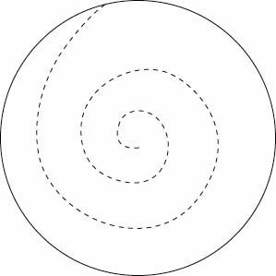
Center

Directions:

- Cut out the circle along then solid line.
- Cut along the dotted line.
- Suspend the spiral through the center point with a thread

- Hold the spiral over the cold hotplate. The spiral doesn’t spin.

Was your prediction correct?

If I turn on the hotplate, the burner will get hot. What will happen to the air around the hotplate?
It will also get hot.

What do you predict will happen to the paper spiral if I turn on the hotplate?

- Hand out the Experiment Report form found on page 58 of this manual.

- Describe the procedure to students and have them record the procedure and their predictions on the Experiment Report form. Have students share their predictions. If students’ predictions differ, have them share their thinking and debate their positions.

- Turn on the hotplate and hold the spiral over it. The spiral spins.

What do you observe happening?
The spiral is spinning.

Was your prediction correct?

What is causing the spiral to spin?
Moving air.

Was the air moving before the hotplate was turned on?
No.

How do we know the air wasn’t moving before?

The spiral wasn’t spinning.

So if the spiral shows the air wasn’t moving when the hotplate was off, and the air was moving when the hotplate was on, what is causing the air to move?
Heat from the hotplate is heating the air around it, and the hot air is moving which is causing the paper spiral to spin.

- Relate the findings to why balloons float.

What do we know about the space between air molecules when they are heated?
The molecules move apart and take up more space.

What happens to the density of the air when the hot air molecules move apart?
The density decreases because there are fewer molecules in a given amount of air.

What happens to the less dense air?

It rises because it weighs less than the air around it

- Have students record their observations and explanations on the Experiment Report form.

Optional Enrichment Activity.

Note:
This activity requires that the air conditioning or heat be turned off for several minutes prior to measuring the air temperature.

Materials
Thermometer
Stepladder

Preparation
Ask the custodian to bring a step ladder to the classroom.
Turn off the heating or air conditioning ten minutes prior to recording the air temperatures.

Procedure
- Hand out the Experiment Report form found on page 58 of this manual.
- Describe the procedure to students and have them record the procedure and their predictions on the Experiment Report form. Have students share their predictions. If students’ predictions differ, have them share their thinking and debate their positions.

- Measure the air temperature just above the floor of the classroom.
- Measure the air temperature just below the ceiling.
- Compare the two temperatures. Ask students to explain the results.
(The air just below the ceiling will be hotter than the air just above the floor. The less dense hot air rises toward the ceiling, while the more dense cool air sinks toward the floor.)

- Have students record their observations and explanations on the Experiment Report form.

Demonstration 2: Convection Currents.

Materials
Convection box
aquarium or any transparent container
cardboard
knife or scissors
2 glass lamp chimneys
black paper
masking tape
or
cardboard box
cellophane wrap
knife or scissors
2 glass lamp chimneys
black paper
masking tape

Candle
Matches
Stick of incense

Preparation
Make a convection box: Cut the cardboard to form a lid to the aquarium. Cut two circles in the cardboard. The diameter of the circles should be just smaller than the base of the lamp chimneys so that they can sit on top of the cardboard. Tape black paper to the back of the aquarium so the smoke is easier to see.
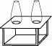
Lamp chimney
Aquarium Version
Cardboard

If no aquarium is available, a cardboard box can be used. Cut the top off the box and tape cellophane over the top. Place the box on its side with the open side facing front. Cut two circles on what is now the top for the lamp chimneys. Then cut a small door in one end. Once the burning candle is placed inside the box, tape over the door to keep air from entering.
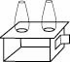
Door
Cellophane
Cardboard Box Version

Procedure

- Engage students with questions like:

Can you see air move?
No, only the effects of moving air.

What happens to air when it’s heated?
It moves up.

- Light the candle and place it under one of the lamp chimney holes. Fit the cardboard lid in place and tape over the seam to keep air from entering. Place the lamp chimneys over the holes in the cardboard.

- Tell students you are about to light the incense and hold it over the lamp chimney which ISN’T over the candle. Ask students what they predict will happen.

- Hand out the Experiment Report form found on page 58 of this manual. Have students record the procedure and their predictions. Have students share their predictions. If students’ predictions differ, have them share their thinking and debate their positions.

- Light the incense and hold it over the lamp chimney which ISN’T over the candle.

What do you observe?
Smoke from the incense is entering the box.

How can you explain your observation?
The candle heats the air. The hot molecules move apart, becoming less dense. The less dense hot air rises out of the chimney. Cooler air enters through the other chimney to take the place of the hot air which left the box.

- Have students record their observations and explanations on the Experiment Report form.

Travel Plan

Review the problem.

- Engage students with questions like:

What prevents us from climbing into the jet stream and just letting it take us wherever it’s blowing?

- If students aren’t prepared with sufficient information to summarize their findings, review the need to know questions, adding additional questions as needed, and allow students time to collect additional information.

- Remind students of the form available under the Hints button to help them collect relevant information, or provide students with a copy of the form, found on page 56 of this manual.

Summarize the findings.

- Ask students to share their findings concerning the following aspects of plotting a travel route:

- There are countries that don’t allow balloons to fly through their air space: Iran, Iraq, Russia, and North Korea. China sometimes grants permission, but only if the balloons avoid certain areas.

- To avoid entering forbidden air space, balloons must sometimes leave the jet stream to find winds blowing in a different direction that will take them around these countries. Getting back into the jet stream can be difficult, a problem which has ended many attempts to fly around the world by balloon.

Review criteria for the final project.

- Direct students to the Project button on the main menu. Reread the expectations relating to the route map, travel plan and permission letter, and answer questions as needed.

Establish Procedures for Travel Plan Calculations.

- Ask students how they might calculate the length of their proposed route in miles and the number of days the flight would take.
- Accept all reasonable methods that are based on mathematical calculation. One way would be to lay a string on top of the route drawn on the route map, then straighten out the string and place it on the map’s scale to find the number of miles the string’s length represents. To calculate the number of days the flight would take, the length of the flight in miles could be divided by the average speed of the jet stream, which is 35 miles per hour in summer and 75 miles per hour in winter.

Identify resources.

- Refer to the Weather & Geography section of the Resources Page and identify relevant links.

Issue a challenge.

- Challenge students to modify their jet stream map to avoid countries which deny access to their air space.
- Challenge students to write their travel plan.
- Challenge students to write a sample letter asking permission to fly through the airspace of one of the countries their route will cross.
- Decide what you expect your students to achieve by the end of the day’s lesson and write the day’s assignment on the board.

Monitor student progress and learning of content.

- Guide student thinking with comments and questions like:

What are the major continents and oceans?
What are 10 countries you will fly over?
Which countries should you avoid? Why?
What is the total distance you will travel? How did you figure that out?
What is the estimated flight speed? How do you know?
Based on distance and estimated speed, how many days will it take you? How did you figure that out?
That’s an interesting idea. What information do you have to back it up?
That’s a good question. Do you have any thoughts on how you’d answer that?
Tell me how you reached that conclusion. What steps did you go through?
That’s an unusual idea, Fred. Steve, what do you think of Fred’s idea?
Tell me what you’ve discovered about…

Provide feedback.

- Review student work.
- Fill out the student progress report found on page 33 of this manual and share your assessment with students.

Technology Integration Option.

- Have students select the country they will write a sample letter to, then use an Internet search engine to locate the address of that country’s United States embassy. Have students use the address in their permission letter.

Optional Enrichment Activity.

- Extend students’ writing for different purposes by having them create the following:

- Persuasive Writing: Identify an appropriate corporate sponsor for their flight, then write a letter asking for sponsorship. The letter should specify the specific sponsorship being solicited, and what the flight team will provide in return. Students may want to investigate sponsorship deals to make their solicitation as realistic as possible by using in Internet search engine and a search string such as writing sponsorship proposal* to locate information on how to write such proposals.

- Informational Writing: Identify an appropriate local news outlet, then write a press release which describes the flight. The press release should mimic newspaper writing which answers the questions Who, What, When, Where and How in the first couple of paragraphs, then provides additional information in the remainder of the article. Students may analyze newspaper articles to make their press releases as realistic as possible.

Supply List

Review the problem.

- Engage students with questions like:

How many days do you expect your flight to take?
What supplies and equipment might you need to complete a flight of that length?

- If students aren’t prepared with sufficient information to summarize their findings, review the need to know questions, adding additional questions as needed, and allow students time to collect additional information.

- Remind students of the form available under the Hints button to help them collect relevant information, or provide students with a copy of the form, found on page 57 of this manual.

Summarize the findings.

- Ask students to share their findings concerning the following aspects of supplying a flight:

- Most flights are expected to take 10 to 20 days.

- Supplies would be needed for both the balloon and crew and would include such basics as:
Food
Water
Clothing
Radio
Navigation equipment
Emergency equipment
Fuel

Students may have found other less obvious pieces of equipment during their reading. Some of the balloons carried a pick to chip off ice that accumulated on the gondola. On some balloons ice weighing as much as 300 pounds collected and formed icicles up to 9 feet long.

- The balloon can carry a limited volume and weight.

- Prompt students to be specific and realistic in the supplies they suggest and the rationale for including them.

Review criteria for the final project.

- Direct students to the Project button on the main menu. Reread the expectations relating to the supply list and rationale and answer questions as needed.

Identify resources.

- Refer to the Prior Attempts and News Articles sections of the Resources Page and identify relevant links.

Issue a challenge.

- Challenge students to create a supply list and rationale for each item included.
- Write what students will be expected to achieve by the end of the day’s lesson on the board.

Monitor student progress.

- Guide student thinking with comments and questions like:

How will this information help you solve the problem?
That’s an interesting idea. What information do you have to back it up?
That’s a good question. Do you have any thoughts on how you’d answer that?
Tell me how you reached that conclusion. What steps did you go through?
That’s an unusual idea, Fred. Steve, what do you think of Fred’s idea?
Tell me what you’ve discovered about…
What do you think might happen if…?

Provide feedback.

- Review student work.
- Fill out the student progress report found on page 34 of this manual and share your assessment with students.

Technology Integration Option.

- Have students record their supply list and rationale in a table (Figure 1 on next page) or T diagram (Figure 2) produced using word processing software.

Figure 1

Item | Rationale
Radio | Need to be able to communicate with the ground crew.
Pick ax | To remove ice that forms on the gondola.

Figure 2

Item Rationale

Radio Need to be able to communicate with the ground crew.

Pick ax. To remove ice that forms on the gondola.

Unit Review and Assessment

Review Up, Up, & Away!.

- Engage students with questions like:

What have we learned from this unit?

- Compile a list of students’ responses on the board.
Possible responses may include the following:
- Although there have been many attempts to fly around the world in a balloon, only one team has successfully accomplished this. No American has ever accomplished this.
- There are three types of balloons—hot air, helium, and Roziere.
- Hot air balloons are easy to control vertically by firing burners or venting hot air. They cannot say in the air very long because as soon as they run out of propane, they must land.
- Helium balloons can say in the air longer than hot air balloons because they maintain lift through the use of helium rather than the burning of propane.
- Sunlight causes the helium in the envelope to heat up and expand, so helium must be vented to keep the envelope from over-inflating and ripping. At night, the helium cools and contracts, causing the balloon to loose lift and descend. Ballast must be dropped to maintain altitude. When the balloonists run out of ballast, the balloon must land.
- Roziere balloons are used for long flights. They are a combination of helium and hot air balloons. The envelope consists of an inner and outer layer. Balloonists control the temperature in the outer hot air portion of the envelope to keep the helium at a constant temperature which limits the venting of helium, thereby prolonging the flight.
- Balloons designed to circle the earth have a gondola, or capsule, that must be sea-worthy in case the balloon goes down in the ocean.
- The capsule must be large enough for the pilots, supplies, and sleeping area, yet it cannot weigh too much or it will be too heavy for the envelope to lift.
- Balloonists can fly around the world in either the northern or southern hemisphere.
- Balloonists primarily use the jet steam to fly around the world. Jet steam winds are fast, reaching speeds of up to 200 mph. They are strongest during the winter months.
- Balloonists also use local winds. If the jet stream is pushing a balloon in the wrong direction, the pilot changes the balloon’s altitude and uses local winds to maintain their course.
- Pilots must ask for permission to fly over foreign countries.
- Iran, Iraq, Russia, and North Korea usually don’t allow balloonists to fly in their airspace. China sometimes grants permission, but only if the balloons avoid certain areas.
- Most flights are expected to take 10-20 days.
- Balloonists need supplies such as food, water, clothing, fuel, and equipment for communication, navigation, emergencies.

Assess student learning.

- Student projects may be used to assess what students have learned. Checklists for grading the quality and content of student projects are provided on page 35 of this manual.

- Learning from the unit may be enhanced by having students present their final projects to the class. Parents may be invited to attend these presentations. Guidelines for student presentations and final projects are provided on page 48 of this manual. To encourage audience attention during project presentations, a presentation feedback checklist which audience members may use to provide feedback to fellow students is provided on page 44 of this manual.

- Students may be asked to reflect upon and assess their own performance and products for the unit. Students may also be asked to assess the performance of other group members. Discrepancies between a student’s self-assessment and that of the teacher or others in the student’s group may be discussed with the student. Final student grades may include a component based on the average of the assessments given by other group members. A self-assessment form is provided on page 38 of this manual.

- Students may also be assessed in a more traditional, content exam form. A bank of possible exam questions is provided on page 39 of this manual.
Assessment Resources
Balloon Design Progress Report Group Members:

Envelope: Good Satisfactory Needs Improvement

Comments:

Gondola: Good Satisfactory Needs Improvement

Comments:

Rationale: Good Satisfactory Needs Improvement

Comments:

Travel Plan Progress Report Group Members:

Route Map: Good Satisfactory Needs Improvement

Comments:

Travel Plan: Good Satisfactory Needs Improvement

Comments:

Country List: Good Satisfactory Needs Improvement

Comments:

Sample Letter: Good Satisfactory Needs Improvement

Comments:
Supply List Progress Report Group Members:

Supply List: Good Satisfactory Needs Improvement

Comments:

Rationale: Good Satisfactory Needs Improvement

Comments:

Final Project Assessment Checklists.

- Each group will turn in a project portfolio which includes:
- balloon design and rationale
- travel plan
- route map
- written description
- country list
- permission letter
- supply list and rationale

- Optional Presentation. Each group will give an oral presentation of their project.

Balloon Design Checklist.

- Directions: Award one or zero points for each criteria listed below.

_____ Provides an illustration or model of the balloon
_____ Identifies the balloon as Rozier type
_____ Identifies the capsule / gondola as pressurized
_____ Describes the design as seaworthy by inclusion of a flotation device

Identifies / labels the following features on the balloon illustration:

_____ Valve _____ Burners
_____ Rip panel _____ Ballast
_____ Gas cell _____ Fuel tank
_____ Hot air cell _____ Trail rope

Travel Plan Checklist.

- Directions: Award one or zero points for each criteria listed below.

Route Map
_____ Includes a route map
_____ Continents and oceans are labeled
_____ Route follows the jet stream (either northern or southern hemisphere – not both)
_____ Start / end points of the route are labeled
_____ Start / end points make a complete circumnavigation of the Earth

Written Travel Plan
_____ Names the launch site
_____ Lists the continents and oceans to be flown over
_____ Lists the countries to be flown over
_____ Lists countries to avoid or states a rationale for not having to avoid any countries
_____ Includes a rationale for the route
_____ Lists the anticipated altitude (miles, meters, or feet – range of altitude is OK)
_____ Calculates the estimated length of the trip (hours or days)

Sample Letter of Permission
_____ States the intent of the project (circumnavigation of the world via balloon)
_____ Requests permission to fly through the country’s air space

Supply List Checklist.

- Directions: Award one or zero points for each criteria listed below.

Includes each of the following:
_____ Food
_____ Rationale for food is provided (to stay alive)
_____ Water
_____ Rationale for water is provided (to stay alive)
_____ Fuel
_____ Rationale for fuel is provided (to power the balloon)
_____ Oxygen
_____ Rationale for oxygen is provided (to breathe at high altitudes)
_____ Navigation device or maps
_____ Rationale for navigation devices / maps is provided (to stay on course / navigate)
_____ Radio / communication device
_____ Rationale for radio is provided (to communicate with ground crew, stay on
course, find out about weather, or other)
_____ Blankets and/or warm clothing
_____ Rationale is provided (to stay warm at high altitudes)
_____ Emergency equipment (first aid kit, life vests, life rafts, or other)
_____ Rationale is provided (to be prepared for emergencies)

Optional Presentation Checklist.

- Award 4 points to a presenter who:
- Stands straight, facing the audience without fidgeting.
- Speaks in a loud, clear voice.
- Makes eye contact with the entire audience.
- Speaks predominantly from memory and uses notes only occasionally.
- Award 3 points if:
The presentation includes three of the four criteria and / or is lower in quality.
- Award 2 points if:
The presentation includes two of the four criteria and / or is lower in quality.
- Award 1 point if:
The presentation includes one of the four criteria and / or is lower in quality.

A presentation checklist form is provided on page 44 of this manual.

How Well Did I Do? Name:

- What’s the best part of your project and why?

- What part of your project needs improvement the most and why?

- What grade would you give your final project and why?

- What grade would you give yourself as a member of your group and why?

- What grade would you give the other group members and why?

Question Bank.

- What is the jet stream, where is it found, and why do balloonists use it when attempting to circumnavigate the earth?
Suggested answer: The jet stream winds are powerful, high altitude winds that circle the globe in two bands, one about half way between the equator and the north pole and the other about half way between the equator and the south pole. Balloonists trying to fly around the world use jet stream winds because they move at speeds up to 200 miles per hour and can extend all the way around the world.

- Why might a balloonist trying to circumnavigate the earth leave the jet stream in favor of local winds? What is the danger in doing so?
Suggested answer: Local winds are used to carry the balloon in a different direction than the jet stream winds. In this way, local winds can be used to steer the balloon around bad weather or countries that refuse to give permission to fly through their airspace. The danger is that the balloonist will not be able to find local winds to carry the balloon back into the jet stream to continue the flight around the world.

- What are the three types of balloons? Describe how a balloonist would ascend or descend with each type.
Suggested answer: The three types of balloons are hot air, helium, and Rozier. To ascend in a hot air balloon, the propane burner is fired to heat the air in the envelope. To descend, the burner is turned off and the air in the envelope is allowed to cool. To descend quickly, hot air can be vented from the envelope. To ascend in a helium balloon, ballast is dropped, while to descend, gas is vented from the envelope. To ascend in a Roziere balloon, the pilot would fire the propane burners or drop ballast, while to descend the pilot would turn off the burners or vent gas from either envelope.

- Why is a Roziere balloon able to stay aloft longer than hot air or helium balloons?
Suggested answer: By surrounding a helium envelope with a hot air envelope, the helium is kept at a more constant temperature. This reduces the venting of gas to keep the helium envelope from over inflating due to thermal expansion in the heat of the day. By not venting helium, the balloon is able to maintain lift for a longer time.

- Why does hot air rise?
Suggested answer: When air molecules are heated, they move further apart. This means that in a given volume of air, there are fewer air molecules. Because there are fewer molecules in a given space, the air in that space weighs less, so it floats upward.
- What causes the wind to blow?
Suggested answer: When the air in the atmosphere is unequally heated, the hotter air rises and cooler air moves in to take its place. This movement of air is called wind.

- Name two countries that don’t allow balloonists to fly through their air-space and describe why.
Suggested answer: Countries limiting overflights include Iran, Iraq, Russia, North Korea and China. These countries limit overflights for military reasons, as each, to one degree or another, is on unfriendly terms with the world community.

- What things would balloonists have to consider when selecting equipment to take on a flight?
Suggested answer: Weight, space and the necessity for being prepared for any likely events.

- Label the continents and oceans on the map below.

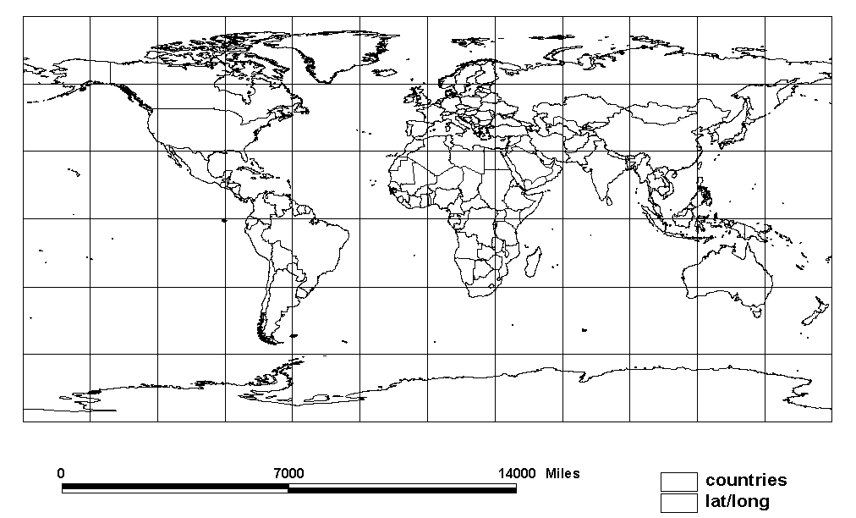

- A balloon is flying straight toward a mountain at 75 miles per hour. If the mountain is 300 miles from the balloon, what is the estimated time it will take the balloon to reach the mountain?

Answer: 4 hours
Teacher Resources

Up, Up, & Away!

A problem-based learning unit integrating meteorology, geography, measurement and technology

Overview:

Our class is beginning a problem based learning unit on ballooning. Problem-based learning asks students to solve a real world problem. Solving the problem requires students to formulate questions, search for information to answer them, and then integrate the information into a workable solution.

Our class problem is to plan a balloon flight that will circle the globe. Many people have attempted this feat, but only one team, the 1999 flight of the Breitling Orbiter 3 piloted by Bertrand Piccard and Brian Jones, has accomplished it. In the process of solving this problem, our class will be learning about why hot air rises, what causes the wind to blow, and how global winds flow in predictable patterns. We’ll also be learning about geography as we plan our route, as well as scale and measurement as we draw the route on a world map and design our balloons.

In searching for information to solve this problem, our class will be using computers to access a hypermedia database.

Expectations:

At the end of the unit, students will have:
- A balloon design in the form of a drawing or non-functional model showing details of the envelope and gondola, plus a written rationale for the design.
- A list of supplies and a rationale for each item.
- A written travel plan that includes the launch site, a description of the continents and oceans to be crossed, a list of the countries to be flown over as well as those to be avoided, a calculation of the length of the trip, and the anticipated altitude of the flight.
- A route map showing the names of the continents and oceans and the intended flight path.
- A sample letter asking for permission to fly over a representative country.

Time Line:

Our class will begin this unit on ______________________________

Final projects are due on ___________________________________

--------------------------------------------- Cut Here ---------------------------------------------------

I have read the project overview and am aware of the project expectations.

Parent Signature ____________________________________ Date _________

Student Signature: _________________________________________________
Presentation Feedback Checklist

Name of Presenter: ______________________________________________________

Your Name: ____________________________________________________________

Directions: Listen to the presentation closely. Rank the speaker by placing a check mark in the box that best describes his / her presentation skills. Then respond to the two items below.

Does the presenter… | Always | Sometimes | Never
stand straight, facing the audience without fidgeting?
speak in a loud, clear voice?
make eye contact with the entire audience?

speak mostly from memory and use notes only when necessary?

One thing I liked about this presentation was:

One question I have for the presenter is:
Student Handouts
The Challenge

After attending last year’s Thunderbird Balloon Festival, you decide you would like to be the first American to fly a balloon nonstop around the world. Flying a balloon around the world nonstop has only been accomplished once before and no American has ever done it, although several have tried. What do you need to do to make this dream come true?

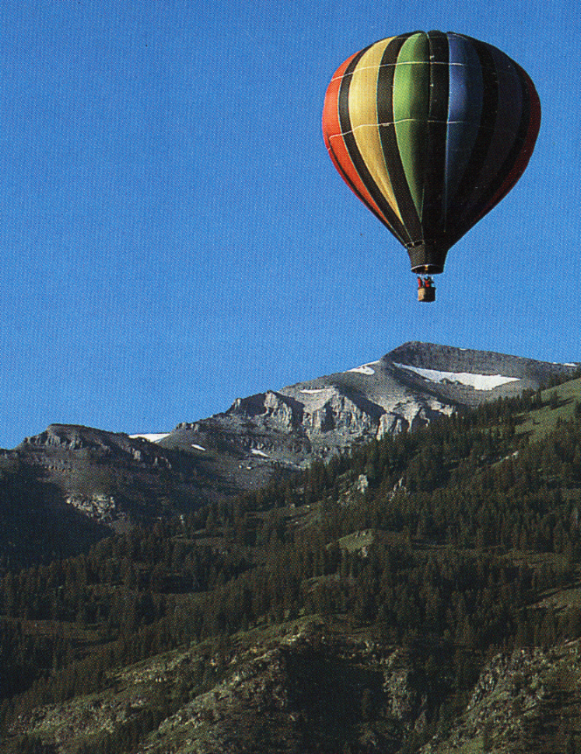

Project Expectations

At the end of the project you should have:

- a balloon design (drawing or model - the model does not need to be functional) showing details of the envelope and gondola, plus a written rationale for the design.
- a list of supplies and a rationale for each item.
- a written travel plan that includes the launch site, a description of the continents and oceans you’ll fly over, your anticipated altitude, and calculations to determine how long your trip may take. Be sure to include an explanation of why you chose your route, a list of the countries you intend to fly over, as well as a list of those countries you’ll have to avoid.
- a route map identifying the seven continents and four oceans and showing your intended flight path.
- a sample letter asking for permission to fly over a representative country.
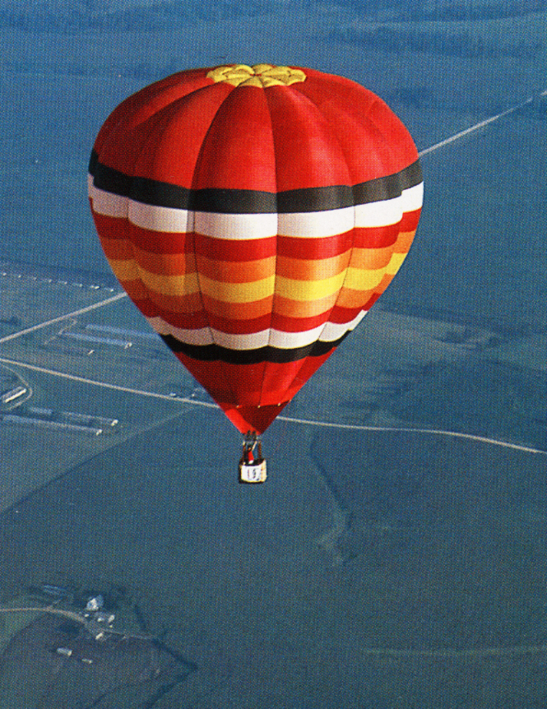

Final Projects and Presentations

The Presentation.

At the end of this unit, you will present your final project to the class. During the presentation, you may use note cards, but you may not simply read your notes. Be sure to use good presentation skills such as the following:

- Stand straight, facing the audience without fidgeting.
- Speak in a loud, clear voice.
- Make eye contact with the entire audience.
- Speak from memory, referring to your notes only when necessary.

Your presentation must describe all aspects of your final project before ending with a statement of what you found most interesting while completing this project.

The Project.

Final projects must include:

- A balloon design in the form of a drawing or non-functional model showing details of the envelope and gondola, plus a written rationale for the design.
- A list of supplies and a rationale for each item.
- A written travel plan that includes the launch site, a description of the continents and oceans to be crossed, a list of countries to be flown over as well as those to be avoided, a calculation of the length of the trip, and the anticipated altitude of the flight.
- A route map showing the names of the seven continents and four oceans and your intended flight path.
- A sample letter asking for permission to fly over a representative country.

Final projects will be presented in the form of a display, and optional model. Displays should be 2 or 3 sided and durable enough to stand safely on a desktop. You are encouraged to be creative when designing your display. Be sure all pictures and diagrams are neatly drawn and labeled. Be sure to check the spelling on everything in the display.
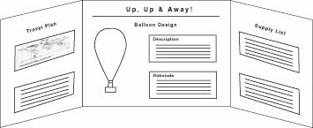
December 25, 1998
Round-the-World
Balloon Adventure Deflates

HONOLULU—Three adventurers trying to make the first non-stop around-the-world flight in a balloon gave up on Friday, ditching in shark-infested waters off Honolulu a little more than halfway through their trip.
The men, Richard Branson, Steve Fossett and Per Lindstrand, quit seven days into their flight after they lost the high-altitude, high speed winds they needed to carry them eastward across the Pacific to North America. They had gotten caught in a low-pressure “trough” and feared they would be stuck there for a week.
“We thought we were going to make it all the way, but we hit a brick wall of bad weather,” said Branson.

THE CRASH

The crew descended in the 272-foot-high, combination helium and hot air balloon and let it hit the Pacific Ocean about 10 miles north of the island of Oahu. The craft bounced across the water for miles because the explosive bolts that were supposed to cut the balloon loose from the crew capsule had been frozen by the cold and didn’t work.
Once the capsule settled in the water, they climbed out the escape hatches in the top and jumped off. The men, wearing their survival suits, were in the water no more than 10 minutes before they were pulled aboard two Coast Guard helicopters.

FAILED ATTEMPTS

All together the three balloonists have made a total of 11 tries at a non-stop balloon flight around the globe. Fossett said, “I’ve made three attempts to fly round the world just in 1998 and it’s getting pretty discouraging.”
The balloon voyage began Dec. 18 in Marrakech, Morocco, and if successful, would have ended in Western Europe. The crew had hoped to reach North America sometime Friday, flying over southern Canada or Washington

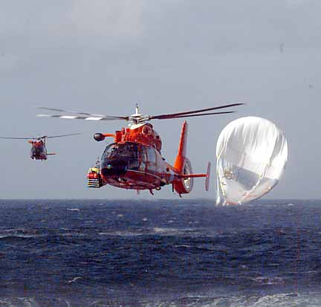

state. They covered 12,500 miles before giving up.

WEATHER & POLITICS

After racing across the Pacific in winds of up to 200 mph, the adventurers’ balloon got sucked into a low-pressure system. They maneuvered the craft up and down between 6,000 feet and 27,000 feet to try to find a fast easterly wind. But the best they could do was a 16 mph wind.
During the journey, the team secured permission from 97 countries to cross their airspace. Iran, Iraq, Russia and North Korea refused permission. The crew also had some tense moments when they passed over China farther north than the balloon had been authorized to fly.
Branson was ready for another attempt. “We have finally cracked everything in the technology,” he said. “We’ll buck up ourselves and start again.”

The original version of this article appeared in the New York Times, written by Bruce Dunford of the Associated Press. The article was modified for length and readability by Jonathan Brinkerhoff.

March 20, 1999

Around the World in 19 Days: Balloonists Make Record Trip

GENEVA - Bertrand Piccard and Brian Jones sailed into history Saturday when their Breitling Orbiter 3 completed the first nonstop balloon trip around the world.

Traveling at an altitude of 36,000 feet, the two balloonists sped past the finish line early Saturday morning, The dangerous voyage had taken the pilots over Europe, Africa, Asia, the Pacific Ocean, Central America and the Atlantic Ocean.

In the grip of a powerful jet stream, the balloon was traveling at about 130 miles an hour when it passed high over the finishing point. With more than one day’s supply of propane fuel still aboard, the Breitling pilots decided to continue on for another day at high speed, then land in Egypt on Sunday morning. They had hoped to set down near the Pyramids in Cairo, but the winds took them too far south, their meteorologists said.

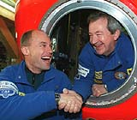

The Breitling’s crew will receive $1 million from the Anheuser-Busch brewing company, as well as the Budweiser Cup, offered to the first balloonist to circle the earth without landing.

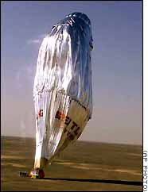

The Dangers

Long distance ballooning can be dangerous. Bad weather, tall mountains, and unfriendly countries can all cause trouble for balloonists. The danger of drifting over unfriendly countries is no idle hazard. Balloonists were shocked in 1995 when two Americans taking part in a balloon race drifted from Poland into Belarus, where they were shot down and killed by a Belarusian helicopter.

Since then, long duration balloonists have tried hard to get permission from all countries they might fly over, but have not always succeeded. China and Russia have been reluctant to admit balloonists. The Breitling team was permitted into Chinese airspace this time, but only on condition that the balloon stay south of the 26th parallel.

Navigating

Since they have no power of their own, balloons are at the mercy of the winds. High-altitude jet stream winds blow at speeds up to 200 miles an hour around the world. But jet streams may stop or divide into branches without warning, sometimes carrying a balloon far off course.

However, there are many low-speed winds at lower altitudes, and by maneuvering between altitudes, a skillful balloonist can usually find a wind going his way.

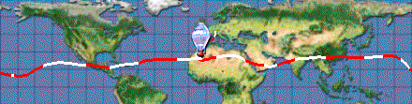

This allows a balloon to change lanes, so to speak, picking a direction that avoids hazards and leads to a fast jet stream. Weathermen, or meteorologists, on the ground help guide balloonists.

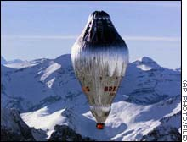

The Cost

During the 1990’s, many balloon teams tried to be first around the world, and their balloons became more and more complex and costly. The actual total cost of long distance balloons is rarely publicly announced, but the Breitling Orbiter 3, built by Cameron Balloons Ltd. of Bristol, England, is known to have cost about $2 million, and that doesn’t include salaries for a 13-member ground crew and many other expenses.

The original version of this article appeared in the New York Times, written by Malcolm W. Brown. The article was modified for length and readability by Jonathan Brinkerhoff.

Information Sources
As you search for information to complete the challenge,
it’s easy to forget where you found things you’ll need later.
That means you have to try to find the information all over
again, which wastes a lot of time. To save you time,
use this form to record where you found information
you might use later to complete the challenge.

Source | Information

Balloon Types

Balloon Type
Balloon Parts
Pros
Cons

Route Map

Jet Stream Map

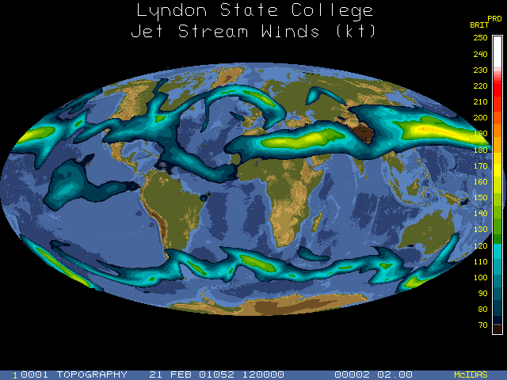

Travel Plan

Northern or Southern Hemisphere:
Why did you pick the hemisphere you did?
Estimated Length of Trip:
How did you determine your estimated trip length?
Place of Departure:
How did you pick your departure point?
Place of Arrival:
How did you pick your arrival point?
Countries to be Crossed:
Countries to be Avoided:

Supply List

Item | Rationale

Experiment Report
Procedure:

What did you predict would happen?

What did you observe happen?

How can you explain your observations?

