Steps in Words | Steps in Numbers | Example
Pick any one digit number | X | 4
Add eight | + 8 | 4 + 8 = 12
Multiply by two | x 2 | 12 X 2 = 24
Subtract six | – 6 | 24 – 6 = 18
Divide by two | ÷ 2 | 18 ÷ 2 = 9
Subtract the original number | – X | 9 – 4 = 5
Multiply by three | x 3 | 5 x 3 = 15
Add two | + 2 | 15 + 2 = 17
The answer will always be 17. |  | 17

Explanation: X

X + 8

2(X + 8)

2(X + 8) – 6

2(X + 8) – 6
2

2(X + 8) – 6 – x
2

2(X + 8) – 6 – x 3
2

2(X + 8) – 6 – x 3 + 2
2

Reduce: ((((X + 8 ) – 3 ) – X ) 3 ) + 2

(( 5 ) 3 ) + 2 = 17

Steps in Words | Steps in Numbers | Example
Pick a number between one and ten | X | 4
Multiply that number by two | x 2 | 4 x 2 = 8
Add ten | + 10 | 8 + 10 = 18
Divide the result by two | ÷ 2 | 18 ÷ 2 = 9
Subtract the original number | – X | 9 – 4 = 5
The result will always be five |  | 5

Explanation: ( X x 2) + 10 - x = 5
2

Reduce 2X + 10 - x = 5
2

( x + 5) – x = 5

Steps in Words | Steps in Numbers | Example
Pick any three digit number | XYZ | 123
Multiply the first digit by 2 | X x 2 | 1 x 2 = 2
Add five | + 5 | 2 + 5 = 7
Multiply by five | x 5 | 7 x 5 = 35
Add the second digit | + Y | 35 + 2 = 37
Multiply by ten | x 10 | 37 x 10 = 370
Add the third digit | + Z | 370 + 3 = 373
Subtract 250 | – 250 | 373 – 250 = 123
The answer is the original number |  | 123

I’ll guess your number.

Steps in Words | Steps in Numbers | Example
Pick a number between one and one hundred | X | 50
Multiply by two | x 2 | 50 x 2 = 100
Add eight | + 8 | 100 + 8 = 108
Multiply by three | x 3 | 108 x 3 = 324
Subtract twenty-four | - 24 | 324 – 24 = 300
Subtract the original number | - X | 300 – 50 = 250
Have them tell you the answer. |  | 250
Divide their answer by 5 | ÷ 5 | 250 ÷ 5 = 50

Explanation: ( (2X + 8) 3) – 24 – X
5

(6X + 24) – 24 – X
5

5X
5

Steps in Words | Steps in Numbers | Example
Pick any three digit number | XYZ | 682
Repeat it to make a six digit number | XYZ,XYZ | 682,682
Divide by eleven | ÷ 11 | 692,682 ÷ 11 = 62,062
Divide by seven | ÷ 7 | 62,062 ÷ 7 = 8,866
Divide by thirteen | ÷ 13 | 8,866 ÷ 13 = 682
The answer will be the orignial number |  | 682

Explanation: Any 3 digit number, when multiplied by 1,001 will repeat (123 x 1,001 = 123,123). The numbers 11, 7 and 13 are the prime factors of 1,001. Thus, you first multiply the number by 1,001, and then divide by 1,001, putting you right back where you started.

Steps in Words | Example
Have someone pick a four digit number | 7,453
To find the answer, put a two in front of the first digit and subtract two from the last digit.  Write the answer down, then complete the problem. | 27,453  – 2  27,451
Have someone pick another four digit number. | 7,453  8,691
Now you write a number which, when added to the second number picked, totals 9,999  9,999 | 7,453  8,691  1,308
Have someone pick another four digit number. | 7,453  8,691  1,308  4,651
Now you write a number which, when added to the last number picked, totals 9,999  9,999 | 7,453  8,691  1,308  4,651  5,348
Now have someone add the numbers. The answer will be the number you wrote down after the first number was picked. | 7,453  8,691  1,308  4,651  + 5,348  27,451
NOTE: If the original number’s last digit is 1 or 0, you’ll have to borrow in order to take 2 away.
Example: For the number 3,451 the answer would be 23,449

To find the age of anyone ten or older:

Steps in words | Steps in numbers | Example 1 | Example 2
Write your age | 24 | 24 | 11
Subtract any one digit number | – X | 24 – 6 = 18 | 11 – 6 = 5
Multiply by nine | x 9 | 18 x 9 = 162 | 5 x 9 = 45
Add your original age | + 24 | 162 + 24 = 186 | 45 + 11 = 56
Have the person tell you their answer at this point.  - If the answer is a three digit number, take the last digit and add it to the first two digits to find their age.  - If the answer is a two digit number, add the two together. |  | 18 + 6 = 24 | 5 + 6 = 11

To find the date of someone’s birthday:

Steps in words | Steps in numbers | Example
Write the number of the month you were born. | X | 10
Multiply by 5 | x 5 | 10 x 5 = 50
Add seven | + 7 | 50 + 7 = 57
Multiply by four | x 4 | 57 x 4 = 228
Add thirteen | + 13 | 228 + 13 = 241
Multiply by 5 | x 5 | 241 x 5 = 1,205
Add the day you were born | + Z | 1,205 + 23 = 1,229
Have the person tell you their answer at this point. Subtract 205, the separate the numbers to find the birthday, in this example, Oct. 23. | – 205 | 1,228 – 205 = 1023  10 / 23

Steps in words | Example
Pick a three digit number. The first digit must be at least two larger than the last digit | 801
Flip or reverse the number and subtract | 801  - 108  693
Flip or reverse the number and add | 693  + 396  1,089
No matter what the starting number, the answer will be 1,089.

Challenge your students to beat you at multiplication. Tell them you’ll even make it easy on them by using the eleven’s table, which is, after all, nothing more than the one’s table used twice. Then use the following trick which works for any three digit number multiplied by eleven.

Steps in Words | Example | Example with carrying
You and your challenger stand with your backs to the board.
Have a student pick any three digit number and write it as two identical problems, one for each of you.  NOTE: There are two examples as carrying may be necessary. | 245  x 11 | 958  x 11
When the class yells go, turn around and write the right-hand digit ( 5 ) | 5 | 8
Add the first two digits from right to left ( 5 + 4 ) and write it | 95 | (13) 8  (1) 38
Add the first two digits from left to right ( 2 + 4 ) and write it | 695 | (14) (1) 38  (15) 38  (1) 538
Write the left hand digit ( 2 ) | 2,695 | (9) (1) 538  10,538

Magic Squares: Any way you add the columns or rows, the answer will be the
same.
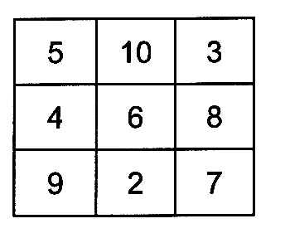
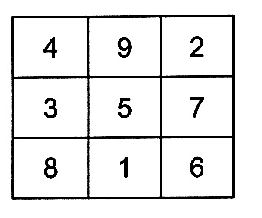
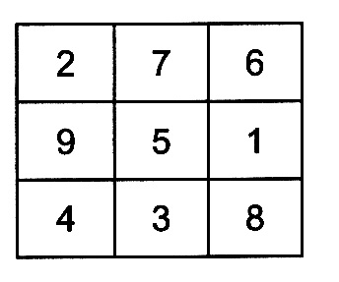
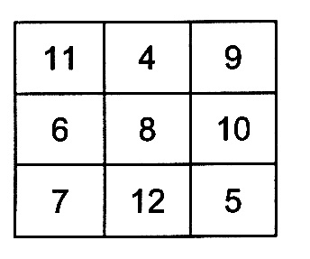

In any magic square with three numbers in each row and column, the center number is always the total divided by three.

Try leaving some of the boxes in the square blank and challenge students to find the numbers that fit. Here are some examples.
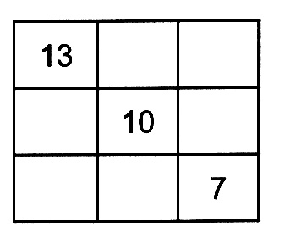
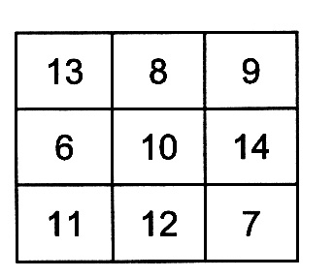
Fill in the numbers six to ANS:
fourteen so each column
and row sums to thirty.
There’s more than one
answer.

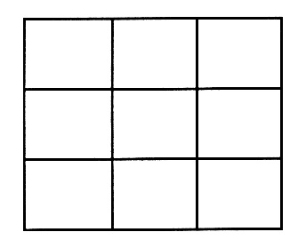
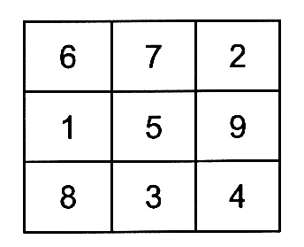
Fill in the numbers one to ANS:
nine so each column and
row sums to fifteen.
Hint: The five goes in the middle.
There’s more than one answer.
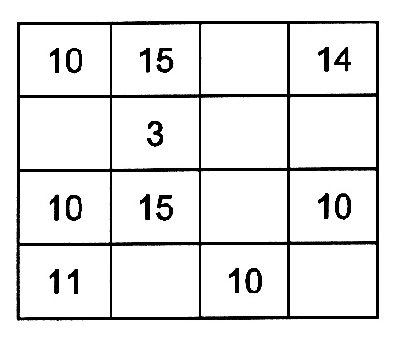
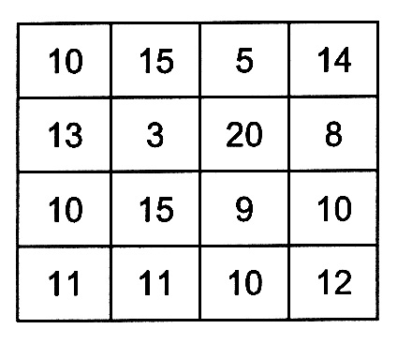

Fill in the square so ANS:
each column and
row sums to forty-four.

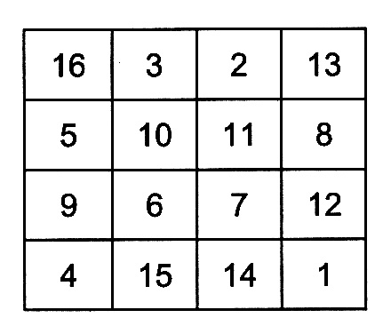
This square is really special. Challenge your students
to find all its secrets.

Answers include:
Each column and row totals 34. Each diagonal totals
34. The four corner numbers total 34. The four
center numbers total 34. The four numbers in each
quarter total 34. The two middle numbers in the first
and last column total 34. The two middle numbers in
the top and bottom rows total 34. A zigzag line
starting with any but a corner square totals 34.
8 : 5 : 4 : 9 : 1 : 7 : 6 : 3 : 2 : 0

The numbers above are in a specific order. Can you figure it out?

ANS: The written names for the numbers are in alphabetical order.

Pick any number (Keep it small if you don’t want to work too hard.)
If the number is even, divide by two.
If the number is odd, multiply by three and add one.
Continue and see what happens.

ANS: a pattern is established. 4, 2, 1, 4, 2, 1…

How long would it take to make one million marks on the blackboard at a rate of one mark per second without stopping? In other words, how long is one million seconds?

1,000,000 sec. x 1 min. x 1 hour x _1 day_ = 11.57 days
60 sec. 60 min. 24 hours

How long would it take to make one billion marks?

1,000,000,000 sec. x 1 min. x 1 hour x _1 day_ x _1 year_ = 31.7 years
60 sec. 60 min. 24 hours 365 days

What’s the largest number you can make using three nines? Use any mathematical operation you like.

ANS: Nine to the ninth power raised to the ninth power. (9⁹)⁹

