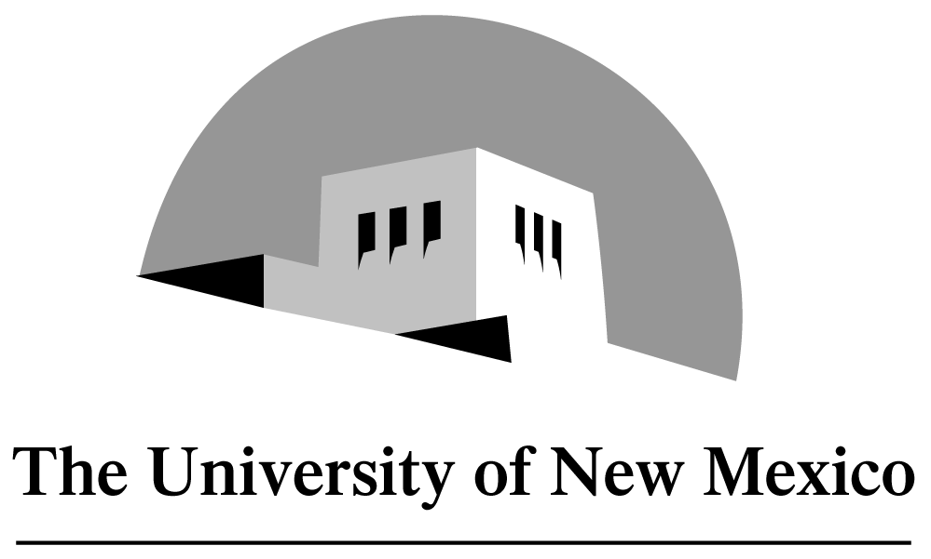
Management Mentorship Program

Be a Management Mentor!

Human Resources is piloting a management mentorship program intended to help new managers experience a successful transition to their job. We are seeking experienced successful managers who are willing to share their experiences and insights in an effort to help other managers also realize success.

Why should you become a mentor?
Mentors will:
- Gain deep satisfaction from sharing expertise and watching a new manager develop
- Add to your already outstanding leadership skills
- Invest in the future of the University
- Contribute to the learning of the organization
- Learn from the mentee’s experiences and insights
- Give something back to the professional community

Who should become a mentor?
Mentors must:
- Have worked at the University for two years or more, at least one year in a managerial position
- Act as a role-model, teacher, companion, networker and resource for the mentee
- Sign and agree to Mentor’s Roles and Responsibilities
- Create long-term and short-term objectives with the mentee
- Maintain consistent contact with the mentee (at least 2 to 4 hours per month)
- Be interested in the growth of someone else and of self

If you are interested in becoming a mentor and contributing toward the success of a new manager at the University of New Mexico, please fill out the Mentor Matching Form at http://www.unm.edu/~hrNEED_URL and submit it to Employee & Organizational Development at MSC04-2780.

For questions or additional information, please visit http://www.unm.edu/~hrNEED_URL or call Employee & Organizational Development at 272-7740.

Employee & Organizational Development
A Division of Human Resources

