Practice Exam #2c: PEP 426 Intermediate Exercise Physiology

Write all answers on the answer sheet provided.

Section1: Multiple Choice
Select the response that best answers the following questions.

- Muscle blood flow during intense exercise can approximate what percentage of cardiac output?

- 15 %
- 45 %
- 65 %
- 70 %
- 90 %

- If hemoglobin concentration is 15.0 g/100 mL, and oxy-hemoglobin saturation is 75%, how much oxygen is in arterial blood?

- 25 mL/100 mL
- 10.5 mL/100 mL
- 18.5 mL/100 mL
- 16 mL/100 mL
- 31 mL/100 mL

- The blood vessels that have the slowest blood flow velocity are?

- arterioles
- capillaries
- arteries
- veins
- venules

- The best criterion for establishing whether VO₂max has been attained is …….

- a VO₂ plateau
- heart rate within ±10 b/min from 220-age
- blood lactate > 8 mmol/L
- RPE > 17
- the inability to continue exercise

- An increase in which of the following will increase oxygen diffusion?

- distance/thickness
- tissue hydration
- myoglobin
- molecular size
- partial pressure gradient

- Which of the following is a non-traditional gland?

- anterior pituitary
- testes
- adrenal
- endothelium
- pancreas

- If the barometric pressure is 540 mmHg, the PaO₂ is ………?

- 72 mmHg
- 42 mmHg
- 28 mmHg
- 86 mmHg
- 100 mmHg

- Glucagon is secreted from the ________ ?

- adrenal medulla
- posterior pituitary
- hypothalamus
- endothelium
- pancreas

- The maximal rate of gastric emptying approximates

- 3 L/hr
- 1.2 L/hr
- 0.5 L/hr
- 40 mL/hr
- 2 L/hr

- The amount of simple carbohydrate needed to be ingested to provide an ergogenic effect during exercise approximates __________?

- 20 g/hr
- 7 g/kg/hr
- 100 g pre-exercise
- 15 g pre-exercise
- 40-45 g/hr

- Dehydration in excess of ………… is likely to lead to heat stroke if exercise continues?

- 1%
- 4%
- 2%
- 8%
- 10%

- In the female, blood estrogen is lowest during ……………

- the early luteal phase
- the late follicular phase
- the early follicular phase
- the entire menstrual cycle
- ovulation

- Which of the following is most likely to limit VO₂max during incremental exercise?

- dehydration
- hypoglycemia
- oxygen delivery (central and peripheral components)
- decreased creatine phosphate
- central nervous system

- During the renal compensation for respiratory alkalosis that occurs during acute altitude exposure, blood bicarbonate ………….

- increases
- buffers twice the number of protons
- is absorbed/retained by the kidney
- remains unchanged
- decreases

- Compared to exercise at sea level, after arrival at altitude which of the following does not happen during the same steady state exercise intensity?

- increased VO₂
- increased heart rate
- decreased cardiac output
- increased blood lactate
- decreased stroke volume

- The proportion of the U.S. adult population that does not perform adequate daily physical activity approximates …..%.

- 30
- 22
- 90
- 70
- 60

- The molecule that decreases lung surface tension, thus increasing compliance is ………...

- ATP
- Nitric oxide
- Adenosine
- surfactant
- creatine

- A decreased blood oxygen content is referred to as ………………..

- ischemia
- hypoxia
- oxygen deficit
- EPOC
- hypoxemia

- Which of the following would worsen the decrement in VO₂max (larger drop in VO₂max) at increased altitude?

- high lactate threshold
- small lean body mass
- low sea level VO₂max
- large lean body mass
- better maintained SaO₂

- How much heat is produced during exercise at a VO₂=3.0 L/min and RER=0.95, with an assumed efficiency of 30%? (see Table)

- 10.5 Kcals/min
- 8.5 Kcals/min
- 13.8 Kcals/min
- 9.2 Kcals/min
- 14.3 Kcals/min

Section 2: True/False
Write either T (true) or F (false) on the answer sheet provided.

- Each of cardiac output and stroke volume plateau near VO₂max in all people.

- As heart rate increases, diastolic filling time increases.

- Blood plasma can hold 0.003 mmHg of oxygen per 1 mmHg barometric pressure.

- Estrogen can impair glucose uptake into skeletal muscle.

- Surfactant functions to increase lung compliance.

- Growth hormone, cortisol and glucogan all function to increase/support liver gluconeogenesis.

- All endurance athletes should complete a low carbohydrate diet in the initial three days of a 7 day glycogen loading regimen to maximize muscle glycogen.

- Blood pH is corrected during chronic altitude exposure due to altered renal function resulting in bicarbonate excretion and acid reabsorption.

- Some sea level residing athletes have been shown to have a detectable decrease in VO₂max at altitude changes as low as 580 m.

- When you perform daily moderate to intense exercise, you get approximately 85% of full heat acclimation potential, not matter what the climate you live in.

- Exercise-induced dehydration can be easily prevented.

- Women are most male-like (endocrinologically) during the luteal phase.

- Carnitine supplementation can increase lipid catabolism during exercise.

- Certain athletes have an increased RDA for protein that can be in excess of 1.2 g/kg/day.

- Caffeine is a CNS depressant.

Section 3: Short Response
Write your answer on the lines provided for each question on the answer sheet.

- What is the difference in the arterial content of oxygen (CaO₂) between sea level and 10,686 ft (Sandia Crest): use the following facts and the O₂-hemoglobin dissociation curve; [Hb]=145 g/L ; no difference b/n P_{A}O₂ and PaO₂ ; 1 m = 3.28 ft ; PB = 760 * [e ^{–(m/7924)}]

- What drink conditions delay gastric emptying?

- What is the role of renin in fluid balance?

- Why is continued exercise during heat stroke potentially deadly?

- How do you know if VO₂max has been attained?

- Why is it extremely difficult to prevent a dehydration during moderate to intense exercise in a hot environment?

- What is acute mountain sickness?

- Why does sweat rate decrease as dehydration becomes more severe?

Use the figure of the O₂-hemoglobin dissociation curve, below, to assist with other questions

Use the RER table, below, to assist with other questions
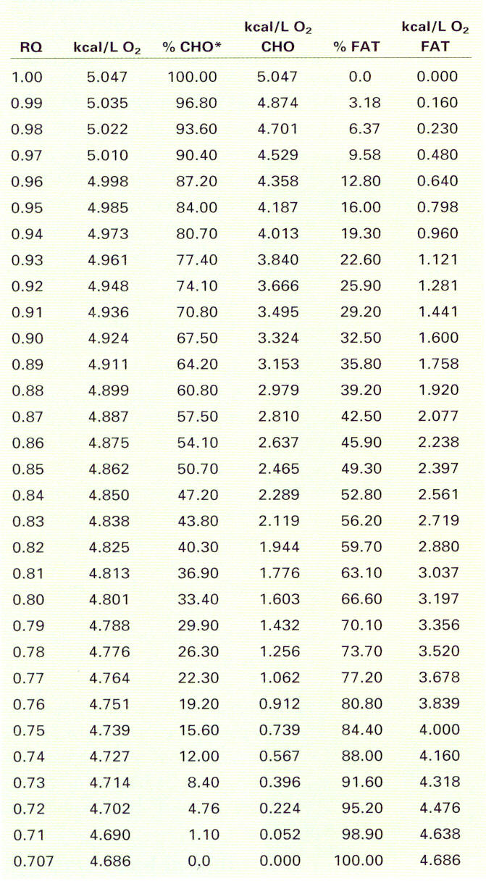

Section 4: Figure Interpretation
Write your answers in the space provided for each question on the answer sheet.

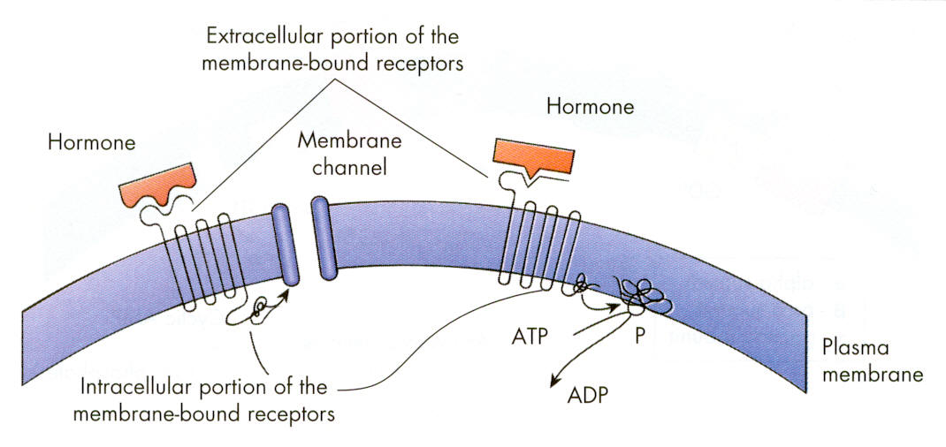
1. What type of hormone has this cellular response mechanism? Give two examples.

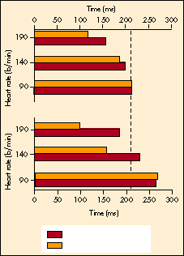

2. How does this figure reveal the importance of the increase in contractility during exercise?

