PEP 426: Research Manuscript Critique Example
Jones AM, Wilkerson DP, DiMenna F, Fulford J, Poole DC. Muscle metabolic responses to exercise above and below the “critical power” assessed using 31P-MRS. Am J Physiol Reg Integr Comp Physiol 294:R585-R593, 2007.
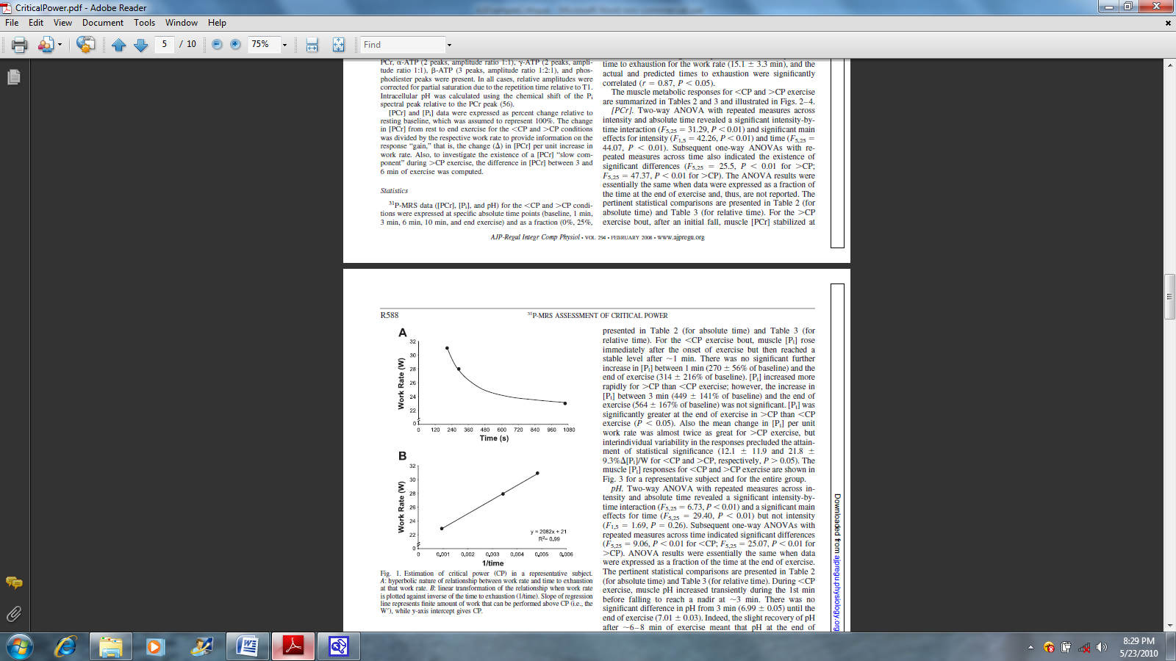
Figure 1. Data from a representative subject for changes in time to fatigue for given exercise intensities for single leg knee extension exercise.
Introduction
Graphing time to fatigue vs. exercise intensity (Watts for cycling) produces a non-linear relationship, where time to fatigue becomes progressively longer for reductions in exercise intensity (Figure 1A). Converting time data to reciprocal values makes this relationship linear (Figure 1B), where the exercise intensity of the y-intercept is known as the “critical power” (CP); the exercise intensity that represents the delineation between steady state (< CP) and non-steady state (> CP) exercise intensities.
Based on the theoretical constructs behind the CP concept, one can hypothesize that exercise intensities < CP should result in stable concentrations of muscle creatine phosphate ([CrP]), inorganic phosphate ([Pi]) and pH. Conversely, exercise intensities > CP should result in a continual decline in muscle [CrP], continual increase in [Pi], and a steady decrease in pH.
The purpose of the study was to use ³¹P MRS as a method to quantify muscle high energy phosphates and pH during single leg knee extension exercise at ~10% below and 10% above the predetermined CP.
Methods
Six recreationally active males volunteered to participate as subjects. Subjects first performed repeated conditions of single leg knee extensions to establish individual exercise intensity vs. time to fatigue relationships. The CP was estimated from this relationship for each subject.
Subjects were then scheduled to perform single leg knee extension exercise in a prone position inside the bore of a 1.5 Tesla superconducting magnet for quantification of muscle phosphate molecules using ³¹P MRS. Subjects completed two trials at ~10% below and 10% above their CP. Knee extension exercise consisted of a non-magnetic pulley system where a rope connected to the subject’s foot was relayed over a mounted pulley connected to calibrated weights. A shaft encoder was used to quantify rotational distance during each contraction, and force was measured from a load placed in series to the rope.
³¹P MRS data was acquired every 1.5 s and averaged every 6 s (4 FID averages) continuously throughout all exercise bouts. Muscle metabolic data were tested at the specific time points of baseline, 1, 3, 6, and 10 min, and end exercise. Data were analyzed using two factor repeated measures ANOVA (Intensity vs. TIME).
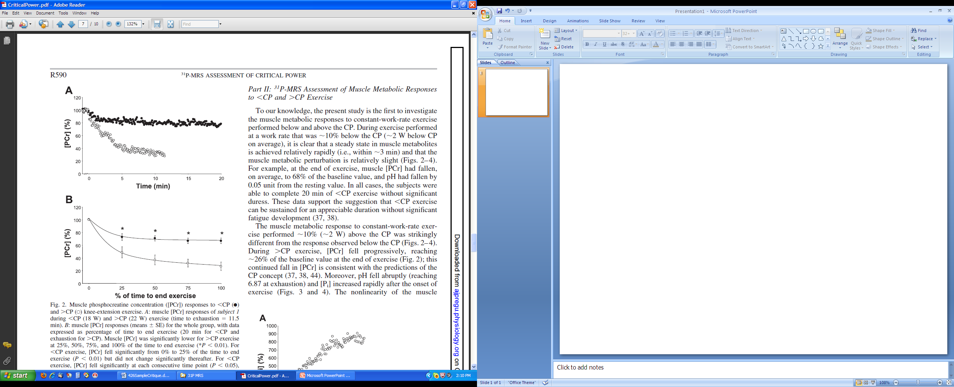
Figure 2. Data for a subject (A) and mean data (B) for all subjects for creatine phosphate (PCr).
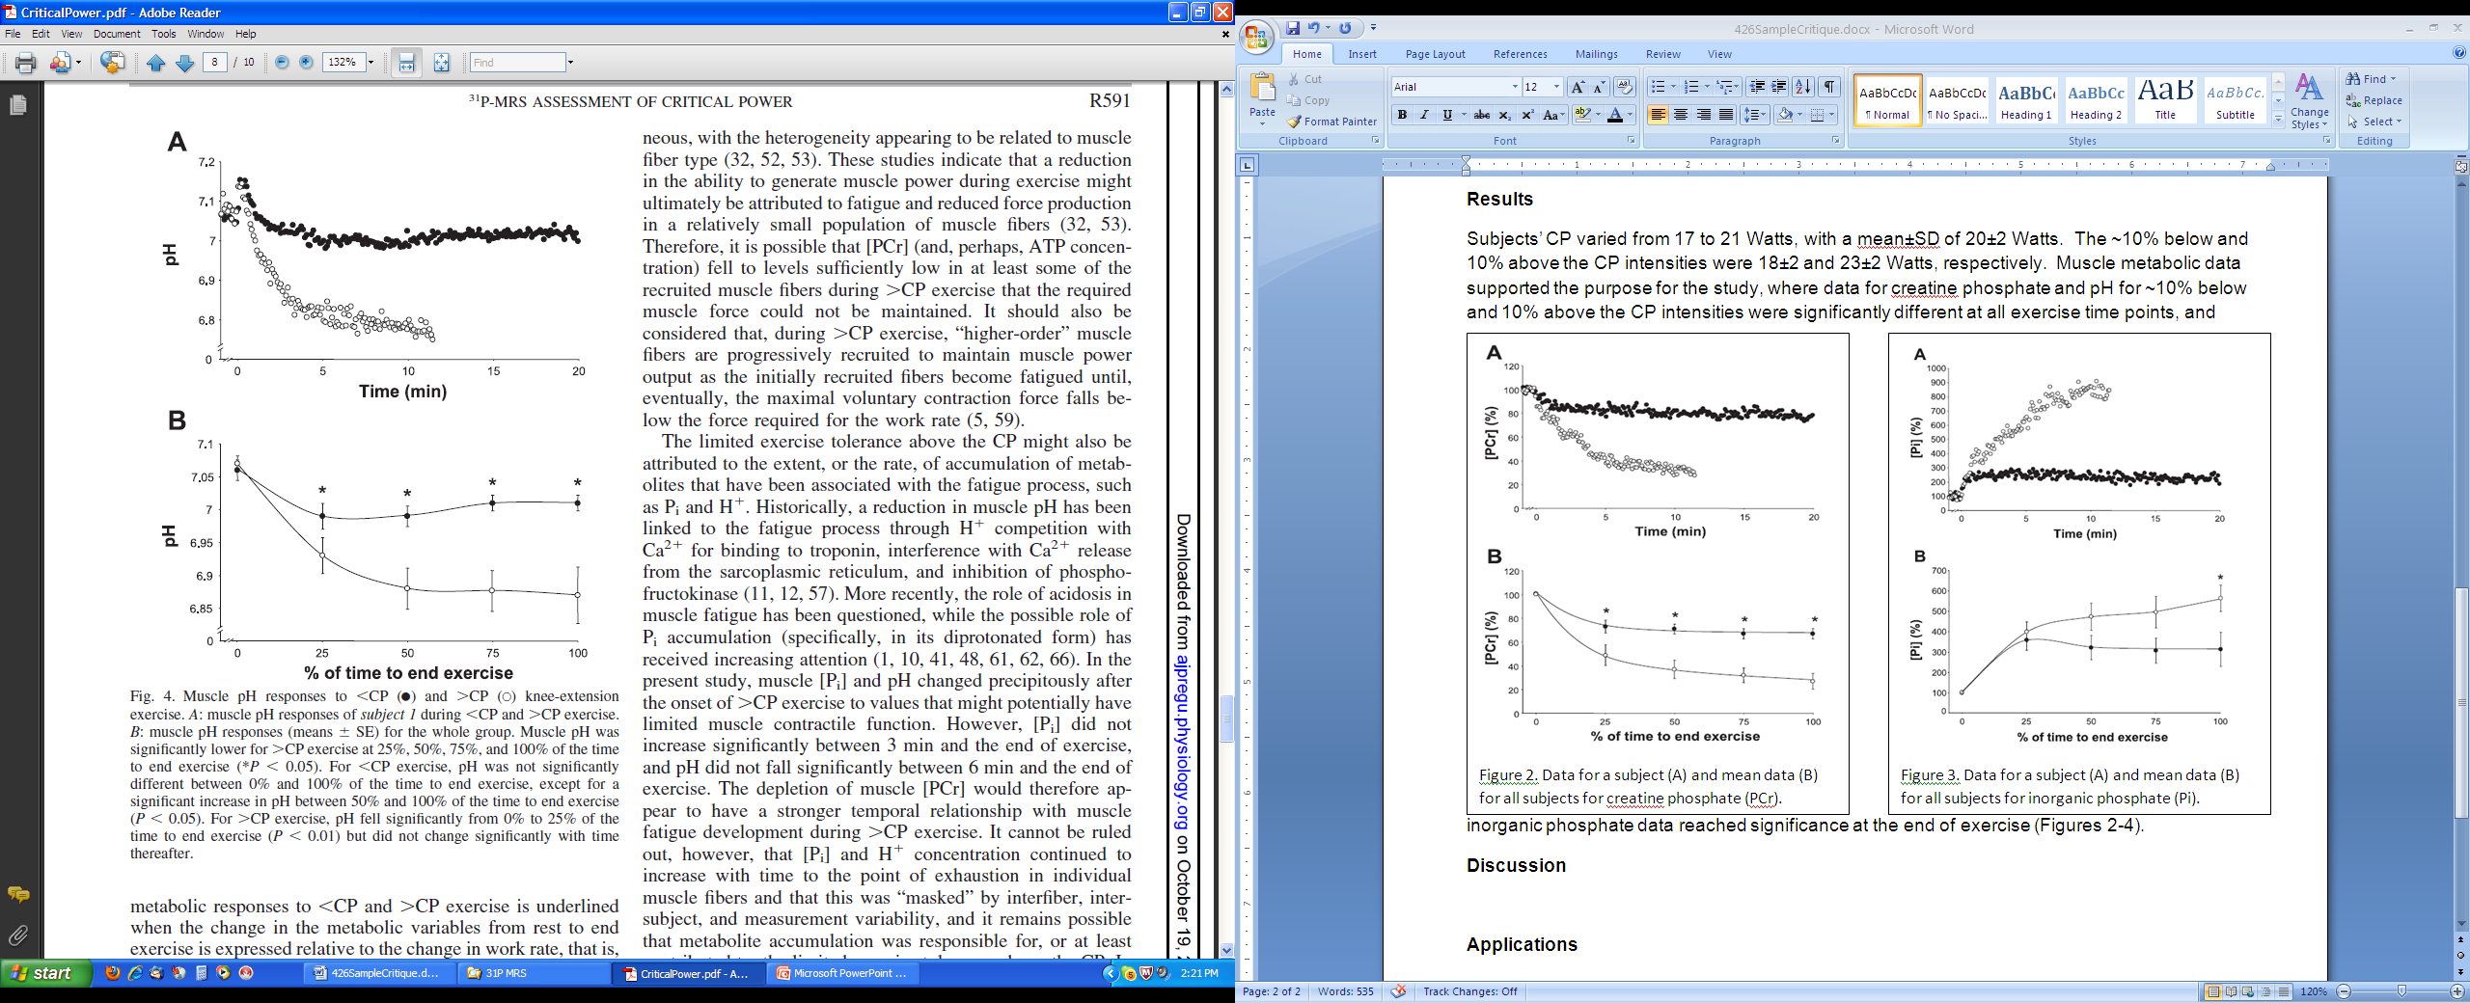
Figure 3. Data for a subject (A) and mean data (B) for all subjects for intramuscular pH.

Results
Subjects’ CP varied from 17 to 21 Watts, with a mean±SD of 20±2 Watts. The ~10% below and 10% above the CP intensities were 18±2 and 23±2 Watts, respectively. Muscle metabolic data supported the purpose for the study, where data for creatine phosphate and pH for ~10% below and 10% above the CP intensities were significantly different at all exercise time points (Figure 2,3), and inorganic phosphate data reached significance at the end of exercise.
Discussion
The results were as expected, revealing the muscle metabolic stress associated with exercise intensities above the CP. While each of CrP, Pi and pH changes in both trials, the ~ 10 below CP trial revealed the ability of muscle to change to an altered consistency, with slightly lower CrP and pH, and higher Pi. Despite the superficial advanced nature of the research, the question was rather basic, and results were as expected based on prior research using indirect calorimetry to monitor whole body energy metabolism.
Applications
This study has limited application. Athletes already understand the concept and importance of steady state vs. non-steady state. The benefit of the study lied in how a sophisticated method was used to monitor metabolic steady vs. non-steady state, and how this supported the CP concept. However, as explained above, the results were predictable and nothing really new was added to the topics of critical power and muscle energy metabolism during exercise.

