Velotron Text File Convert Instructions
I completed the programming for the conversion of the Velotron .txt file. Remember, I had to remove all the initial wording of the file features and subject details, etc, and then remove all the “” marks around the data. I also removed the column of blank Heart Rate data.
Here is how you should use the program, along with images of the program interface.

- The shortcut to the program is on the desktop – it is called “VelotronCleanTXT” and looks like this.
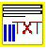
- Double lick the icon to run the program. The user interface screen looks like this.
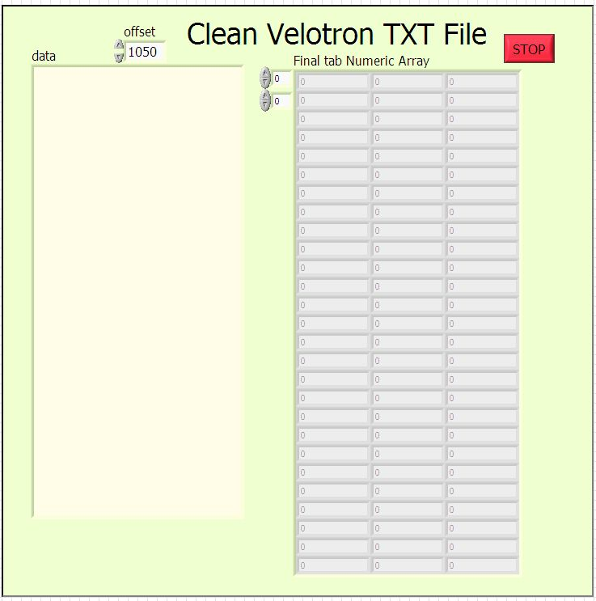
- You will be immediately asked to open a txt file via a standard dialogue box. However, note from the above image that there is a “data” box and an array display. The data box will show the raw txt file contents from the Velotron file once you select a file. The array display will show the result of the conversion. The “offset” controller is for you to use to alter the number of characters that are deleted from the Velotron file so that only data is left.
- For example, the image below shows the imported data with the first 1050 characters deleted. Every subject will have a different number of these initial characters based on name length differences, etc. In this example, you need to click on the toggle up portion of the controller to increase the characters deleted. Do this slowly, as it takes a couple of seconds for the program to all the crunching to edit the data file with each change. The goal is edit the file so that you only have the data remaining (see next).
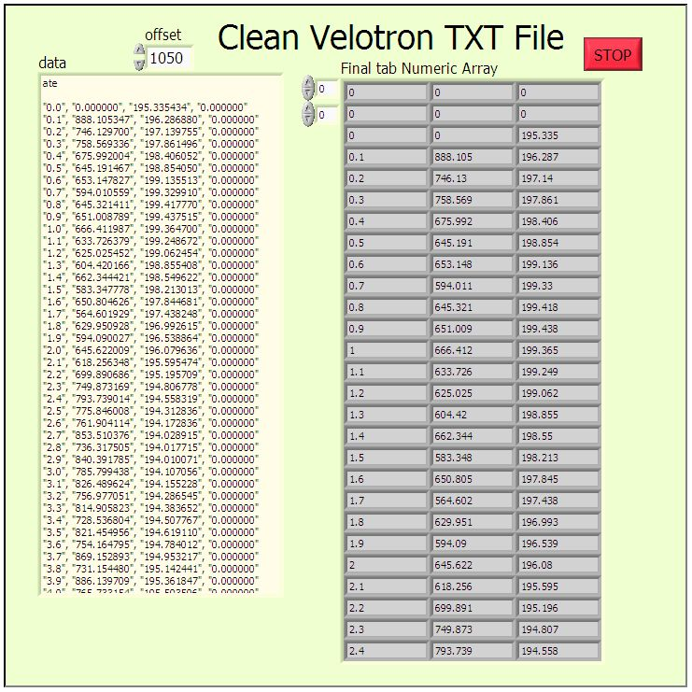
- OK, so you have now edited your file, and it should look like the image below.
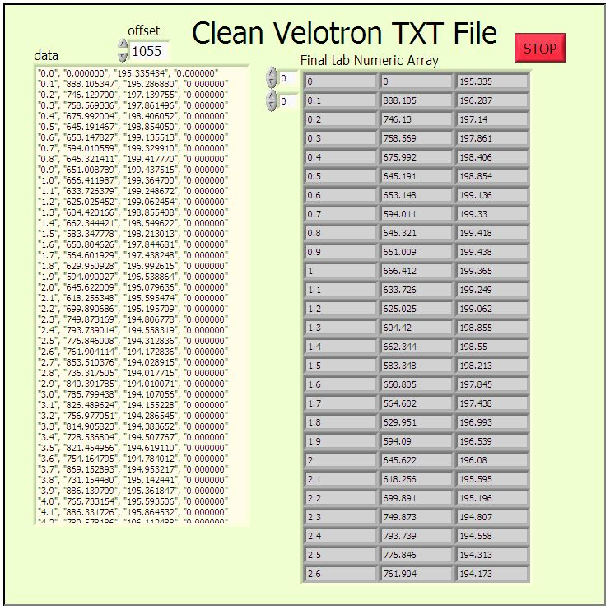
- Now you have only the data and the array display now separates all data into correct cells organized by rows and columns. The “$” symbols are now removed.
- Click “STOP” to end the program and a dialogue box will appear for you to save your converted data file. I recommend that you save it (I would name it so that it is clear that the file is not converted!!!) to your client location in the Velotron program database tree so that all your data is in the one location.
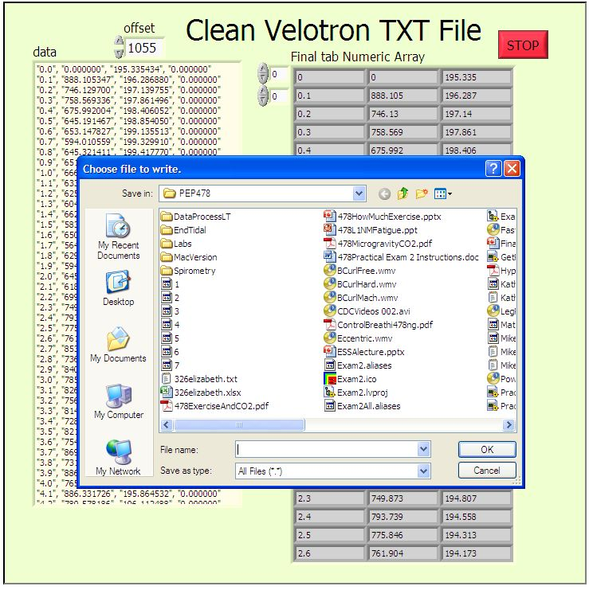
- Transfer the converted file to your jump drive for importing into Excel. There are no Microsoft Office programs on the Velotron computer.
- To import into Excel, ignore the initial warning command. The file will import fine as a tab delimited txt file.

