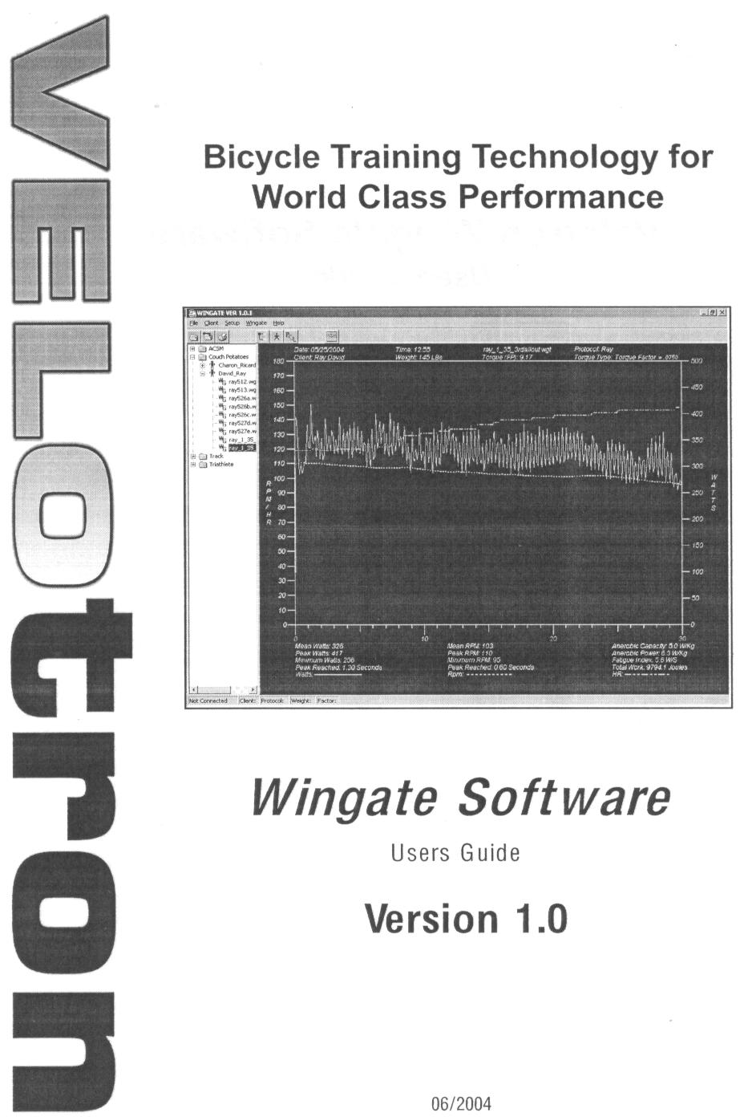
Tips From Dr. Robergs
I sorted out the issues with saving clients and data. Here is what you need to do.

- Note that in the left folder structure I now have a folder for Sports Physiology. This is the database that you need to enter into the New Client page. You do not need to create a new database. (see page 20 of the following instructions).
- You cannot save data and then export the results if the client is not stored into the database! Thus, do not forget item 1 above!
- To enter a new client (your subject), follow the directions on page 19 and 20.
- Once you have entered your client, linked to the Sports Physiology database, then proceed to the instructions on page 23.
- After the test, you can decrease the load on the bike by using the “load down” arrow icon near the top of the screen.
- The instructions at the bottom of page 17 reveal how to export the test data. Note that the file is a comma delimited .txt file. Also, be aware that you need to access the file tree on the left of the initial screen to get these files. Simply click on the expand check mark to the left of the database and then the client, and then the test to access the data. Right click on a test file to get the export option. Select where you want to save this data (you may as well default save to the client folder of the database), and then click OK.

