Using The EPL Monark Ergometer SDI Wingate Test System

The system we use is configured for the SDI hardware component and software approach. We recently upgraded software for Windows, and to enable testing durations up to 2 minutes.

Operating Procedures
30 s Wingate
- Turn on the computer.
- Click “START”, and then click on the SDI shortcut icon.
- The SDI software will boot up, and you will see the window and header options.

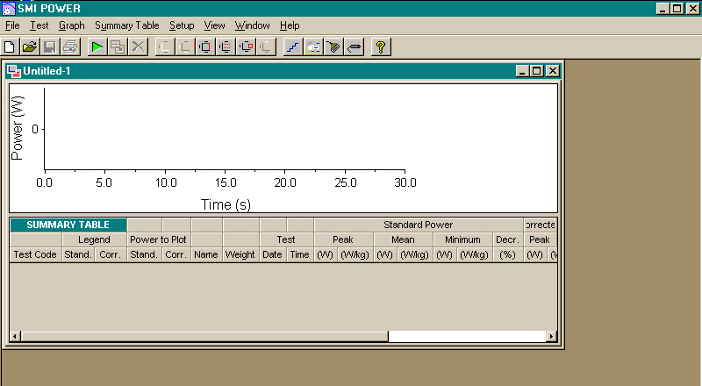

- Click “TEST”, and then “New” for a new test. A new window will open.

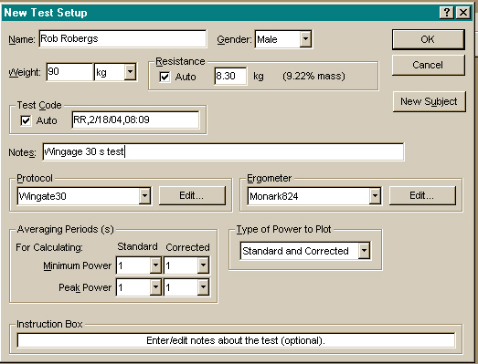

- Enter your subject’s details. Note the content for Resistance. Selecting Auto will result in a calculation of the load at 9.22% body mass. De-selecting Auto will allow you to enter another load. You can change your Protocol to a longer test (120s), and I will explain this option later. The default for the Monark bike is correct at Monark824. Clock “OK”, and the test graph window opens.

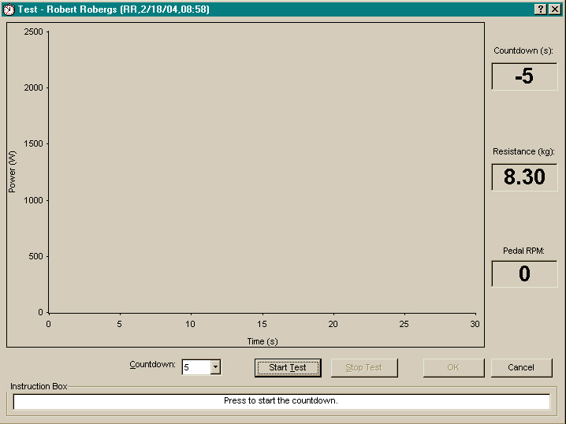

- Have the subject perform a warm-up prior to the test. I recommend that you require your subject to cycle with only the load plate as resistance at 70-80 rev/min for 5 min.
- Have your subject rest for 2 min after the warm-up.
- Make sure the correct load is on the load plate. To start the test, grab the weight strap and lift it so that there is no resistance on the flywheel. Click “Start Test”. At this time, a 5 s count down timer will start (see top right of the screen window). Have the subject increase cadence until a maximal cadence is attained (must be within the 5 s count down), and when the timer reaches “0”, let go of the weight strap.
- Provide encouragement to the subject.
- The test collection will end automatically once the time has elapsed. Click the “OK” button, and you will be taken back to the original test window with the test data now presented in a smaller graph.

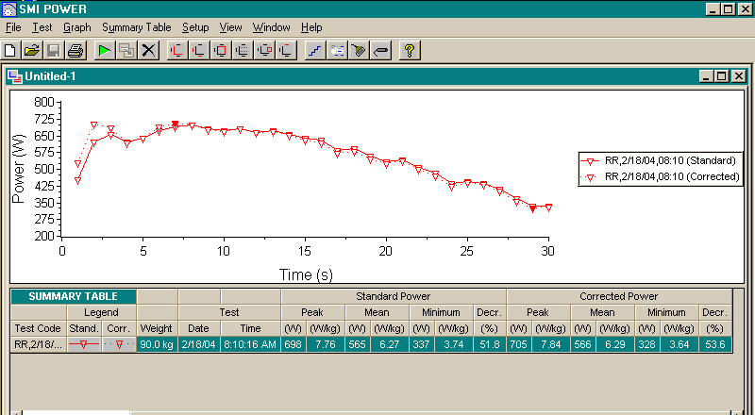

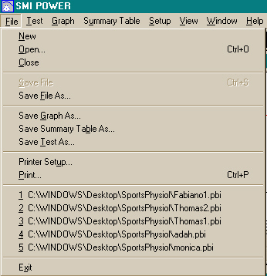

- Click “FILE”, then “Save File As” to save the test to the computer. Make sure the data is saved to the Sports Physiology Folder on C drive. Then click “FILE”, then “Save Test As” to save the test as a tab-delimited text file to the computer. You can then import this into Excel for subsequent graphical presentation.
- To see the text file data table, Click “TEST”, then “View”, and you should see a similar table to the one below.

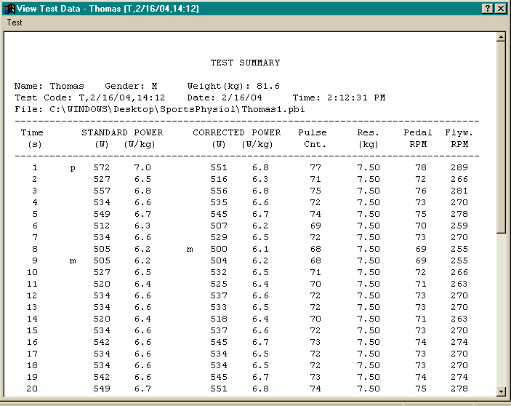

120 s Test
  - If you are conducting a 2 min test, you need to use a different load than the recommended 7-10% of body weight for the Wingate test. You set this at step 5, above. We find that a Watts intensity approximating 110% of the Watts at VO2max works well for a 2 min test. However, as the program will not go beyond 2 min, I suggest you use 120% of the Watts at VO2max, as you need to have the subject fatigue in less than 2 min. The closer this fatigue is to 2 min, the more valid the test. Thus, work out a suitable cadence for your subject, and back calculate to determine a resistance that computes the target Watts. For example, if Watts at VO2max = 400, then 120% Watts at VO2max = 480.
Thus, 480 * 6.118 = 2936.64 kgm/min = load (kg) * 6 * 80 rev/min.
Thus, kg load = 2936.64 / (6 * 80) = 6.12 kg. As we do not have weights in small increments, I would round down to 6 kg.
  - Once the test is complete, proceed as for the 30 s test instructions above.

