Research Methods: Exam 1

Multiple Choice
Select the correct answer.

- The main benefit of random assignment of subjects to groups is that …..

  - It protects against unknown confounding variables
  - It will always guarantee equal between-groups subject characteristics
  - It increases statistical power
  - It will decrease subject drop out
  - None of the above

- In experimental research, independent variables are ………

  - those that are measured pre- and post intervention
  - used as exclusion criteria
  - never used
  - the grouping or different levels of the experimental conditions
  - used as inclusion criteria

- Correlation research is used to,

  - simplify research methods
  - quantify how 2 or more variables are related and to allow prediction
  - compare two or more means
  - determine cause-effect relationships between 2 or more variables
  - avoid doing complicated statistics

- The commonly accepted level of a type II error probability is ……….

  - 0.05
  - 0.2
  - 0.8
  - 1.0
  - -0.1

- The term “apriori” refers to ….

  - statistical power
  - type II error
  - data processing after the study has been completed
  - type I error
  - before data collection, or the start of the study

6 What type of sampling strategy is the following?

Researchers developed a list of potential subjects for their study. From this list, subjects were grouped by age (by 10 year increments), gender and ethnicity. Subjects of identical age, gender and ethnicity were then randomly allocated to four different groups. This was repeated until 40 subjects per group were selected that allowed equal representation based on age (by decade), gender and ethnicity.

- Simple random
- Systematic sampling
- Cluster
- Convenience
- Stratified random

7 Which of the following is not recognized as a “bad” trait of science?

- intuition
- authority
- poor knowledge
- empiricism
- tenacity

8 Variables that can alter or interfere with how a treatment influences a dependent variable are referred to as,

- factors
- null hypotheses
- confounding variables
- experimental error
- type I errors

9 The generally accepted value for the probability for protection against committing a type I error is ……

- 0.05
- 0.8
- 0.75
- 0.1
- 0.2

10 The recommended statistic for representing the variance of the dependent variable is the …

- standard error of the mean
- standard deviation
- mode
- median
- mean

11 Which of the following influences statistical power?

- sample size
- repeated measures vs. between groups statistics
- variability of the dependent variable
- the alpha (α) level
- all of the above

12 Effect size is defined as

- (x – M) / N -1
- (X1 – X2) / N
- (x – M) / N
- (Mean1 – Mean2) / Std Dev.
- X_{1-n}/N

True/False

- Ideally, words used to label variables or measurements in titles and hypotheses should be operationally defined/clear.

- If possible, random sampling of subjects and assignment of subjects to groups should always be performed.

- Additional inclusion and exclusion criteria will increase statistical power but likely decrease external validity.

- Non-significant findings in research should be interpreted as the study failed and the research has no meaning.

- A typical value for acceptable statistical power is 0.8.

- Accepting the Null Hypothesis when there is no difference between the means is a Type I error.

- Repeated measures or time series research designs involve the use of the same subjects in different trials/conditions.

- When using small (< 20 subjects/group) sample size increases, it is best to not rely on randomization to minimize group differences on specific measurements.

- Sample size does not influence statistical power.

- Researchers should strive to sample just enough subjects to demonstrate a meaningful effect to be significant at an acceptable statistical power.

Short Answer
1. What is a hypothesis, and how should it be worded?

2. What is statistical power? Provide a mathematical and written explanation.

3. Why are constructs more often bad than good in science?

4. Explain the scientific problems of each of the following.
- tenacity

- intuition

- authority

5. Based on the following, determine the anticipated effect size and then the sample size needed for statistical power at 0.8.

SD from prior research = 9.6; Anticipated meaningful mean difference to be obtained = 5.5

6. List and explain at least 4 confounding variables in experimental research.

7. The following is a research statement and explanation.
The purpose of this study was to compare the influence of three different training regimens (plyometrics vs. short intervals vs. weight raining) on 40m sprint performance in male and female collegiate track athletes who did and did not take creatine supplementation.

Identify the following.

- What is purpose of the study?

- What is/are the dependent variable(s)?

- What is/are the independent variable(s)?

- Draw the independent and dependent variable table for this research design (see question 9).

8. Based on the above research statement, provide an operational definition of sprint performance?

9. Be creative and devise an experimental study that involves two factors (IV’s) that have 3 and 4 levels, respectively. Duplicate the research design table below to identify your IV’s and DV’s. Clearly reveal how you obtain subjects, identify your control group/condition, and identify as many confounding variables as possible.

 |  | IV 1 =
IV 2 = | Levels
IV 2 = |  | DVs | DVs | DVs | DVs
IV 2 = |  | DVs | DVs | DVs | DVs
IV 2 = |  | DVs | DVs | DVs | DVs
IV = Independent Variable (or factor)
DVs = Dependent Variables

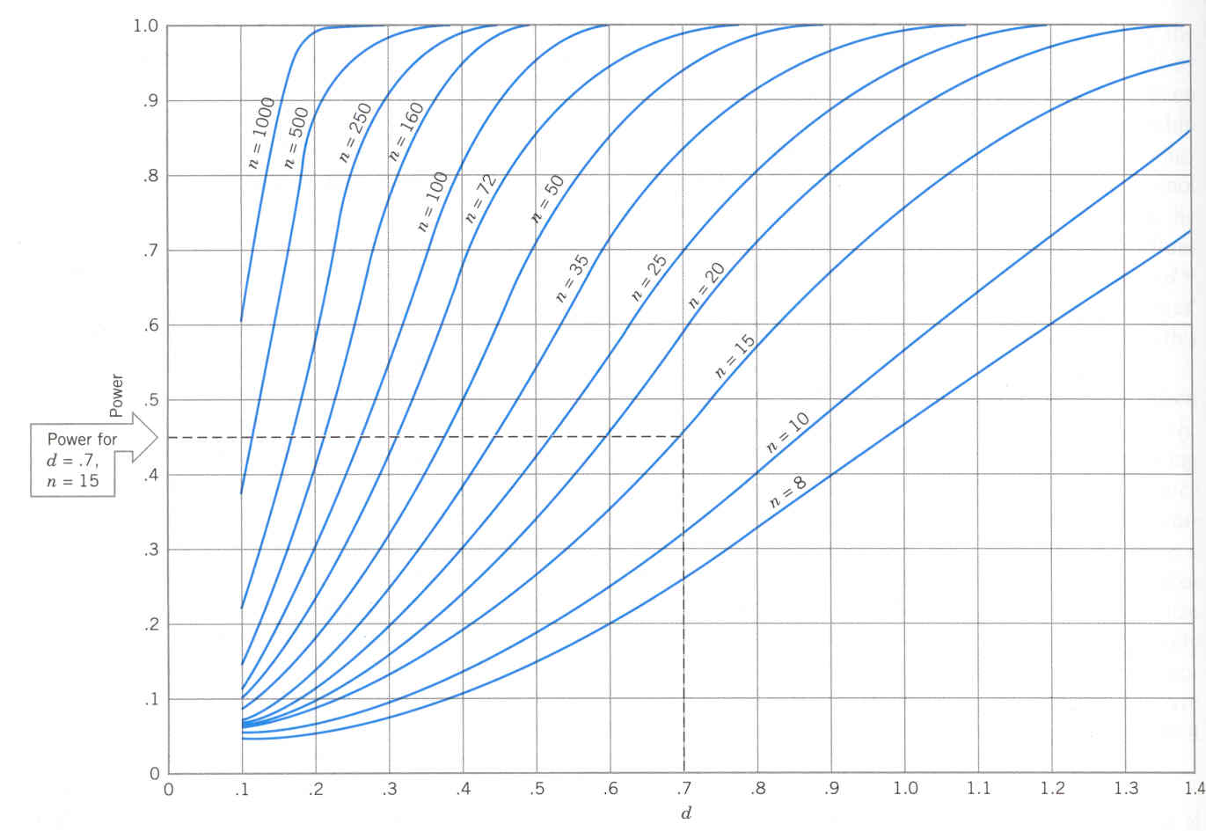
Note, this power curve chart is for t-test H_{o}:μ₁ - μ ₂ = 0, independent samples, α = 0.05

