JEPonline
Journal of Exercise Physiologyonline

Official Journal of The
American Society of Exercise Physiologists (ASEP)

ISSN 1097-9751
An International Electronic Journal
Volume 6 Number 2 May 2003

EDITORIAL

A CRITICAL REVIEW OF PEER REVIEW: THE NEED TO SCRUTINIZE THE “GATEKEEPERS” OF RESEARCH IN EXERCISE PHYSIOLOGY

ROBERT A. ROBERGS

Exercise Physiology Laboratories, Exercise Science Program, University of New Mexico

JEPonline. 2003;6(2):i-xiii.

INTRODUCTION

I have developed as an educator and researcher accepting the premise that any system of peer review was unquestionably good. An explanation for this belief can be based, in part, on the mentor system within academia. After all, we can be molded as students to reflect the attitudes and professional interpretations of those we hold in high esteem. In addition, a summary of the historical development of peer review (see latter section) reveals that the process flourished relatively recently. Consequently, the more senior scientists of today who have and continue to function as mentors to many of our "younger" researchers, can recognize and remember the time of the transition in science towards an organized editorial peer review system for research manuscripts and grant submission (1,2).

I have memories of my mentors receiving that magical letter in the mail, stating that a manuscript was accepted for publication. Naturally, I also remember doing the same in my earlier years in academia. I also recollect telling my students that there is a real need to please the reviewers in preparing manuscripts, reinforcing a concept that the end was a justification of the means. In hindsight, this scenario is quite shocking; that the need to publish in a peer review system supersedes the need for original thought, expression, and perhaps to even question conventional thinking.

In my last five years as a Ph.D. qualified educator and researcher, I have come to question the peer review process that we are forced into with many of the journals that publish research of exercise physiology. Too often I have found myself, as well as my senior doctoral students, judged in a peer review system comprising so called "experts" who do not seem to understand exercise physiology. Too may reviewers have not been aware of the needs of exercise physiologists, or the fundamental importance of specific topics within the discipline and professional practice of exercise physiology. Recently, my exposure to reviewers and associate editors has led me to conclude that not all decisions on rejection are made based on the scientific merit of the manuscript. Such negative experiences have led me to question how the peer review process functions in the many journals that exercise physiologists can publish their research or creative ideas in.

A simple evaluation of the more prestigious journals of our field reveals that none is truly an exercise physiology journal. Such journals span the fields of sports medicine, applied physiology, sports nutrition, and pure or basic physiology. Consequently, many of the manuscripts that enter into the process of peer review in these journals may be handled by an associate editor who is not an exercise physiologist, and be reviewed by scientists who are also not trained in exercise physiology. If an important condition of publication is to be able to answer the question of how a manuscript can contribute to the body of knowledge in a field, topic, discipline, or profession, then the lack of exercise physiologists as reviewers in our prestigious journals is not conducive to a fair review. Unfortunately, my experience with attempts to publish via peer review in our prestigious journals goes well beyond this major failing. I have experienced conflicts of interest in the review process, where manuscripts are prevented from publication due to data and interpretations that disagree with the past published findings of the reviewers. In these situations, the associate editors have failed to adhere to the scientific method by demanding that only objective, research supported criticisms of the manuscript content are valid. Too often associate editors have allowed reviewer personal opinions and biases to determine the fate of a manuscript.

I have discussed my frustrations of the peer review process with many of my colleagues, and have found that they also have numerous stories of unfair reviews. There are stories of second and third rounds of manuscript revisions, ending in rejection without any explanation of the decision. Stories of where reviewers' demand that certain interpretations or sections be removed that oppose past interpretations or conclusions on a given topic, and when this is not done for sound scientific and ethical reasons, all of which are explained to the reviewers and associate editor, the manuscript is rejected.
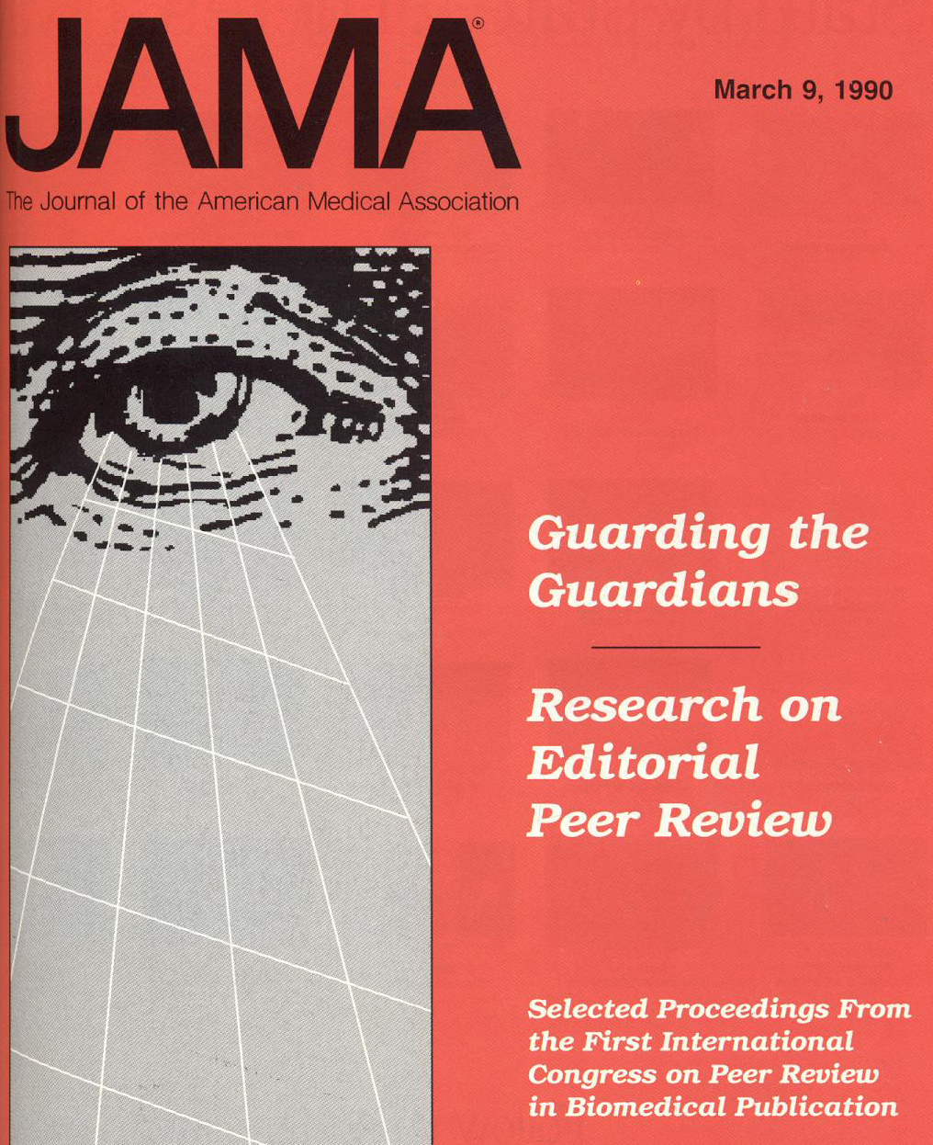

Figure 1. The illustration used for the cover of the JAMA issue containing manuscripts from The First International Congress on Editorial Peer Review in Biomedical Publication (March 9, 1990, Vol 263, No. 10).
As a professional exercise physiologists, I can no longer function without expressing my dismay at the clear fact that there seems to be a blatant disregard for the need to develop and reinforce a scrutinizing eye on the scientific peer review process (Figure 1) (3,4). If publication of scientific findings and thought is the backbone of our knowledge, understanding, and development, then, as scientists, we should be meticulous in ensuring that the review and decisions involved in publication acceptance or rejection are as thorough and valid as possible. This is not characteristic of exercise physiology, sports medicine, or applied physiology.

My frustrations led me to examine the prior research and commentary of the peer review process. I was surprised to find a large body of published work on the scientific peer review process, as well as to learn that many of my criticisms of the system have been raised before and applied to a broad spectrum of disciplines and professions. As scientists and educators, we should view the peer review process as a dynamic entity that can continually be sculptured towards heightened knowledge and function. For certain, it is not a bastion or an ivory tower that cannot be questioned or challenged. The peer review process is such an important part of the scientific method that we need to ensure that it is fair, valid, ethical, and functioning in the best interests of the development of the exercise physiology body of knowledge. As such, a critical review, or scrutinizing eye, of the peer review process is not just essential but long overdue.

Consequently, the purpose of this editorial is to raise the concern that the peer review process, as is currently conducted in many journals that publish exercise physiology research, is far from adequate. I am committed to providing exercise physiologists with a clear assessment of the peer review process based on prior published research and commentaries, and recommendations for how the peer review process should function to uphold the incredibly important features of the scientific method.

RESEARCH OF PEER REVIEW

There is a surprisingly large body of research, writing, and criticism of the scientific peer review process. In particular, a conference on the process was sponsored by the American Medical Association (AMA). The conference was announced with three years notice in 1986 to: “stimulate scientists to investigate those aspects of peer review that intrigued them, to discuss relevant and pressing issues in peer review, and to throw light on what has become one of the most important quality-control mechanisms in science” (4). The conference was held in Chicago in 1989. A selection of the resulting publications of this meeting can be found in the Journal of the American Medical Association (JAMA) (1990; 263(10)1317-1444). Many manuscripts of this symposium edition are essential readings for all research scientists. In particular, all scientists should read the writings of Horrobin (5), Chalmers et al. (6), Burnham (2) and Sharp (7). The cover art of this issue of JAMA was the first computer generated graphic used as a cover for the journal, and revealed an eye, presented to symbolize the scrutinizing process of scientific peer review. This eye (Figure 1) was an enticing addition to the title and preceding introductory comments of this manuscript.

In addition to the issue of JAMA, Daniel (8) provides an excellent text that summarizes the predominant published works on editorial peer review. Daniel figuratively describes the peer review process as a "Gatekeeper" of science, recognizing the power that peer reviewers and editors have over research publication.
What Is Peer Review

The Process
As currently used by most journals that publish research of exercise physiology, the process of peer review is relatively simple. A manuscript is submitted for publication to a journal editor-in-chief. The editorial office distributes the manuscript to an associate editor that has knowledge of the research topic. The associate editor is responsible for handling the review of the manuscript, which involves the selection of one or more, typically two, reviewers who research similar topics to that of the manuscript, and as such are often referred to as "experts" in that field of research inquiry. Depending on the journal, the manuscript can be reviewed with the reviewers not knowing the authors (blind review) or with author information provided. The reviewers are charged with details of a review process that are unknown to the submitting author. Some journals provide the reviewers with specific criteria to assist them in the review process, which is generally not provided to the authors until after the review, if at all. Based on the reviewers' comments, the associate editor makes a decision after the first review to allow continued review or rejection of the manuscript. In either case, the reviewer and editor comments are returned to the author. For all journals that publish exercise physiology and related research, there is only one that I have published in (Sportscience (www.sportsci.org)) that reveals the identity of the reviewers to the authors and/or the identity of the reviewers within the published version of the manuscript.

Typically, manuscript acceptance occurs after the second round of reviews whereby the authors' responses to the reviewers' comments, concerns, and changes to the revised manuscript can be assessed. However, it is not uncommon for manuscript reviews to go beyond two rounds. In the event of opposing recommendations between two reviewers, a third reviewer may be recruited or the associate editor can weigh the comments and causes for the opposing review recommendations and make the final decision.

For the main journals that publish exercise physiology research, none provides submitting authors with a clear description of the review process or the items that collectively contribute to the reviewers’ or associate editor ‘s decision making process. Also, and of considerable importance, no journal either provides information on how to challenge the review decision or how a journal handles such challenges.

A Brief History
If you are of similar age to me, then you are probably not aware of any other means to assess the suitability of a manuscript for publication other than the peer review system described in the previous section. As such, I have often assumed that an organized peer review process is as old as science itself. This is far from the truth. Reading of the documents that reveal the history of the process of peer review reinforces the fact that today’s system of peer review is a relatively recent fixture of the scientific method. Furthermore, the process of peer review remains a dynamic entity that should continue to be refined.

The earliest identification of the onset of peer review depends on your philosophical definition of peer review. Kronick (1) states that the intent, or essential feature, of peer review is to ask for advice. The first evidence of deliberate seeking of advice from knowledgeable persons in the process of manuscript evaluation occurred in 1752 when the Royal Society of London formed a committee (Committee on Papers) to pre-review all manuscripts published in their journal, Philosophical Transactions (first issue in 1665). This committee was charged with the responsibility to review all submitted manuscripts and to use, when possible, members of the “Society” that were known for their knowledge on any topic.

Despite the early introduction of the peer review system, there is no historical evidence that such a process was recognized to be important across the scientific disciplines. In fact, Burnham (2) states that, “…peer review came at various times to various journals for a wide variety of reasons”. Although evidence exists for some journals to have adopted a peer review system prior to the 20th century, other journals such as The Journal of the American Medical Association (JAMA) sought external opinion on manuscripts “only rarely” through to the 1950s (2).

Despite the slow adoption of the peer review system, there were many commentaries of the philosophical strengths of the system. For example, in 1893, the then editor of the British Medical Journal stated, "A medical journal, in order to raise to the height of extended usefulness, needs to be written from end to end by experts…" (2). Despite expressions of the meritorious qualities of peer review, adoption of a peer review system by medical journals was not a defining feature of the history of medical science. The slow process of adopting a peer review system has been explained by a combination of factors:
- arrogance (no need to seek outside opinions),
- the belief that specialization in research and application was not the future of science or medicine,
- the shortage of manuscripts for publication,
- the belief that advanced degrees were adequate verification of quality writing for publication in any journal,
- the belief that journal content was as much educational as revealing of new evidence or data interpretation, and
- the time and personnel burden of seeking peer review.

Despite these reasons for not using the peer review process, it obviously became widespread throughout the scientific community. The most logical explanation for this change has been argued to be the tremendous growth in manuscript submissions that coincided with the post World-War II erra, and the electronic technological achievements that followed this time period (1,2). Journal editors experienced a transition of too few manuscripts to too many. A greater selectivity was needed to review the manuscripts and, therefore, the external peer review process gained momentum and sense of importance. No longer could a select panel of “inside” reviewers serve each journal..

Despite the attractiveness of the peer review system to handle the pressing issues faced by the editors, the peer review system was not adopted for its ability to improve manuscript content and validity. Rather, the system was adopted, at least equally, as an answer to the realities of scientific publication where the volume of submissions out-stripped the resources of journals and professional organizations. In the sections to follow, the growing pains of the peer review system are raised and presented as “concerns”. The “concerns” have been recognized for several decades, and some scientific areas that have a long history of journal publication, such as medicine and the social sciences, have attempted to reform their peer review systems. However, the same cannot be said for “younger” fields of inquiry such as exercise physiology, applied physiology and sports medicine.
Concerns With Scientific Peer Review
Reading of the published works pertaining to the scientific peer review process reveals that there is an overwhelming uniformity in concern that such a process is too often unable to validly and objectively decide on acceptance or rejection of manuscripts. This body of published work addresses many concerns of the peer review process as is currently employed across the scientific community. Rather than reinvent concise summaries of this material, I want to present quotes from prior scientists who should be recognized for their courage and clarity in critically evaluating the scientific peer review process.

Cicchetti (9):
“In summary, on the basis of the best controlled studies of the peer-review process to date, we are forced to conclude that referees do at times apply subjective criteria, which cannot be described as “fair”, “careful”, “tactful”, or “constructive”, despite the fact that such traits are widely accepted as desirable characteristics of referees”

Bornstein (10):
“… we know that: (1) inter-reviewer reliability in peer review is generally low; and (2) we have no hard evidence that reviews have predictive (or discriminative) validity. To the extent that “confirmatory bias” and other variables unrelated to research quality demonstrably affect the outcome of peer reviews, the internal validity of the peer review process is also compromised. To anyone interested in the process of scientific inquiry and the dissemination of scientific knowledge, such findings are - to say the least – a bit unnerving. Because we regard peer review as a “test” or measure of the scientific worth of manuscripts and grant proposals, we should be able to demonstrate that this “test” is psychometrically sound.”

Baue (11):
“The peer review system for scientific journals has been criticized because it is slow, expensive, and time consuming for many scientists; it is also anonymous, which allows for the possibility of elitism, bigotry, prejudice, difficulty in publishing work by new or young scientists, and delay in publishing innovative work.”

There are many such quotes within the published articles on peer review. Some will be presented in subsequent sections of this editorial. I structured the following material based on the main concerns that have been raised by prior authors, along with additional concerns of my own.

Failure To Acknowledge and Accept Research and Writing That Challenges Contemporary Thought
The most perplexing problem of the peer review process is the impasse the editors and reviewers have in regards to research and writing that challenges contemporary thought in exercise physiology and within other scientific topics. Kornhuber (12) has stated his opinion of this system best:

" (the peer review system is)…. unreliable, invalid, and harmful to the best type of research - that which is innovative."

Surely one of the purposes of scientific publication is to invite, not block, the publication of concepts and scientific interpretations that challenge contemporary thought. Such manuscripts that provide challenge should ideally present arguments supported by objective evidence and/or evidence that oppose contemporary thought. However, even the publication of challenging beliefs without objective evidence is worthwhile, for all scientific discoveries first start with theories or hypotheses that need to be tested. There is merit in challenging concepts and ideas since the effort can result in new theories and hypotheses. To block such manuscripts is a form of scientific arrogance that curtails the very essence of the scientific process; that of an open inquiry and shared thoughts leading to heightened knowledge and understanding.

For the reasons stated above, another editorial of this May 1, 2003 issue of JEPonline (13) introduces a new Topic Category of published manuscripts: "New Ideas". This category is for manuscripts on topics that oppose conventional thought, or introduce novel methods, data processing, or interpretations that may be rejected by editors and reviewers of other journals. More content and explanation can be found in the editorial.

Statistics on the Lack of Consensus in Peer Review
Ciocchetti (9) has been the most widely cited author and scientist who has objectively investigated the reliability of peer review. An important and quantifiable feature of per review is the incidence of two reviewers independently reaching the same conclusion on specific features of a manuscript under review. Such inter-reviewer agreement has been tested in numerous behavioral and scientific journals, with data reported as the intra-class correlation coefficient. If reviewers are competent in their work, and manuscript rejection or acceptance is based on sound criteria that can be clearly identified in the review process, then there should be consensus in review decisions between multiple "experts" who review manuscripts, and intra-class correlation coefficients should be close to 1.0.
Table 1. Potential sources of bias in peer review.
Sub-category | Sources of Bias
General
 | For or against certain topics or approaches
 | For the orthodox and against the unconventional
 | For originality
 | For advisors (and other helpers) who put on an “authors hat”
 | Against those whose recent papers on the same subject were accepted but ill-received
 | Against authors who seem over-productive, which includes salami publication
 | For or against certain institutions/individuals
 | Against negative studies
Reviewer Selection
 | Hoping for answer “yes” or “no”
 | Pointing the reviewer in one direction or another
 | Know antagonisms, including those noted by author
 | Known competitors, including those noted by author
 | Conflict of interest (not just commercial)
Reviewer Report
 | Has reviewer seen paper before (eg. for another journal) or earlier, on a funding committee for example?
 | Does reviewer’s report show stigmata of bias?
 | Does author’s reasoned response suggest bias rather than simply disagreement?
 | Does reviewer declare a bias? They may not rule him or her out?
Final Evaluation
 | Bias of tyranny of numbers. What, now, is in the journal’s pipeline?
Adapted from Sharp (7)

Unfortunately, the available data indicate that there is minimal consensus in peer review between multiple reviewers. Ciocchetti (9) reported intra-class correlation coefficients ranging from 0.7 to 0.37 for different components of the review process (eg. reader interest, originality, quality of references, etc.). When concerned with decisions for acceptance or rejection, the data are not improved, with biomedical journals reporting between 0.31 to 0.37. In the world of statistics, such results are considered poor, and as expressed by Cole et al. (16) concerning the likelihood for acceptance of a grant based on peer review, "…depends to a significant extent on chance".

One can only conclude from these data that peer review does not necessarily function as a gold standard for a critical assessment of manuscript suitability for publication. In addition, if the reviewers cannot agree, then the editors of journals play a defining part in deciphering what is and is not suitable for publication. I have not been able to find any scientific evaluation of the editorial decision-making process, or aspects within this process, in the published literature.

Evidence of Publication Bias By Reviewers and Editors
Publication bias has been defined in many ways, ranging from the general; events during the writing and/or review process that distorts the representation of truth (7); to itemized features of the scientific process (Table 1).

One could probably add to each section of Sharp’s (7) content in Table 1, and journal editors might find this to be a useful exercise. However, another way to organize publication bias has been described by Chalmers et al. (6) in a manuscript that is essential reading for any scientist. Chalmers et al. grouped publication bias into three distinct categories termed, 1) Pre-publication bias, 2) Publication bias, and 3) Post-publication bias. Pre-publication bias deals with the bias inherent in conducting research, interpreting the findings and writing the manuscript. Interestingly, a component of pre-publication bias is a decision to not publish at all, or delay publication. Publication bias refers to the bias injected into the editorial peer review system by the editorial peer review process itself. Post-publication bias refers to the bias that exists in the reading and interpretation of research. This bias is best exemplified by scientists who disagree on the interpretation of data from a given study, with these differences stemming largely from their own biases of the topic. Post-publication bias also serves to subconsciously reinforce biases from the preceding categories resulting in a total misunderstanding of the topic. There are numerous examples of these scenarios in exercise physiology, with the notable ones being the anaerobic threshold concept and terminology, the believed interdependence between the oxygen deficit and debt, the central cardio-pulmonary limitation to VO₂max dogma, and the lactic acidosis misunderstanding of metabolic biochemistry.
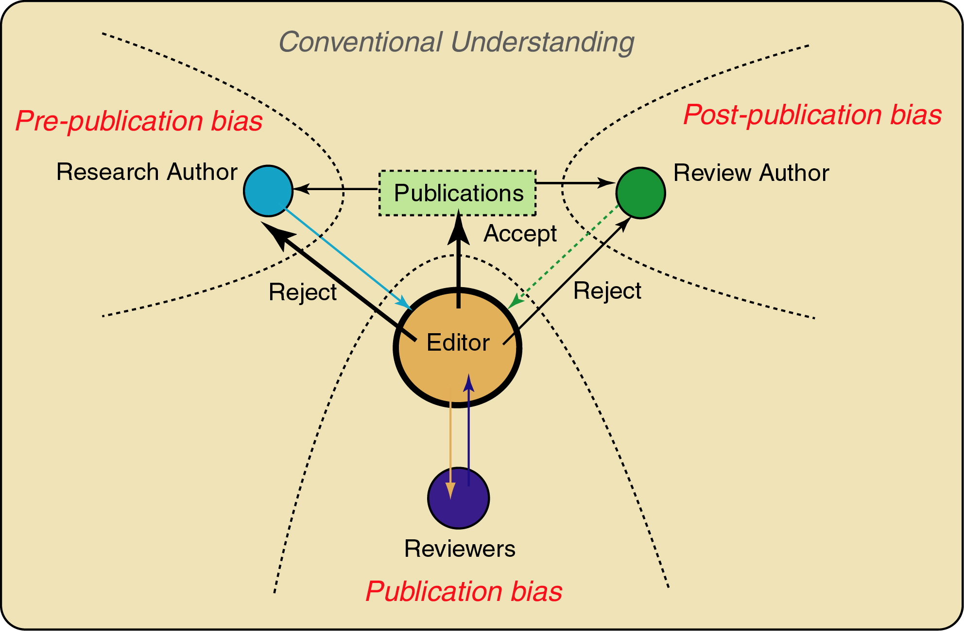

Figure 2. A model of the vicious cycle of publication bias that can be manifest due to a faulty editorial peer review system.
Although Chalmers et al. (6) are to be commended for their insight into publication bias, they do not fully reveal the insidious nature of bias at the level of editorial peer review (publication bias). I have tried to more clearly reveal the interconnectedness of the three components of publication phases, as illustrated in Figure 2. Editorial peer review functions at the heart of the publication process, and is therefore a powerful protector against bias, as well as a propagator of bias when it exists. For example, if there are biased reviewers of certain topics that are widely used for many journals related to a field of inquiry, then this bias influences the manuscripts published, which in-turn functions to form the interpretations presented in review manuscripts or meta analyses, which in-turn further mould the conventional thought that forms the backdrop or milieu in which additional questions are raised, researched and written for publication. The often-toted “old boy” network of editors who seek out their colleagues known for publication on certain areas of inquiry is probably the worst example of a potential editorial peer review system ripe for publication bias. The result is a system that passes such bias to the broader scientific community, protects itself from criticism by further rejection of competing manuscripts that differ to their “collective bias”, resulting in the misunderstanding of a topic and a slanted conventional understanding. Clearly, this is a detrimental system to the knowledge base of any discipline/profession/topic of inquiry.

Many forms of bias in the editorial peer review system are not amenable to objective research. Nevertheless, Mahoney (17) has published what has become a classic and widely cited study of publication bias pertaining to the presentation and direction of findings presented in the Results and the Discussion sections of manuscripts. Mahoney researched the responses of 75 reviewers for one journal to a manuscript that was identical in Introduction, Methods and Procedures, but differed in the findings and related discussion. Where data was presented as significant differences, versus non-significant, manuscripts were rated more highly across numerous criteria, resulting in publication merit scores of 3.2 versus 1.8, respectively. Clearly, there exists a bias in the editorial peer review system for favoring manuscripts from studies that show a statistical difference of some sort. All editors need to be aware of this preference and how it can undermine the scientific method.

THE HUMAN COSTS OF INVALID PEER REVIEW

The process of publication and peer review is linked to numerous career and financial implications for the authors of the manuscripts. When the peer review process is ethical and fair, the link of a publication to advancement in career opportunities works. But, when the process is unethical or unfair, there are significant human costs (e.g., failure to be promoted or even tenured). And, yet there is also the possibility of such professional and financial forces can also reinforce an unethical peer review process where authors function to "please" reviewers. Writing to please the reviewers to increase the likelihood for publication at the expense of originality and creative thought is not good research. Worse yet, and most devastatingly, the failure to question or challenge conventional thinking and accepted opinions threatens the sustainability of the research process as our primary method of accessing new knowledge.

For authors who challenge their colleagues through novel research questions, research designs, and data interpretation, publication of their work is generally very difficult (if not impossible) in today's system of peer review. This is far from acceptable. As mentioned earlier, failure to publish can influence the progression towards tenure and promotion in the university system, retard financial support in the private sector, and obstruct students in training from expanding their published record and resume. This is especially serious for students who require publications to improve their attractiveness for eventual employment and entrance into either the private sector or university teaching and research institutions.

A participant in the peer review process who is not aware or respectful of the human costs of an invalid peer review opens the door to an unethical peer review process. In reality, both the scientific method and human costs of peer review need to be recognized throughout the peer review process by both the reviewers and associate editor.

LEGAL ACTION AGAINST INVALID PEER REVIEW
An invalid peer review is not only a discredit to the scientific method, but also has human consequences that directly and indirectly relate to financial loss. In today's litigious society, the obvious issue of concern relates to the potential for legal action against the journal and/or the associate editor and peer reviewers. Is there a history of legal action resulting from an invalid peer review process?

The answer is yes, but cases are few. Debakey (18) noted in 1990 that several law suits were filed concerning publication bias preventing manuscript acceptance and publication in journals. I could find no added details of such suits, or of others currently in process (19).

PAST SUGGESTIONS FOR IMPROVING PEER REVIEW

Several journal editors have proposed modifications to the peer review process to improve the ethical nature of the system (20-24). The following content reflect some of these ideas.

Not All Manuscripts Should be Peer-reviewed
Perhaps some manuscripts that touch on controversial topics, or are so innovative as to be misunderstood by reviewers, should not be reviewed externally.

Blinded Peer Review
Blinded peer review can pertain to the reviewers being blind to the authors, or the authors being blind to the reviewers. When pertaining to reviewers being blind to the authors, existing data indicate that most reviewers (75%) can detect the identity of a recognized researcher of a given topic, even when blinded. Although this only applies to recognized authors based on content and writing style, it none-the-less presents an uneven playing field for the young or new author to a given research topic. Consequently, some journals leave the blinded status of manuscripts to the discretion of the submitting author.

A more debated issue is the blinded nature of the reviewers to the authors. As such, the editorial peer review system has often been compared to the legal system: where peers are used to judge the meritorious nature of a manuscript. However, as accurately explained by Baue (11), editorial peer review is dissimilar to the jury system in that a peer review team is not formed publicly, the identity of the peer reviewers is not publicized, and all reviewers act individually and anonymously. As such, there is no functional trait that guarantees fairness in editorial peer-review.

Proponents of a peer review system where reviewer identities are not revealed to the author (author-blinded) argue that a blinded system is necessary for the reviewers to remain objective and fair in their criticism (18). There is fear that negative decisions on manuscripts may result in personal communication of protestations from the authors to the reviewers. In addition, anonymity also prevents an experienced, or well-known author from intimidating a younger, or less-experienced reviewer, into agreement. Finally, it is important to consider that reviewers function without pay, and the final decision on manuscript acceptance/rejection is not with the reviewers but the editor, who is known to the authors.

Conversely, opponents of author-blinded peer review claim that such anonymity opens the door to impropriety on behalf of the reviewers. Such impropriety could exist in the form of intellectual property theft, where the reviewer delays publication to refine his or her own research or grant agenda. Reviewers could delay manuscript publication to ensure that their publication currently in review could be published first, and all this could eventuate without knowledge of the author. As such, disclosing reviewers could promote heightened integrity in the process due to the need for accountability by the reviewers. Knowing the reviewers means also knowing of any potential bias that might have entered the review process. A more important issue is that if the review process is fair, ethical, and valid, then why does it need to be anonymous? An anonymous peer review system only reinforces all that is potentially bad about peer review. A reviewer that cannot review a manuscript knowing full disclosure probably should not be a reviewer for the manuscript in the first place. Finally, it makes intuitive sense that reviewers be held to the same standards as the authors.

Some journals have attempted to modify their position on peer review anonymity. However, very few journals have actually deviated from an editorial peer review system that adopts a policy of author-blinded peer review.

Seeking Statements of Integrity From Reviewers
This is a logical effort to suppress reviewer bias. However, the final enforcement of such statements would need to come from the editor, and it is unclear how bias is going to be detected if it exists. This remains a needed feature of the peer review process, and I am not sure which journals in exercise physiology or related fields do this.

Assisting Reviewers With A Structured Check-list
The provision to the reviewers of a structured check-list has become a more common feature of peer-reviewed journals in exercise physiology and related fields. Typically, reviewers are provided a form that presents key features of manuscript assessment. The reviewer uses this form to aid his or her evaluation of the manuscript, and the editor then interprets the replies. This certainly provides a more consistent structure to the comments returned to the editor from the reviewers, but it does nothing to minimize reviewer or editor bias.

Increasing the Number of Reviewers
Typically, an editor may decide to solicit a third reviewer to resolve disputes. However, given the earlier data reported for reviewer disagreement on manuscript assessment, it is unlikely that such a practice is valid or helpful. Consequently, it is the editor who must function to decipher opposing reviewer comments. Clearly, the editor is in an important and powerful position to weed out bias, and focus on scientific and research method content.

The Establishment of an Appeal System
This is crucial, as I explain below. Such a system needs to not only provide a means for authors to voice their opinions about the specific details of the review, but more importantly, to act on such criticism in a fair way so that bias can be detected, and when present, be divorced from the decision making process as much as possible.

RECOMMENDATIONS FOR A NEW SYSTEM OF PEER REVIEW

The following content represents my ideas for how the system of scientific peer review should function. This content will be re-written as a formal explanation of the peer review process used by JEPonline, and will then be submitted to the ASEP Board of Directors for review and an eventual vote on its adoption for use with JEPonline.
The Purpose of Peer Review For JEPonline
Horrobin (5) has stated, “If we do not know why we are engaging in peer review, we are unlikely to be very good at it.” I agree. I fear that this common sense beginning to the use of peer review has been overlooked by many journal editors, resulting in the indirect proliferation of bias in editorial peer review. A clear statement for why peer review is used by the journal is a primary step in framing a fair and valid peer review system.

Horribin explained his rationale for needing peer review for medical journals to be:

“The purpose of peer review should be nothing less than to facilitate the introduction into medicine of improvements in curing, relieving, and comforting. Even in those many fields of biomedical research that are remote from clinical practice, the peer reviewer should always be asking the question, “Is this a possible innovation that should be encouraged because at some time it could lead to improvements in the treatment of patients?””

Consequently, I see the need for peer review in JEPonline to be:

" JEPonline adopts a peer review system for submitted manuscripts to facilitate the introduction of research findings, laboratory methods, or knowledge that ultimately improves the application of exercise or physical activity for disease diagnosis and prevention, health, physical fitness and performance."

Submission Criteria
Science is not for sale, nor is science a field only for the grant funded, institutionally supported, or wealthy. There should be no cost to any scientist to publish his or her work in a peer reviewed journal. Any journal that has submission and/or page charges should change this policy so that the costs for publishing the journal are catered to by other resources. In addition, journals that have or currently require a charge for any part of the publication process should reveal their accounting so that scientists and/or scholars know whether or not profit is made from the journal. It is unethical for any journal and/or organization to profit from scientific publication.
Developing A Contract Between the Author and the Journal Regarding Peer Review
Submitting authors have rights. An author who enters into the peer review process of a journal commits to a contract, as does the journal, for the fair and ethical review of the manuscript. It is the journal's responsibility to have such a contract and to explain the contract to the author(s). The author(s) should have the opportunity to question the review of a manuscript and challenge any aspect of the review process on grounds of ethics and scientific content. A journal needs to have a system in place to handle such challenges. Such a contract could be stated in the following way:

"The American Society of Exercise Physiologists (ASEP) recognizes the rights of submitting authors, and it's responsibilities in providing a valid and ethical peer review process leading to either the publication or rejection of submitted manuscripts. As an author of a manuscript submitted to JEPonline, you have the following rights:
- A valid and ethical peer review process.
- To cancel or delay the review process at your discretion without any present or future penalty.
- To communicate to the associate editor or editor-in-chief at any time in the review process.
- To challenge the scientific merit, or ethical nature of any comment in a review, using objective evidence.
- The expectation that the journal editorial staff will respect any challenge and make decisions solely based on scientific merit.
- To be viewed as the "expert" on the topic of the manuscript, and therefore, held in equal or higher standing to the status of any "expert" reviewer.

As an author, you have expectations of the editorial staff of JEPonline. The guarantees provided to you by JEPonline are as follows:

- One or more reviewers will review your manuscript, at the discretion of the editor-in-chief or associate editor.
- Since one competent reviewer is better than two reviewers who may not be necessarily competent in the topic at question, one person will review some manuscripts.
- Only reviewers who have a record of professionalism and ethical conduct will be asked to review manuscripts. Being a recognized expert on a field of research inquiry is not necessarily a qualification to be a good peer reviewer.
- Any reviewer who has a conflict of interest in the peer review process must rescind an invitation to review your manuscript. All reviewers are informed of this requirement. If this is not done, and evidence of this failure is brought to the attention of the Editor-in-Chief, the reviewer at question will no longer be able to review for JEPonline.
- Any reviewer who is disrespectful to an author, based on the wording of review comments, will no longer be able to review for JEPonline, and any manuscript rejected in this failed process will be reviewed at the editorial level in an expeditious manner.
- Decision on manuscript acceptance or rejection is to be based on objective research evidence, and not personal opinion or other subjective biases. The associate editors and Editor-in-Chief will do their best to detect subjective biases expressed by reviewers, and a decision on the manuscript will be adjusted accordingly.
- Challenges to the content of any review are to be handled by the Editor-in-Chief, and if appropriate, an additional reviewer may be recruited. Decisions on any challenge will be based on published scientific evidence, and if not available, greatest weight will be placed on the author's opinion.
- New or innovative research methods, questions, hypotheses and commentaries are welcomed by JEPonline. The journal even recognizes the scientific contributions provided by even radically different opinions, and will publish such manuscripts as a “New Ideas” topic category that are given more “flexibility” in the review process.
- The editorial staff at JEPonline function to direct the review process, and also help you improve your manuscript for eventual publication. If need be, we can help authors better present data in Tables and Figures, as well as re-write specific sections of the manuscript. We function not to only review, judge and edit, but also HELP.
- Although the duration of the review process is not totally controlled by the editorial staff of JEPonline, effort will always be exerted to reduce the time of the peer review. Journal policy is to try to have the period of the initial review kept to less than 8 weeks. Where the journal has been unsuccessful at accomplishing this, the Editor-in-Chief will expedite subsequent review and pre-publication requirements for manuscripts accepted for publication.
- As JEPonline is currently published quarterly (4 issues/year), the time from acceptance to publication should be no more than two issues (6 months). In reality, the time span is much less than this, as most manuscripts accepted for publication within 2 weeks of an issue will most likely make that issue unless it is already full (~10 manuscripts). As such, the most likely longest time to publication after acceptance is 3 1/2 months. Based on the growing popularity and acceptance of JEPonline, it will not be long before a more frequent publication schedule commences.
- To date, the shortest time from submission to publication has been 2 weeks, while the longest has been 18 months. The editorial staff of JEPonline strive to make this total time as short as possible, for science is improved by rapid publication."

CONCLUSIONS
The editorial peer review process is, and should remain, a system open to change and reform. All journals should adopt methods to ensure, as best as possible, a fair and valid peer review system for submitted manuscripts. Journal editors and reviewers need to recognize their susceptibility for injecting bias into the scientific method, and how this can have deleterious consequences to the development of the conventional thought that exists on any topic within a field or profession.

REFERENCES

- Kronick DA. Peer review in 18th-Century scientific journalism. JAMA 1990;263(10);1321-1322.
- Burnham JC. The evolution of editorial peer review. JAMA 1990;263(10);1323-1329.
- Rennie D. (Editor) Guarding the guardians - Research on editorial peer review (Selected proceedings from the first international congress on peer review in biomedical publication) JAMA 1990;263(10);1311-1441.
- Rennie D. (Editor) Editorial peer review in biomedical publication: The first international congress JAMA 1990;263(10);1317.
- Horrobin DF. The philosophical basis of peer review and the suppression of innovation. JAMA 1990; 263(10):1438-1441.
- Chalmers TC, Frank CS, Reitman D. Minimizing the three stages of publication bias. JAMA 1990;263(10);1392-1395.
- Sharp DW. What can be done and should be done to reduce publication bias. JAMA 1990;263(10);1390-1391.
- Daniel HD. Guardians of science: Fairness and reliability of peer review. 1993; VCH, Weinheim, Germany.
- Ciocchetti D. The reliability of peer review for manuscript and grant submissions: A cross disciplinary investigation. Behav Brain Sci 1991;14:119-135.
- Bornstein RF. The predictive validity of peer review: A neglected issue. Behav Brain Sci 1991;14(10:138-139.
- Baue AE. Peer and/or peerless review. Arch Surgery 1985;120(8):885-88.
- Kornhuber HH. Mehr forschungseffizienz durch objektivere Beurteilung von forschungsleistungen. In Daniel HD and Fisch R. (editors) Evaluation von forschung: Methoden - ergebnisse - stellungnahmen. (S. 361-382), 1988; Universitatsverlag Konstanz, Konstanz.
- Robergs RA. (Editorial) New topic category in JEPonline. JEPonline. 2003;6(2):xiii.
- Marsh HW and Ball S. The peer review process used to evaluate manuscripts submitted to academic journals: Interjudgemental reliability. J Exp Edn 1989;57(2):151-169.
- Laming D. Why is the reliability of peer review so low? Behav Brain Sci 1991;14(1):154-156.
- Mahoney MJ. Publication prejudices: An experimental study of confirmatory bias in the peer review system. Cogn Therapy Res 1977;1(2):161-175.
- Cole S., Cole JR, Simon GA. Chance and consensus in peer review. Science 1981;214:881-886.
- Debakey L. Journal peer reviewing: Anonymity or disclosure? Arch Opthalmol 1990;108(3):345-349.
- Chubin DE and Hackett EJ. Peer review and the courts: Notes of a participant scientist. Bull Sci Technol Society 1982; 2:423-432.
- Glenn ND. The journal article review process - Some proposals for change. Am Sociologist 1976; 11:179-185.
- Anderson RE. Guidelines for review of a manuscript. Human Pathology 1990;21(4):359-360.
- Eysenck HJ and Eysenck SBG. Peer review: advice to referees and contributors (Editorial). Personality Individ Diff 1992;13(4):393-399.
- Daniel TM. Why manuscripts are rejected: With thanks to our reviewers (Editorial). J Lab Clin Med 1991; 117(1):1-2.
- Fiske DW. and Fogg L. But the reviewers are making different criticisms of my paper! Am Psychologist 1990; 45(5):591-598.

