Research Methods: Exam 1

Multiple Choice
Select the correct answer.

- A true experimental research study requires?

  - more than one group
  - random subject assignment to groups, a control group and one or more interventions
  - Chi-Square statistics
  - correlation analyses
  - selecting subjects from pre-existing groups

- Which variable is mostly used in qualitative research?

  - nominal
  - ordinal
  - interval
  - ratio
  - C and D

- The purpose of correlation research is to,

  - determine cause-effect relationships between 2 or more variables
  - quantify how 2 or more variables are related and to allow prediction
  - compare two or more means
  - simplify research methods
  - avoid doing statistics

- When it is unethical or impossible to expose subjects to certain interventions, which of the following research designs is commonly used?

  - true experimental
  - causal-comparative
  - experimental
  - case study
  - historical

- In experimental research, the control group ……

  - is exposed to all interventions
  - must have subjects that differ to those in experimental groups
  - is always recruited and measured at the end of the study
  - is not needed
  - undergoes all measurements but is not exposed to any intervention

6 What type of sampling strategy is the following?

Researchers relied on selecting subjects from a long list of names based on prior communication with the people revealing a strong interest to participate in research. Potential subjects were called by phone and the first 20 who agreed to participate were chosen for the study.

- Simple random
- Systematic sampling
- Cluster
- Convenience
- Stratified random

7 Rationalism and Empiricism can be defined together as ….?

- Testing a hypothesis without prior knowledge
- Developing hypotheses
- Requiring expert opinion prior to acceptance of a theory
- Logical thought leading to a hypothesis that is tested
- Logical thought leading to an assumption that is accepted

8 Variables that can alter or interfere with how a treatment influences a dependent variable are referred to as,

- factors
- null hypotheses
- confounding variables
- experimental error
- type I errors

9 The accepted minimal value for the probability for committing a type II error is ……

- 0.05
- 0.8
- 0.75
- 0.1
- 0.2

10 The recommended statistic for representing the variance of the dependent variable is the …

- standard error of the mean
- standard deviation
- mode
- median
- mean

11 Why is simple random sampling often an unrealistic option to a researcher?

- samples of convenience are far better
- it is not that simple
- requires too much time of the researcher
- there is often no access or knowledge of the entire population
- an unsuitable method for statistics

12 Effect size is defined as

- (x – M) / N -1
- (X1 – X2) / N
- (x – M) / N
- (Mean1 – Mean2) / Std Dev.
- X_{1-n}/N

True/False

- There can only be one independent variable in research.

- In true-experimental research, subjects are observed/tested without random sampling.

- Dependent variables are manipulated by researchers.

- The standard error of the mean should be used to represent the variance of the dependent variable around the mean.

- A typical value for acceptable statistical power is 0.8.

- Accepting the Null Hypothesis when there is a difference between the means is a Type II error.

- Repeated measures or time series research designs remove all potential confounding variables.

- As sample size increases, sampling error decreases.

- The variance of the DV does not influence statistical power.

- Researchers should estimate sample size and statistical power apriori.

Short Answer
1. What is a hypothesis, and how should it be worded?

2. What factors combine to influence statistical power?

3. Why is a construct different than a fact?

4. When would you use the Chi Square statistic?

5. As a researcher, what ways, other than randomization, can you better ensure that multiple groups of subjects are as similar as possible on multiple potentially confounding variables?

6. Based on the following, determine the anticipated effect size and then the sample size needed for statistical power at 0.8.

SD from prior research = 12.8; Anticipated meaningful mean difference to be obtained = 3.5

7. List and explain at least 4 confounding variables in experimental research.

8. The following is a research statement and explanation. Identify the following.

The purpose of this study was to compare the influence of three different fertilizers on tomato size and number. Three separate beds of the same soil were prepared. In each bed, 10 tomato plants were planted. The same amount of water and fertilizer treatments were provided to each, with the only difference being the type of fertilizer used on each bed.

- What is purpose of the study?

- What is/are the dependent variable(s)?

- What is/are the independent variable(s)?

- Draw the independent and dependent variable table for this research design (see question 10).

9. Based on the above research statement, provide an operational definition of tomato size?

10. Be creative and devise an experimental study that involves two factors (IV’s) that have 3 and 4 levels, respectively. Duplicate the research design table below to identify your IV’s and DV’s. Clearly reveal how you obtain subjects, identify your control group/condition, and identify as many confounding variables as possible.

 |  | IV 1 =
IV 2 = | Levels
IV 2 = |  | DVs | DVs | DVs | DVs
IV 2 = |  | DVs | DVs | DVs | DVs
IV 2 = |  | DVs | DVs | DVs | DVs
IV = Independent Variable (or factor)
DVs = Dependent Variables

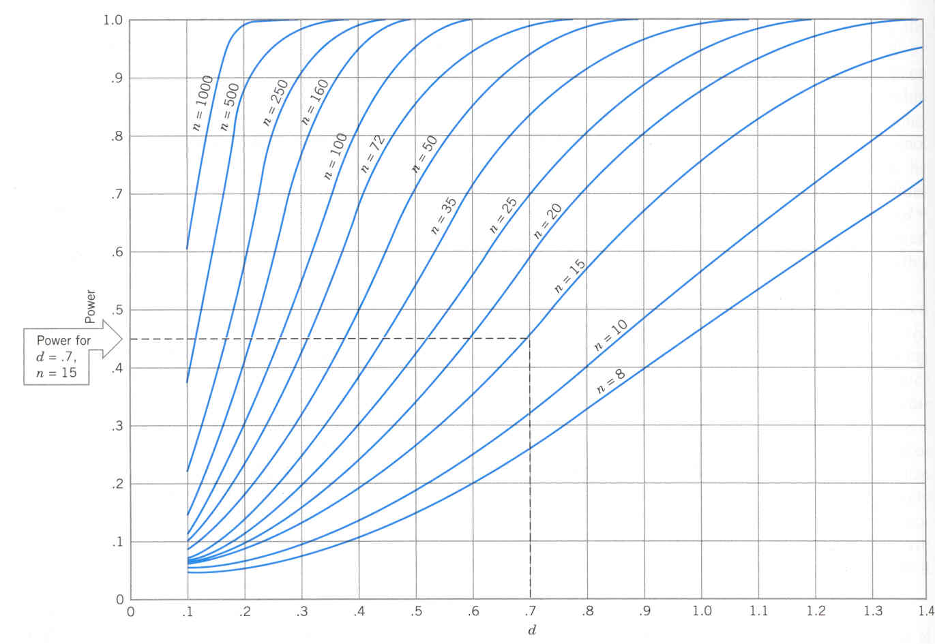
Note, this power curve chart is for t-test H_{o}:μ₁ - μ ₂ = 0, independent samples, α = 0.05

