PEP 535 - Exercise Biochemistry
Exam #1

The questions on this exam are all short answer/essay questions, and I expect that your answers will be thorough. However, being thorough does not necessarily relate to length !!! In fact, too much length that is uncalled for will increase the likelihood for lost marks due to errors! Use the point value for the question to help determine the length of your answer.

I recommend using diagrams to aid your explanations and reduce the length of your writing sections.

Use your Green Answer booklet to write your answers to all questions.

Good luck.
Dr. Rob Robergs

1. Explain the multiple reasons for why ATP should not be viewed as an energy store in skeletal muscle. (10 points)

The muscle [ATP] exists as a component of the adenylate pool which is governed by numerous reactions that function to maintain tissue [ATP]. Collectively, the substrates and products of ATP hydrolysis cannot change in extreme amounts, as this would seriously alter the free energy release of ATP hydrolysis, causing excessive or insufficient free energy release, neither of which are conducive to homeostasis. For example, if the [ATP] decreased excessively, then there would be dramatic reductions in the ∆G for ATP hydrolysis resulting in impaired capacities for cell work. Conversely, if the [ATP] was increased, then the ∆G for ATP hydrolysis would increase, making excessive free energy release and increased heat production, as well as a limited potential to reform ATP due to the diminished possibility for coupling to reactions that were at least equally free energy releasing compared to the free energy need for forming ATP. The concept that muscle [ATP] was ever a part of an energy store (the ATP-PC system) was an over-simplistic, and perhaps even incompetent summary of muscle energy catabolism.

2. Why are enzymes important for cellular energy metabolism? Hint – there are several reasons! (10 points)

Enzymes,
- Increase the rates of chemical reactions without altering substrates and products, and the bioenergetic principles of free energy release and directionality. This is important, for intracellular [S] and [P] are very low, and although exergonic reactions exist, they do not occur at life sustaining rates unless in the presence of an enzyme.
- Can be Michaelis-Menten is kinetics, or allosteric. Michaelis-Menten enzymes can be inhibited, but are not activated. These enzymes are very responsive to changes in [S] and [P], where more [S] increases reaction velocity and more [P] decreases reaction velocity.
- Allow coupling between exergonic and theoretically endergonic reactions. Such coupling provides for the transfer of free energy from an exergonic reaction to an energy needing reaction (endergonic). Assuming the sum of the ∆Gs for these coupled reactions results in a -∆G, the reaction will proceed in the given direction. Coupling is essential for life at the cellular level, and therefore for life in a holistic sense.

3. Calculate the absolute (in vivo) Gibb’s free energy change of ATP hydrolysis.

ATP <---------> ADP + Pi (15 points)
ΔG = G°’ + R T ln ([P] / [S]) R = 0.001986 Kcal/mol, T = °K

ΔG = G°’ + R T ln ([P] / [S])
= -7.3 + 0.001986 x 310 x (ln (0.000001204 x 6.0)/10)
= -7.3 + (0.65166 x (ln 0.000000722))
= -7.3 + (0.65166 x -14.1407)
= -7.3 + -9.2
= -16.5 Kcals/M

When using a higher muscle [ADP] = 0.05
ΔG = G°’ + R T ln ([P] / [S])
= -7.3 + 0.001986 x 310 x (ln (0.05 x 6.0)/10)
= -7.3 + (0.65166 x (ln 0.03))
= -7.3 + (0.65166 x -3.5)
= -7.3 + -2.28
= -9.58 Kcals/M

4. Explain/define the following terms; (25 points)

Exergonic
Free energy releasing and entropy increasing chemical reactions

Endergonic
Chemical reactions that require free energy input to proceed in the stated direction.

Allosteric
Class of enzymes that can be activated and inhibited. Allosteric enzymes also possess a sigmoidal activity curve when expressed to [S]. This occurs by cooperativity, where binding of multiple substrates to the enzyme enhanced enzyme activity.

Entropy
Randomness or disorder

Gibbs Free Energy
The energy release that accompanies an energy transfer that is available to a cell to perform work.

Equilibrium
When the rates of forward and reverse directionality of a chemical reaction are equal, causing no change in [S] and [P].

Mass action ratio
The ratio of [P] to [S] inside a cell, which by definition infers that the mass action ratio is not a constant but a dynamic variable.

Equilibrium constant
The ratio of [P] to [S] for a chemical reaction under standard conditions (starting at 1 M [S] and [P], phH=7, T = 25 °C).

- How is pH calculated from the ³¹P MRS spectrum? Provide an illustration to support your answer.
(10 points)
From the ppm shift between CrP and Pi. As a higher proportion of the [Pi] becomes protonated, there is a change in the resonance frequency of Pi in the 31P MRS spectrum. The ppm shit is used in a modification of the Hendersen-Hasselbach equation to compute pH (see below).

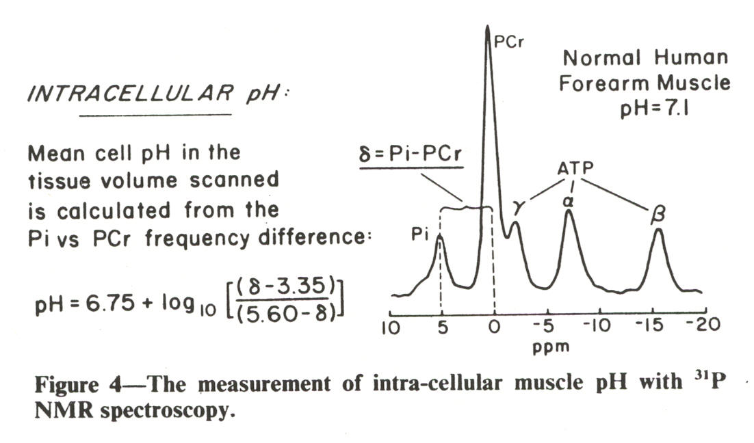

- Draw a diagram that shows the metabolic connections between catabolism and anabolism. Do your best at identifying the main substrates and products of each metabolic component.
(10 points)

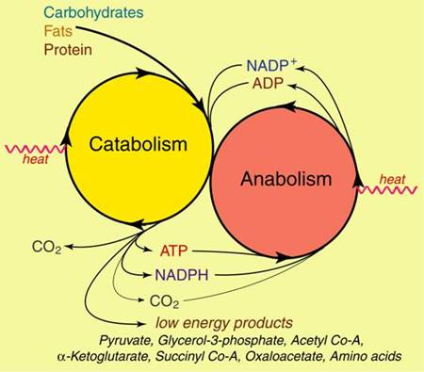

- Explain the creatine kinase shuttle, and provide some insight into why this is so important for understanding free energy transfer within a cell during metabolic stress. (10 points)

For a cell to rely on diffusion for ATP and ADP and Pi to re-enter mitochondria would render energy catabolism from mitochondrial respiration a very slow process. Data from ³¹P MRS exists to show involvement of CrP in muscle contractions during low to moderate exercise intensities that can be sustained in steady state metabolic conditions. Thus, it has been proposed (still a theory!) that terminal phosphate groups are cleaved from mitochondrial ATP by a mitochondrial membrane bound CK enzyme. These terminal phosphates are then shuttled throughout the cytosol, leaving the original mitochondrial ADP inside the mitochondria. Presumably, Pi is readily transported back into mitochondria.

- Explain the biochemical source of heat production during energy catabolism during exercise. (10 points)
Heat production occurs from the free energy release of chemical reactions that are not coupled to ATP production. Based on measurements of mechanical efficiency during exercise, such efficiency approximates 25-30%.

