Calinda Shely
ENG 540
Romano
4-28-09

Frances Willard (1839-1898): Educator, Temperance Worker, Women’s Rights Reformer

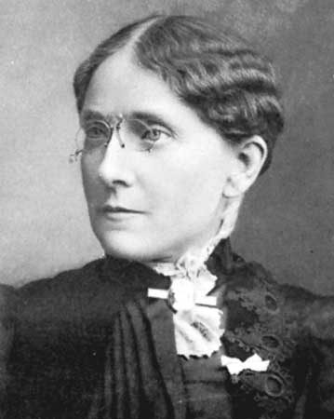
- Attended Northwestern Female College
- Became President of Evanston College for Ladies in 1871
- Became Dean of Women at Northwestern University in 1873
- Resigned as Dean in 1874 and became National Corresponding Secretary of the Women’s Christian Temperance Union (WCTU)
- Was elected President of WCTU in 1879 and served till her death in 1898
- Founded The Union Signal in 1892 and served as editor till 1898.

Rhetorical Venues:
- Homes—private sphere
- Churches—religious work and charity
- Public Halls—public sphere

Rhetorical Strategies:
- “Womanly womanliness”
  - Euphemistic language
  - Dress/appearance
- Sermonizing
- Reaffirmation of traditions
- Humility

Publications and Speeches:
- “The Average Woman”
- Do Everything: A Handbook for the World’s White Ribboners
- Glimpses of Fifty Years: The Autobiography of an American Woman
- How to Conduct a Public Meeting
- How to Organize a Woman’s Christian Temperance Movement
- “The Independent’s Celebration”
- “A New Profession for Women”
- “A New Departure in Normal Higher Education”
- “Woman’s Work in Education”
Willard is perhaps best known for her temperance work, but another cause she believed strongly in was female suffrage. She saw the two objectives, along with education for women, as highly interrelated.

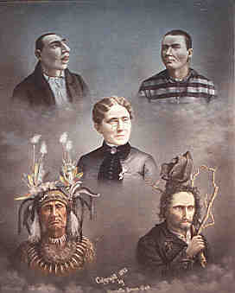

This painting, American Woman and her Political Peers, features Willard with a convict, an American Indian, a “lunatic,” and an “idiot.”

Secondary Criticism:
- Athney, Stephanie. “Eugenic Feminisms in Late Nineteenth-Century America: Reading Race in Victoria Woodhull, Frances Willard, Anna Julia Cooper, and Ida B. Wells.” Genders. 31 (2000).
- Bizzell, Patricia. “Frances Willard, Phoebe Palmer, and the Ethos of the Methodist Woman Preacher.” Rhetoric Society Quarterly. 36.4 (2006): 377-98.
- Donawerth, Jane. “Poaching on Men’s Philosophies of Rhetoric: Eighteenth- and Nineteenth-Century Rhetorical Theory by Women.” Philosophy and Rhetoric. 33.3 (2000): 243-58.
- Marilley, Suzanne M. “Frances Willard and the Feminism of Fear.” Feminist Studies. 19.1 (1993): 123-46.
- Slagell, Amy. “The Rhetorical Structure of Frances E. Willard’s Campaign for Woman Suffrage, 1876-1896.” Rhetoric and Public Affairs. 4.1 (2001): 1-23.

Works Cited

Campbell, Karlyn Kohrs. Man Cannot Speak for Her. New York: Greenwood, 1989. Print.

Martin, Scott C. Devil of the Domestic Sphere: Temperance, Gender, and Middle-Class Ideology. DeKalb: Northern Illinois UP, 2008. Print.
Mattingly, Carol. Well-Tempered Women: Nineteenth-Century Temperance Rhetoric. Carbondale, IL: Southern Illinois UP, 1998. Print.
Tyrrell, Ian R. Woman’s World, Woman’s Empire: The Women’s Christian Temperance Union in International Perspective, 1880-1930. Chapel Hill: U of North Carolina P, 1991. Print.
Woman’s Christian Temperance Union (WCTU). “Frances.” Woman’s Christian Temperance Union. April 3, 2009. Accessed April 24, 2009. Web.

