Gast Chapter 8: Visual Representation of Data
What is the purpose of graphic displays? (p.167)
1.
2.
3.
What are the four principles that help graphs communicate information to readers? (p.167)
1.
2.
3.
4.
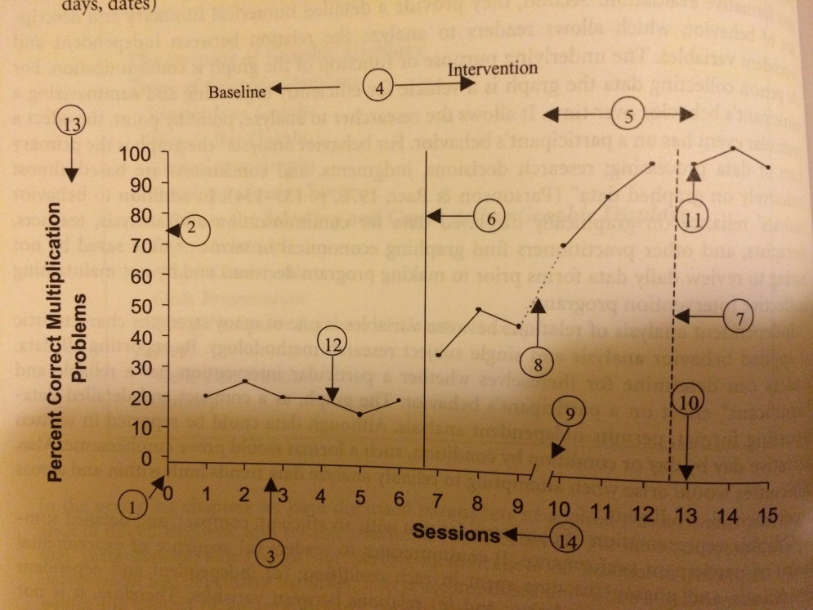
Label the parts of this graph (p. 168)
1. 8.
2. 9.
3. 10.
4. 11.
5. 12.
6. 13.
7. 14.

(p. 169) Condition Labels: one or two descriptive words or common abbreviations that identify each ____________ ____________.

Why are line graphs used to communicate data? (p.171)

______ _________ traditionally have been used by applied researchers to display ________ _______
and ____________ ____________. (p.172)
Bar graphs may prove useful when communicating a child’s progress to _________. (p.172)
(p.175) according to Cooper et al. (2007), cumulative graphs should be chosen over simple line graphs when:
a.)
b.)
c.)
(p. 177) When are semi-logarithmic charts created?

(p. 177) Where can recommended guidelines for preparing graphic displays be found? _______ manual
(p. 178) ______ graphs are used to prepare serial data. (data where it is connected)
(p. 178) Combination _______ and _______ graphs are sometimes used when more than three variables appear within a single graph.
(p. 178) Combination ______ and ______ graphs are also occasionally used when concurrently monitoring ______ or more behaviors where one is intended to _________ the other.
(p. 178) How do you separate experimental conditions on a graph (e.g., A-B)?

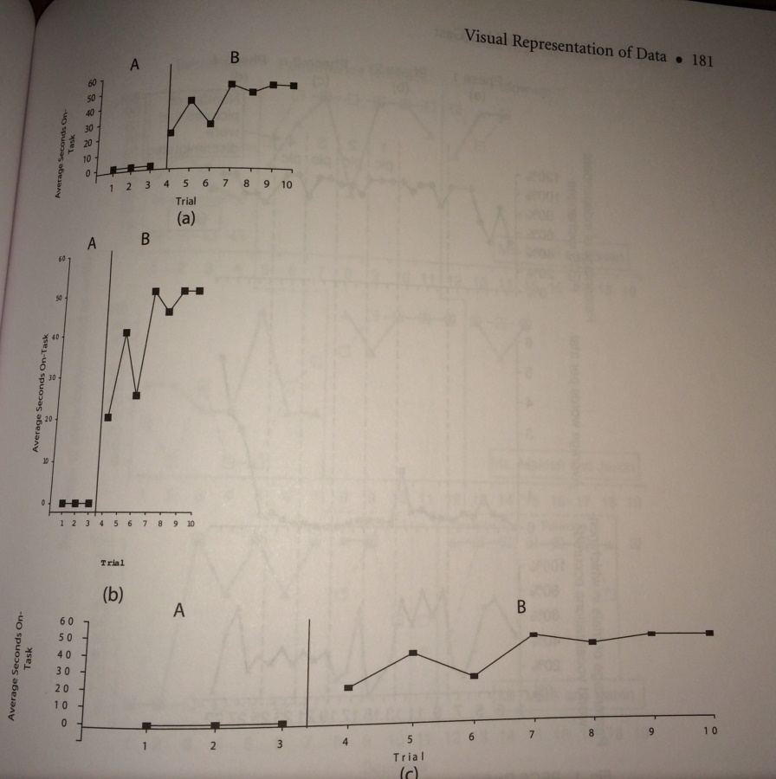
What is wrong with graph (b) and graph (c)? (p.181)

(p. 185) Why would you use “blocking” of data?

(p. 185) It is appropriate to block data only if blocking does not mask the _____________ of data.
(p. 185) why is it dangerous to block data?

(p. 188) What is misleading about these graphs?
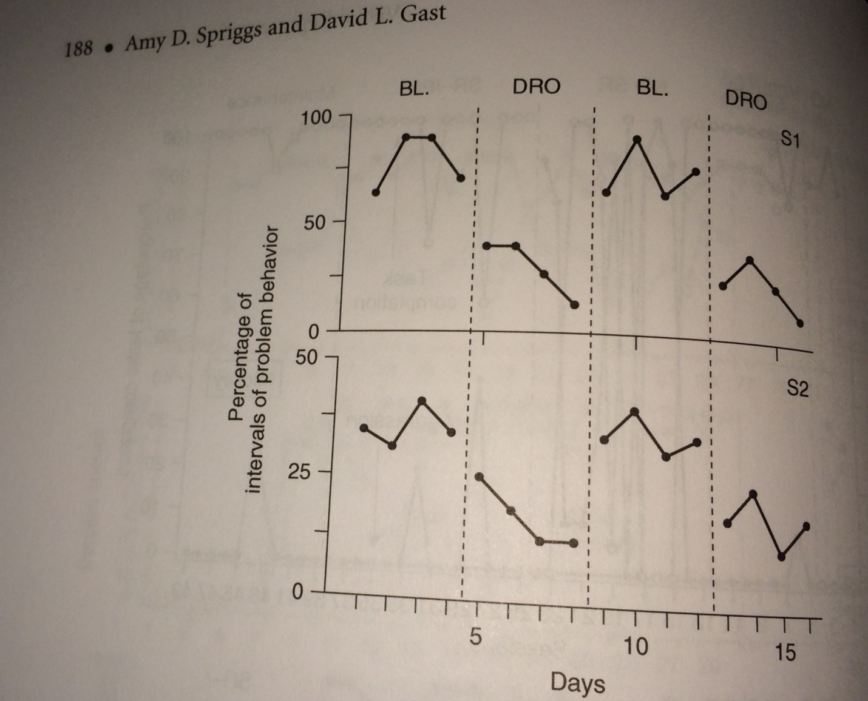

What two research articles outline how to create single-case research study graphs using Excel? (p.189 and p. 197)?

What appendix can be used for creating a simple line graph in Microsoft Excel? (p. 193-195)

What appendix can be used for creating a simple bar graph in Microsoft Excel? (p. 195-197)

