SPC ED 619 Take Home Quiz 2 Due: 11/6/13
Use your text, readings, and class notes to answer the following:

1. (2 pts) Examine the following graph.
- Describe the displayed data in terms of each of the components of visual analysis we discussed in class and that you read about (i.e., trend, level, variability, immediacy of effect, overlap).
- Use the components of visual analysis to determine if these data demonstrate a functional relation between the intervention and the dependent variable. Explain your reasoning. 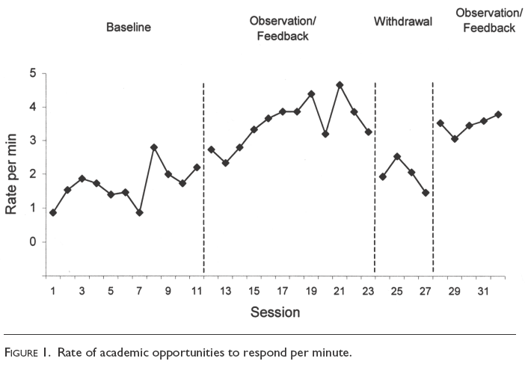

2. (1 pt) Examine the graph and identify what type of design is being used. Briefly explain the rationale and the advantages and disadvantages inherent in using this variation of a withdrawal design.
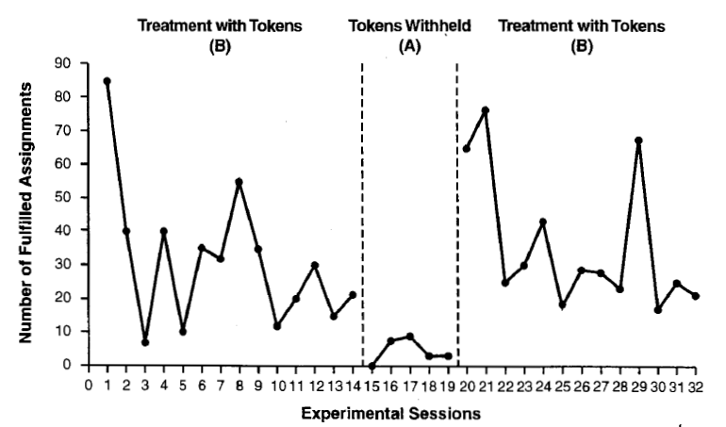

3. (1 pt) Examine the graph below that shows one tier from a multiple probe design. Briefly explain the: rationale, advantages and disadvantages inherent in a multiple probe design.

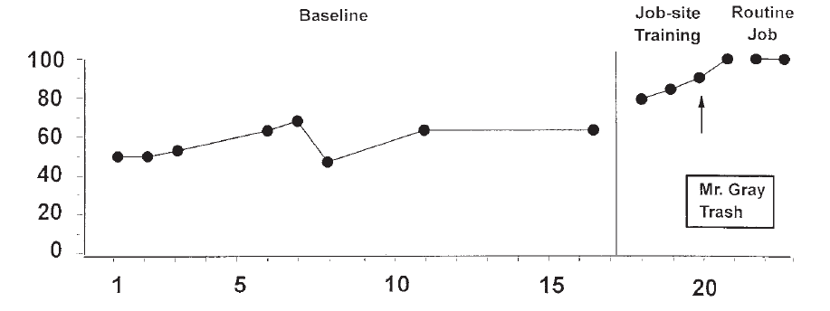

4. (1 pt) Examine the graph below and identify what type of design is being used. Explain the rationale and the advantages and disadvantages inherent in using this design.

Experiment 1: Percentage of Intervals of Appropriate In-Seat Behavior for Sam in Baseline, Vest With No Weight, and Weighted Vest

5. (1 pt) Provide a (a) definition for each of these terms (use your own words) and (b) explain their importance in designing a single-case research study.
- Reversibility of behavior
- Multitreatment interference

6. (4 pts) Read the following scenario and:
- Determine what would be an appropriate research question for this situation. Specifically, if you were asked to design a research study to help with this situation, what would the research question be? Write it out.
- Determine what would be the most appropriate single-case research design to use in examining/answering this research question and provide a thorough discussion of your rationale for this choice. In this discussion, explain how the characteristics of the design you chose would help answer the question.
Tomas Teacher has a classroom full of energetic middle school boys. Their high-energy behavior results in frequent disruptions throughout the day and as a result, the students’ academic progress is being negatively affected. Mr. Teacher asks the district’s behavioral consultant for help. They consider several options to help the students gain control over their behavior, including a token system combining positive reinforcement with response cost (earning tokens for on-task behavior and losing them when exhibiting disruptive behaviors), differential reinforcement of low rates of behavior (DRL), and sending offending students to the school’s inschool suspension program. After much discussion, they can’t make a decision because they aren’t sure which might work best with this particular group of students.

