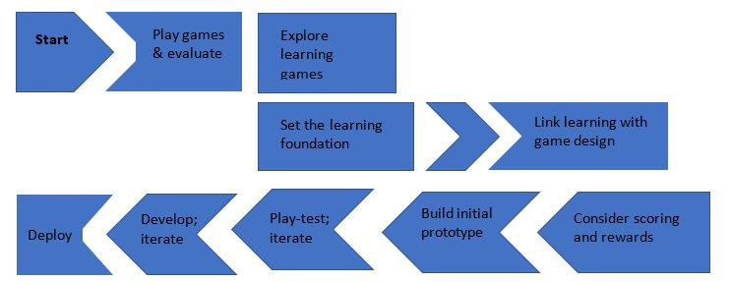
Design a Game Activity

Step 1. Choose ACRL Framework and any Knowledge Practice or Disposition that will serve as the focus for the game. Write it on your Design Sheet

Authority Is Constructed and Contextual

Learners who are developing their information literate abilities
- define different types of authority, such as subject expertise (e.g., scholarship), societal position (e.g., public office or title), or special experience (e.g., participating in a historic event);
- use research tools and indicators of authority to determine the credibility of sources, understanding the elements that might temper this credibility;
- understand that many disciplines have acknowledged authorities in the sense of well-known scholars and publications that are widely considered “standard,” and yet, even in those situations, some scholars would challenge the authority of those sources;
- recognize that authoritative content may be packaged formally or informally and may include sources of all media types;
- acknowledge they are developing their own authoritative voices in a particular area and recognize the responsibilities this entails, including seeking accuracy and reliability, respecting intellectual property, and participating in communities of practice;
- understand the increasingly social nature of the information ecosystem where authorities actively connect with one another and sources develop over time.
- develop and maintain an open mind when encountering varied and sometimes conflicting perspectives;
- motivate themselves to find authoritative sources, recognizing that authority may be conferred or manifested in unexpected ways;
- develop awareness of the importance of assessing content with a skeptical stance and with a self-awareness of their own biases and worldview;
- question traditional notions of granting authority and recognize the value of diverse ideas and worldviews;
- are conscious that maintaining these attitudes and actions requires frequent self-evaluation

Information Creation as a Process

Learners who are developing their information literate abilities
- articulate the capabilities and constraints of information developed through various creation processes;
- assess the fit between an information product’s creation process and a particular information need;
- articulate the traditional and emerging processes of information creation and dissemination in a particular discipline;
- recognize that information may be perceived differently based on the format in which it is packaged;
- recognize the implications of information formats that contain static or dynamic information;
- monitor the value that is placed upon different types of information products in varying contexts;
- transfer knowledge of capabilities and constraints to new types of information products;
- develop, in their own creation processes, an understanding that their choices impact the purposes for which the information product will be used and the message it conveys.
- are inclined to seek out characteristics of information products that indicate the underlying creation process;
- value the process of matching an information need with an appropriate product;
- accept that the creation of information may begin initially through communicating in a range of formats or modes;
- accept the ambiguity surrounding the potential value of information creation expressed in emerging formats or modes;
- resist the tendency to equate format with the underlying creation process;
- understand that different methods of information dissemination with different purposes are available for their use.

Research as Inquiry

Learners who are developing their information literate abilities
- formulate questions for research based on information gaps or on reexamination of existing, possibly conflicting, information;
- determine an appropriate scope of investigation;
- deal with complex research by breaking complex questions into simple ones, limiting the scope of investigations;
- use various research methods, based on need, circumstance, and type of inquiry;
- monitor gathered information and assess for gaps or weaknesses;
- organize information in meaningful ways;
- synthesize ideas gathered from multiple sources;
- draw reasonable conclusions based on the analysis and interpretation of information
- consider research as open-ended exploration and engagement with information;
- appreciate that a question may appear to be simple but still disruptive and important to research;
- value intellectual curiosity in developing questions and learning new investigative methods;
- maintain an open mind and a critical stance;
- value persistence, adaptability, and flexibility and recognize that ambiguity can benefit the research process;
- seek multiple perspectives during information gathering and assessment;
- seek appropriate help when needed;
- follow ethical and legal guidelines in gathering and using information;
- demonstrate intellectual humility (i.e., recognize their own intellectual or experiential limitations).

Scholarship as Conversation

Learners who are developing their information literate abilities
- cite the contributing work of others in their own information production;
- contribute to scholarly conversation at an appropriate level, such as local online community, guided discussion, undergraduate research journal, conference presentation/poster session;
- identify barriers to entering scholarly conversation via various venues;
- critically evaluate contributions made by others in participatory information environments;
- identify the contribution that particular articles, books, and other scholarly pieces make to disciplinary knowledge;
- summarize the changes in scholarly perspective over time on a particular topic within a specific discipline;
- recognize that a given scholarly work may not represent the only or even the majority perspective on the issue.
- recognize they are often entering into an ongoing scholarly conversation and not a finished conversation;
- seek out conversations taking place in their research area;
- see themselves as contributors to scholarship rather than only consumers of it;
- recognize that scholarly conversations take place in various venues;
- suspend judgment on the value of a particular piece of scholarship until the larger context for the scholarly conversation is better understood;
- understand the responsibility that comes with entering the conversation through participatory channels;
- value user-generated content and evaluate contributions made by others;
- recognize that systems privilege authorities and that not having a fluency in the language and process of a discipline disempowers their ability to participate and engage.

Searching as Strategic Exploration

Learners who are developing their information literate abilities
- determine the initial scope of the task required to meet their information needs;
- identify interested parties, such as scholars, organizations, governments, and industries, who might produce information about a topic and then determine how to access that information;
- utilize divergent (e.g., brainstorming) and convergent (e.g., selecting the best source) thinking when searching;
- match information needs and search strategies to appropriate search tools;
- design and refine needs and search strategies as necessary, based on search results;
- understand how information systems (i.e., collections of recorded information) are organized in order to access relevant information;
- use different types of searching language (e.g., controlled vocabulary, keywords, natural language) appropriately;
- manage searching processes and results effectively.
- exhibit mental flexibility and creativity
- understand that first attempts at searching do not always produce adequate results
- realize that information sources vary greatly in content and format and have varying relevance and value, depending on the needs and nature of the search
- seek guidance from experts, such as librarians, researchers, and professionals
- recognize the value of browsing and other serendipitous methods of information gathering
- persist in the face of search challenges, and know when they have enough information to complete the information task.

Information Has Value

Learners who are developing their information literate abilities
- give credit to the original ideas of others through proper attribution and citation;
- understand that intellectual property is a legal and social construct that varies by culture;
- articulate the purpose and distinguishing characteristics of copyright, fair use, open access, and the public domain;
- understand how and why some individuals or groups of individuals may be underrepresented or systematically marginalized within the systems that produce and disseminate information;
- recognize issues of access or lack of access to information sources;
- decide where and how their information is published;
- understand how the commodification of their personal information and online interactions affects the information they receive and the information they produce or disseminate online;
- make informed choices regarding their online actions in full awareness of issues related to privacy and the commodification of personal information.
- respect the original ideas of others;
- value the skills, time, and effort needed to produce knowledge;
- see themselves as contributors to the information marketplace rather than only consumers of it.
- are inclined to examine their own information privilege.

Step 2. Learning Outcome(s): Create at least 1 Learning Outcome related to the ACRL Frame and write it on the Worksheet. Be sure to identify your audience (student will be able to …..)

Step 3. Assessment: Choose an assessment that will allow your audience to perform tasks that demonstrate understanding and identify the criteria you will judge these tasks. What other means might you collect evidence of understanding? Write it on your Worksheet.
Possible Assessments:
Minute Paper | Poll/ Survey | Your choice:
Rubric | Muddiest Point
Scorecard | Quiz

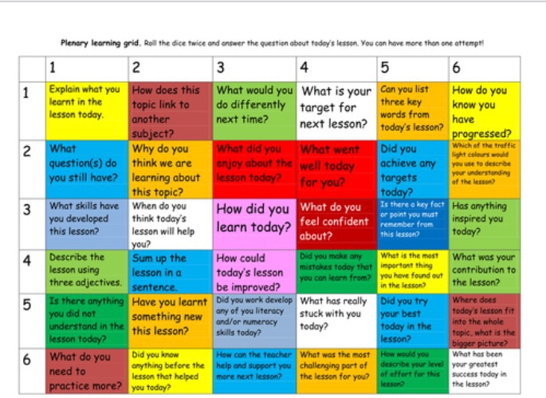
Step 4. Pedagogical/Classroom Techniques: Identify at least 2 activities from the Pedagogical Technique list or choose one of your own and write it on your Worksheet.
Pair/Share/Report | Brainstorm | Jigsaw
Pair/Share/Record | Questions/Answers | Presentation
Individual work | Scaffolding | Repetition
Small Group Record/Report | Demonstration | Feedback
 | Directed practice | Reflection

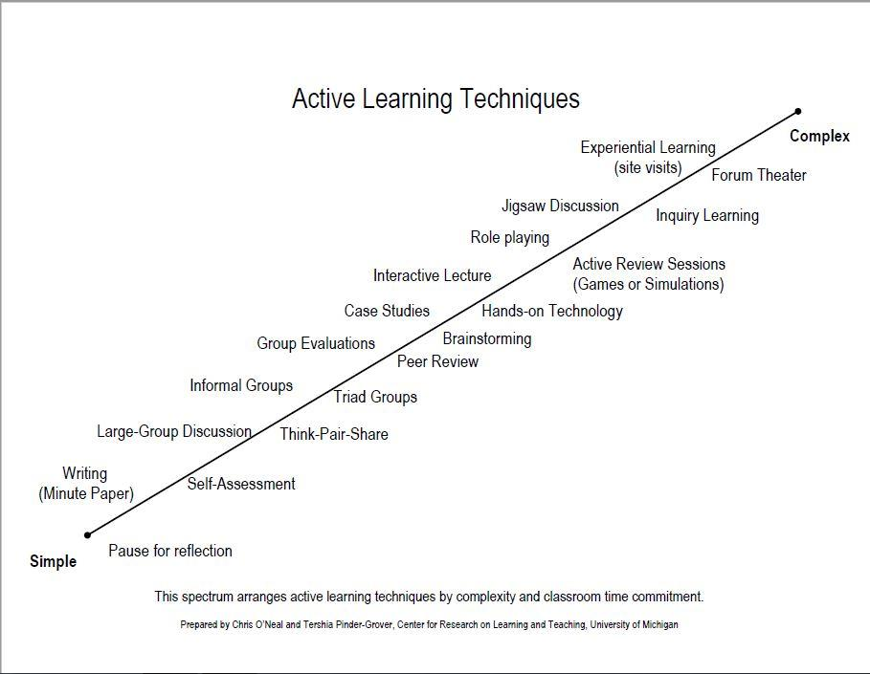

Step 5. Task(s) Choose a tool from the Tools Lists and a verb from the Verbs List to create a task. Create at least 2 Tasks the students will do in the game. Write the tasks on the Worksheet.
Tool List |  | Verbs List
Library Catalog |  | Write
Books |  | Read
Periodicals/Scholarly Journals |  | Analyze
Newspapers |  | Evaluate
Articles |  | Use
Video/Images |  | List
Quotes/Summaries/Paraphrases |  | Apply
Paragraphs |  | Identify
Databases |  | Report
Annotated Bibliography |  | Summarize
Maps |  | Explain
Keywords |  | Demonstrate
Citations |  | Select
Sentences |  | Find
Other? |  | Create
 |  | Compare
 |  | Other?

Example of task: Use a database to find scholarly articles.
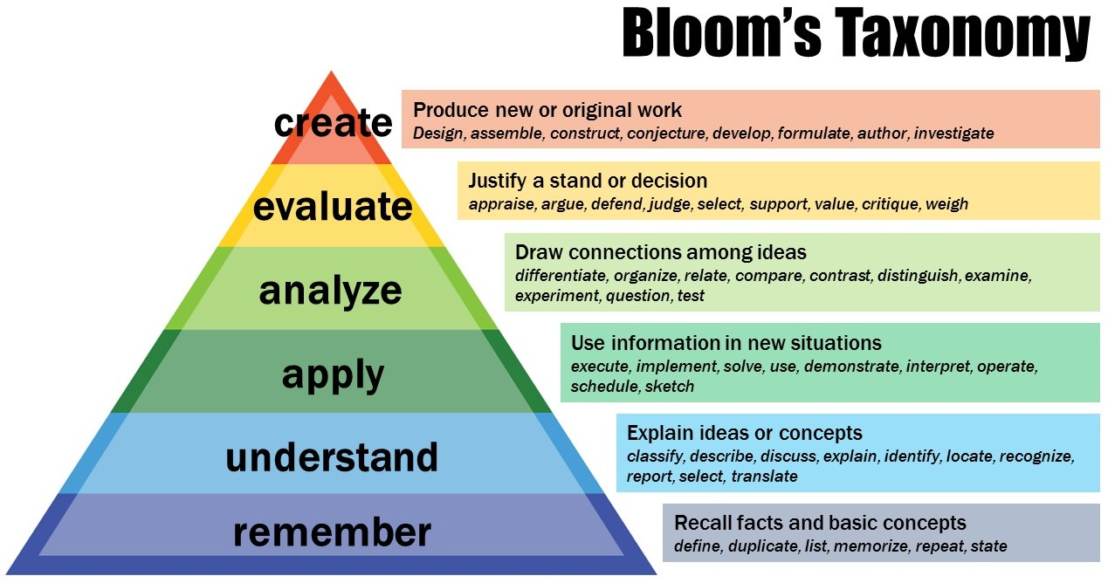

Step 6. Game Dynamics: Choose at least 1 Game Dynamic to use. Mutiple game dynamics can be combined. Write it your Worksheet.
Game Dynamic | Definition/Description | Example
Race to the Finish | Get to finish first or before time runs out; success achieves a goal within a specific time period | Candyland, Mario Kart
Territory Acquisition | Acquire or take property; success increases territory and failure shrinks territory | Risk, Carcasonne, Civilization
Exploration | Wander through the game world to find things of value | Tomb Raider, Clue
Collecting | Find specific things; success is making associations to acquire the thing | Trivial Pursuit, Knowledge Guru
Rescue or Escape | Get out of or away from something or the reverse chase something to catch it. Success can be mastering knowledge that allows survival or finding something. | Capture the Flag,
Alignment | Put game pieces in a specific order; useful for recognizing sequence, and identification. | Candy Crush, Solitare
Forbidden act | Win game by breaking rules or wrong moves are encouraged | Twister
Construct or build | Create, manage and maintain objects. Successful plays see that knowledge can be used to create real world application. | SimCity, Minecraft, Catan
Outwit | Use knowledge to win | Trivial Pursuit
Solution | Solve a problem or puzzle. Use to reinforce specific skills or knowledge. | Chess
Matching | Recognize specific things as alike | Spot It, Memore

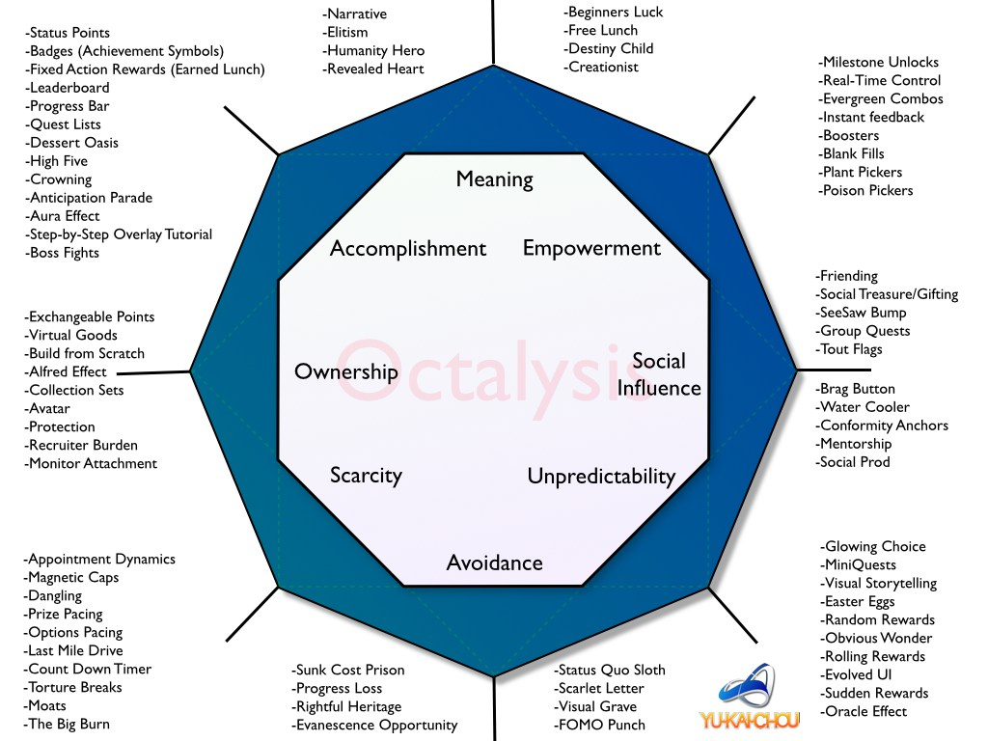
Step 7. Game Motivation: Choose at least 3 Game motivators to use to motivate your players. Write them on your Worksheet.
Fun (Lazzaro 2004) | Conflict | Aesthetics
Social Interaction (Chou 2017) | Cooperation/Collaboration | Narrative/Story
Meaning (Chou 2017 | Competition | Theme
Discovery | Strategy | Resources
Fantasy | Chance/Unpredictability (Chou 2017) | Time
Mastery | Curiosity | Levels
Ownership/Possession (Chou 2017) | Challenge | Creativity with Feedback (Chou 2017)
Exploration | Control | Reward (points, tokens, etc)
Accomplishment (Chou 2017) | Ownership/Possession (Chou 2017) | Character
Avoidance | Scarcity (Chou 2017) | Progress (leaderboards)
Change | Autonomy | Recognition (badges)
Purpose
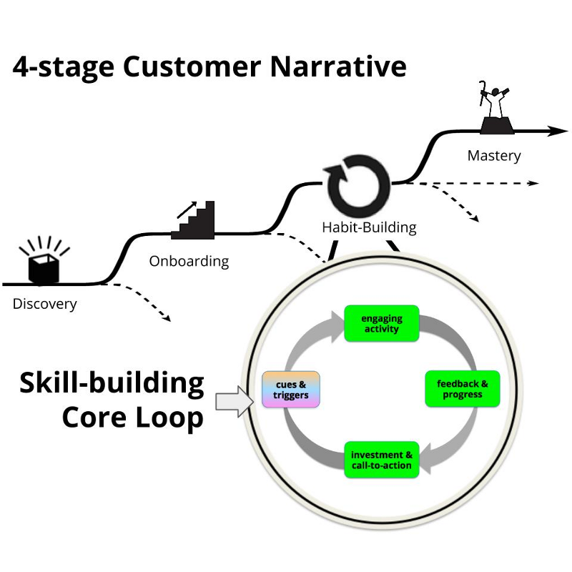
Step 8. Game Technology: Choose at least 1 Game Technology to use as part of game structure. Write it on your Worksheet.
Cards
Cubes
Categories
SmartBoard
Goosechase
Twine
Dice
Random Number Generator
Spinning wheel of choice
Jeopardy
Concentration
Your choice
Quizizz
Kahoot
Puzzle Board
Board Game
Lockbox
Escape Room

Step 9. Game Description and Rules: Write a description of what you would like to happen in your game. How players would win. What the challenges or levels might be. Identify any specific rules for the game. Write this information on your Worksheet.
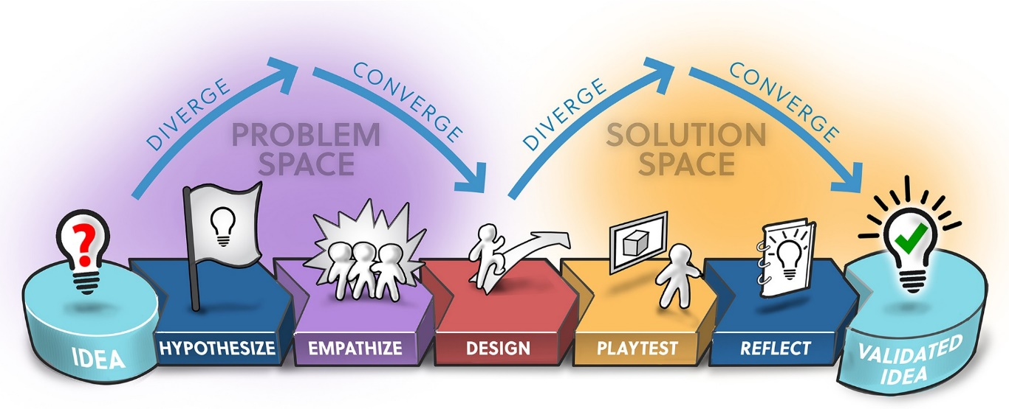

Step 10. Share: Be prepared to share draft Game with other groups.

