Photocubes / W questions and Other Possibilities
Create a cube from any of these charts. Also potential for assessment.
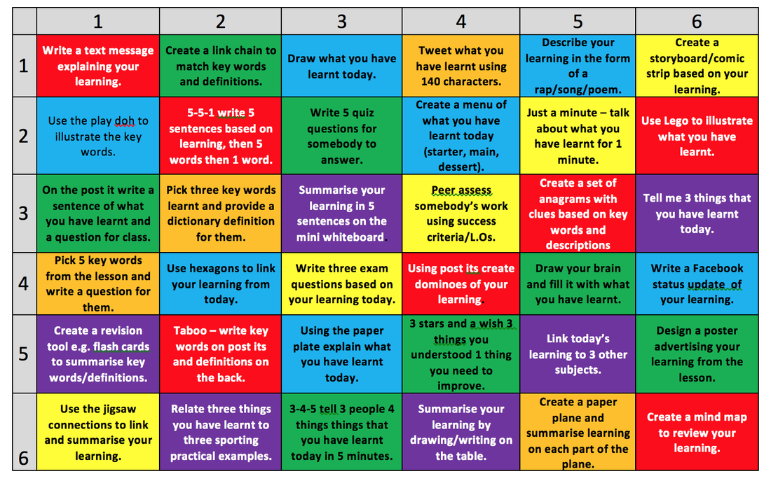

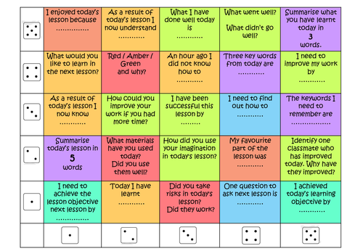

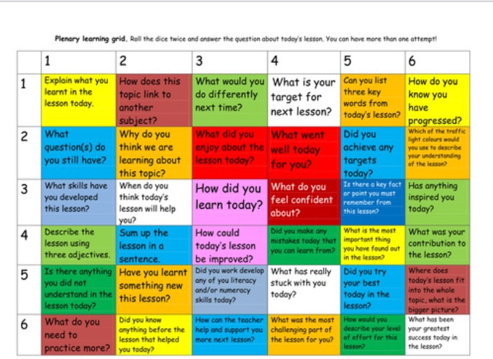
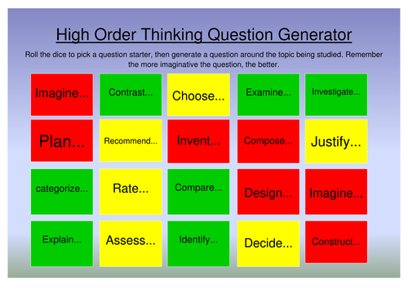

R | Roll the Cube
A | Answer the Question | 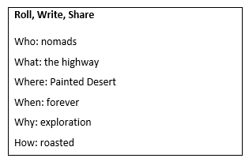
T | Talk with Neighbors | 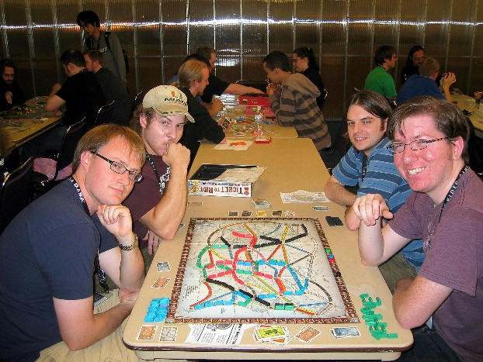

Roll, Write, Share  Who:  What:  Where:  When:  Why:  How | Roll, Write, Share  Who:  What:  Where:  When:  Why:  How
Roll, Write, Share  Who:  What:  Where:  When:  Why:  How | Roll, Write, Share  Who:  What:  Where:  When:  Why:  How
Roll, Write, Share  Who:  What:  Where:  When:  Why:  How | Roll, Write, Share  Who:  What:  Where:  When:  Why:  How

Have you used games in instruction?  If so, how? | Which of your instructional activities would you consider gamifying?
In what ways will your students be engaged by gamification? | How will gamification meet instructors’ needs?
Do you play games in your free time? How often? What type of games? | 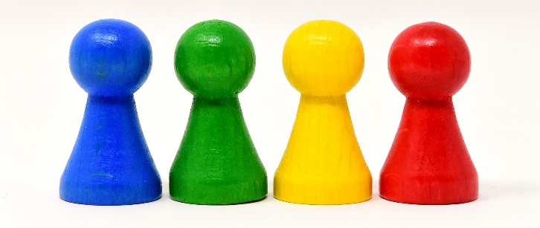  What are challenges to implementing gamification in your instruction?

Why? | When?
 | 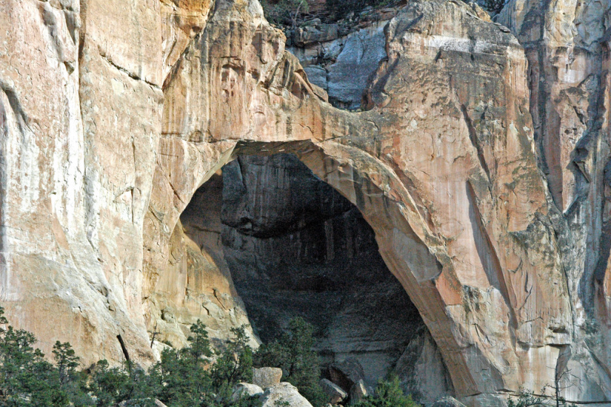
Who? | What?
Where? | How?

