Identify Need:
Instructional Goal |  |  | After playing this game learners will:
Learning Objectives |  |  | To achieve this goal, learners need to be able to:
Core Dynamics |  |  | Race to the finish  Territory acquisition  Exploration  Collecting | Rescue or escape  Alignment  Forbidden act  Construct or build | Outwit  Solution  Matching
Tasks:
(Specific activities the learners will do)
Game Mechanics: (learning loop—Kim)  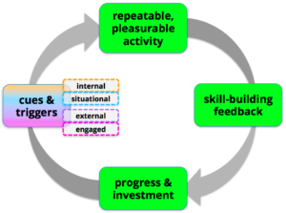 |  |  | The description/rules for this game are the following:
Game Motivators:
Aesthetics  Chance  Competition  Conflict | Cooperation  Levels  Resources  Rewards | Story  Strategy  Theme  Time
Feedback  (Mastery Journey—Kim)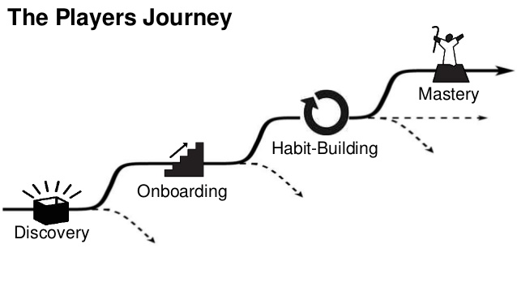 |  |  | Learners will receive feedback at the following places in the game:  (Discovery, Onboarding, Habit Building, Mastery)

