# Create a Story (Iota Cards)

# **Game Key**

|  |  |  |  |  |  |  |
| --- | --- | --- | --- | --- | --- | --- |
| **Color** | **Element** | **Element Examples** | **Time Period** | **Quantity** | **Shape** | **Time Period** |
| Red | Character | Hero, heroine, villain |  | Number of characters | Circle | Future |
| Blue | Setting | Country, building, room |  | Number of settings | Triangle | Present |
| Green | Ending | Death, Marriage, Party | Shape on this color determines time period. | Number of possible endings | Square | Past |
| Yellow | Product | Song, Book, Website |  | Number of products to create | Cross | Multiple |

**Instructions:** Pick 4 cards, one of each color. Pay attention to the shapes, colors and numbers to determine what you will be doing with the cards. The color of the card determines the element. The number determines the quantity of the element. The shape determines the time period for the story. Your green card will determine the time period you will use for the activity.

**For Example:** For this set you would create a story with 2 characters (red card), 3 settings (blue card), 2 possible endings in a 2 different time periods (green card), in 4 different product formats (yellow card). Flip over for a worksheet to use with the exercise.

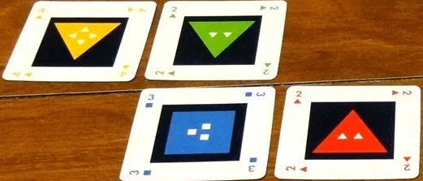

My Story Cards Worksheet:

|  |  |  |
| --- | --- | --- |
| Color | # on Card | Possible story elements |
| Red |  |  |
| Blue |  |  |
| Yellow |  |  |
| Green | # and Shape |  |
| Time Period |  |  |