Exam #2 Prac a: PEP 426 Intermediate Exercise Physiology

Write all answers on the answer sheet provided.

Section 1: Multiple Choice
Select the response that best answers the following questions.

- It has been estimated that the proportion of US adults who have cardiovascular disease, but do not know they have it, approximates ……?

- 50 %
- 41 %
- 65 %
- 10 %
- 85 %

- When a person is exercising on a cycle ergometer at 2.8 kg load and a cadence of 75 rev/min, what is the power output expressed as Watts?

- 140
- 105
- 235
- 206
- 185

- Which nutrient yields 5.05 Kcals/L VO₂?

- carbohydrate
- fat
- protein
- alcohol
- short chain amino acids

- For most individuals, it is best to keep protocol duration for VO₂max testing between …….

- 16 - 20 min
- 10 - 14 min
- 6 - 8 min
- 12 - 16 min
- 8 - 10 min

- An increase in which of the following will increase oxygen diffusion?

- surface area
- atmospheric pressure
- partial pressure gradient
- gas temperature
- all of the above

- The water vapor pressure for saturated air (RH=100%) at 37°C is ….

- 25 mmHg
- 52 mmHg
- 1.34 mmHg
- 6 mmHg
- 47 mmHg

- If the barometric pressure is 685 mmHg, the PaO₂ approximates ………? (assume PAO₂ = PaO₂)

- 93 mmHg
- 42 mmHg
- 81 mmHg
- 106 mmHg
- 100 mmHg

- The Haldane Transformation is expressed as ……………

- VO₂ = VI⋅FIO₂ – VE⋅FEO₂
- VI⋅FIN₂ = VE⋅FEN₂
- VCO₂/VO₂
- VCO₂ = VE⋅FECO₂ – VI⋅FIC₂
- VO₂ = Q⋅(a-vO₂Δ)

- The “oxygen deficit” refers to ………..

- excess post-exercise (recovery) VO₂
- metabolic acidosis
- muscle fatigue
- the difference between measured VO₂ and actual VO₂ demand
- lactate accumulation

- How many Kcals is expended at a VO₂ of 4.25 L/min at an RER of 0.98 for 35 min?

- 480
- 747
- 689
- 593
- 635

- 1 Watt equals how many kgm/min?

- 2
- 4
- 6.118
- 9.5
- 5.435

- The two hormones involved in the conservation of body water are ……..?

- ADH and aldosterone
- EPO and ACTH
- insulin and glucagon
- epinephrine and norepinephrine
- ANPs and nitric oxide

- In order to lose body fat and prevent sedentary lifestyle disease, people should exercise ………….?

- by only completing light exercise, such as walking, for no more than 30 min
- simply by accumulating 30 min of activity each day
- to prepare themselves for a marathon race within 6 months from the start of training
- by only doing long and slow walking and jogging
- by completing moderate to intense, quality exercise training designed to improve physical fitness parameters, at least 5 times/week

- What is the partial pressure of a gas that makes up 78.08% of air, at a barometric pressure of 745 mmHg?

- 489 mmHg
- 582 mmHg
- 647 mmHg
- 712 mmHg
- 514 mmHg

- For a highly-trained endurance athlete, the range of stroke volume (rest to VO₂max) could be ………….

- 120 – 190 mL
- 60 – 250 mL
- 42 – 115 mL
- 75 – 160 mL
- 80 – 130 mL

- Which of the following nutritional ergogenic aids has been shown by research to be effective at improving intermittent intense exercise performance?

- carnitine
- phosphate
- fat
- creatine
- carbohydrate-electrolyte solutions

- The main benefit of surfactant in the lung is to ……………….?

- improve oxygen diffusion
- decrease surface tension
- lower residual volume
- increase surface tension
- allow bubble formation

- In clinical exercise physiology and cardiology, afterload refers to ………………

- systolic blood pressure
- ejection fraction
- diastolic blood pressure
- end diastolic volume
- end systolic volume

- What causes the increase in ventilation at the ventilation threshold?

- excess CO₂ from proton (H+) buffering by bicarbonate
- hypoxia
- pain
- increased blood lactate
- increased temperature

- The respective inspired gas fractions for oxygen (FIO₂), nitrogen (FIN₂) and carbon dioxide (VICO₂) are ………..

- 0.1546, 0.7903, 0.0005
- 0.2009, 0.7895, 0.001
- 0.2059, 0.80, 0.005
- 0.2095, 0.7808, 0.0003
- 0.21, 0.81, 0.0009

Section 2: True/False
Write either T (true) or F (false) on the answer sheet provided.

- Body weight changes should really only be used as an acute measure of fluid loss/gain.

- During increasing exercise intensities, the duration of both systole and diastole shorten.

- Oxygen has a greater solubility than CO₂.

- Caffeine ingestion can stimulate increased cardiac arrhythmias, especially in people not accustomed to caffeine ingestion.

- Surfactant functions to increase the work of breathing.

- Improved running track materials, shoes, clothing, and equipment (e.g. road and track bikes), are all examples of mechanical ergogenic aids.

- In the U.S., health data on adults reveals that diabetes, over-fatness, and inactivity continue to worsen despite more than 20 years of effort to reverse these trends.

- At sea level, the PAO₂ approximates 104 mmHg.

- The term “contractility”, in relation to cardiovascular physiology, refers to the increased myocardial performance for an increase in EDV.

- The typical PAO₂ here in Albuquerque approximates 85 mmHg.

- All subjects show a VO₂ plateau at VO₂max.

- The α- and β-receptors of vascular smooth muscle bind acetylcholine.

- Most blood CO₂ is transported as HCO₃⁻ after conversion by the carbonic anhydrase reaction.

- The blood oxygen content for a person with a [Hb] = 145 grams/L, and a SaO₂ = 98% is 190.4 mL/L.

- Excessive hyperventilation can raise blood pH and induce nausea.

Section 3: Short Response
Write your answer on the lines provided for each question on the answer sheet.

- What is the difference in the arterial content of oxygen (CaO₂) between Albuquerque (5,500 ft) and 10,700 ft (Sandia Crest): use the following facts and the O₂-hemoglobin dissociation curve; [Hb]=14.5 g/L ; no difference b/n P_{A}O₂ and PaO₂ ; 1 m = 3.28 ft ; PB = 760 * [e ^{–(m/7924)}]

- Estimate the biological energy expenditure of a person exercising at 350 Watts on a cycle ergometer, with an efficiency of 26.4%.

- Why is it better to train individuals, regardless of age, for increased physical fitness to oppose or prevent being over-fat and develop cardiovascular disease or diabetes?

- Why does it take longer for O₂ to equilibrate in the lung (PAO₂ to PaO₂) and diffuse from blood in the periphery, compared to CO₂?

- Answer the following questions based on this exercise example.

P_{B} = 630 mmHg ; Tgas = 20°C ; expired gas RH = 100%

VE ATPS = 176 L/min ; FEO₂ = 0.1782 ; FECO₂ = 0.0369 ; Body weight = 88 kg

VE STPD = VE ATPS x (273 / (273 + Tgas)) x ((P_{B} – PH₂O)/760 mmHg)

VI STPD = (VE STPD x ((0.9906 – (FEO₂ + FECO₂))/0.7808)

VO₂ STPD = (VI STPD x 0.2095) – (VE x FEO₂)

VCO₂ STPD = (VE STPD x FECO₂) – (VI STPD x 0.0003) ; RER = VCO₂ / VO₂

- Calculate VE STPD and VI STPD.

- Calculate VO₂, VCO₂ and RER.

- Using the RER table provided, calculate the contribution (% and grams) of fat and carbohydrate to metabolism. If RER > 1.0, assume 100% CHO!

- Comment on the metabolic/exercise condition and the fitness of the subject that is likely to be associated with these numbers.

Use the figure of the O₂-hemoglobin dissociation curve, and conversion factors, below, to assist questions.
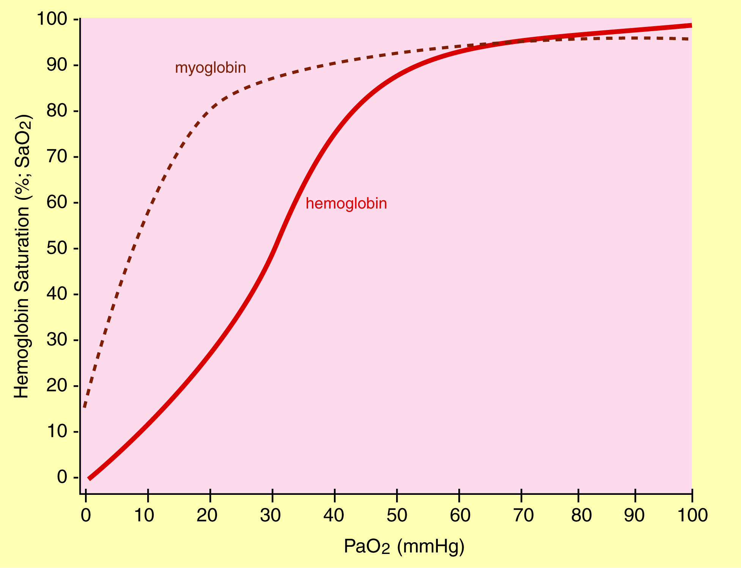
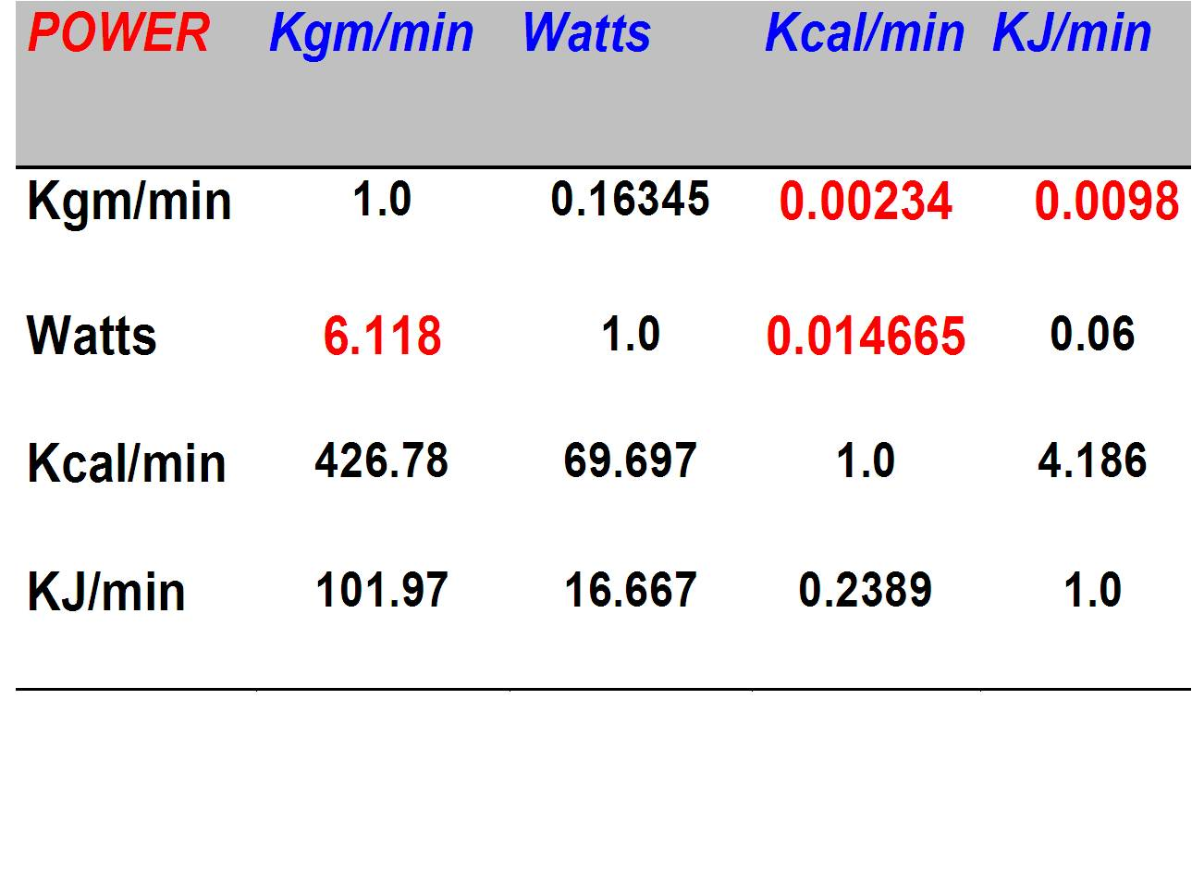

Use the RER table, below, to assist with questions

Use the saturated water vapor pressure table, below, to assist with questions
Temp (°C) | P_{H2O} (mmHg)
14 | 12.9
15 | 13.5
16 | 14.1
17 | 14.9
18 | 15.5
19 | 16.5
20 | 17.5
21 | 18.7
22 | 19.8
23 | 21.1
24 | 22.4
25 | 23.8
26 | 25.2
27 | 26.7
28 | 28.3
29 | 30.0
30 | 31.8
31 | 33.7
32 | 35.7
33 | 37.7
34 | 39.9
35 | 42.2
36 | 44.6
37 | 47.1
38 | 49.4
39 | 52.0
40 | 54.7

