Exam #2: PEP 426 Intermediate Exercise Physiology

Write all answers on the answer sheet provided.

Section 1: Multiple Choice
Select the response that best answers the following questions.

- When a person is exercising on a cycle ergometer at 2.8 kg load and a cadence of 75 rev/min, what is the power output expressed as Watts?

- 140
- 105
- 235
- 206
- 185

- Which nutrient yields 5.05 Kcals/L VO₂?

- carbohydrate
- fat
- protein
- alcohol
- short chain amino acids

- The water vapor pressure for saturated air (RH=100%) at 37°C is ….

- 25 mmHg
- 52 mmHg
- 1.34 mmHg
- 6 mmHg
- 47 mmHg

- The Haldane Transformation is expressed as ……………

- VO₂ = VI⋅FIO₂ – VE⋅FEO₂
- VI⋅FIN₂ = VE⋅FEN₂
- VCO₂/VO₂
- VCO₂ = VE⋅FECO₂ – VI⋅FIC₂
- VO₂ = Q⋅(a-vO₂Δ)

- How many Kcals is expended at a VO₂ of 4.25 L/min at an RER of 0.98 for 35 min?

- 480
- 747
- 689
- 593
- 635

- 1 Watt equals how many kgm/min?

- 2
- 4
- 6.118
- 9.5
- 5.435

- The respective inspired gas fractions for oxygen (FIO₂), nitrogen (FIN₂) and carbon dioxide (VICO₂) are ………..

- 0.1546, 0.7903, 0.0005
- 0.2009, 0.7895, 0.001
- 0.2059, 0.80, 0.005
- 0.2095, 0.7808, 0.0003
- 0.21, 0.81, 0.0009

Section 2: True/False
Write either T (true) or F (false) on the answer sheet provided.

- At an RER of 1.0 during steady state exercise, the body is expending 5.05 Kcals/L of VO₂.

- The inspired fraction of oxygen (FIO₂) equals 0.2095.

- For expired gas sampled in our teaching lab during normal environmental conditions, the corrections for temperature and pressure from ATPS to STPD will always be each >1 and cause a smaller volume of air when expressed STPD.

- The inspired fraction of carbon dioxide (FICO₂) is 0.7808.

- The VO₂ cost of steady state cycling is different for men vs. women.

- Cells have a greater metabolic efficiency (ATP per VO₂) for fat catabolism than carbohydrate catabolism.

- The body is about 25 – 30% efficient in converting chemical energy to physical energy production during exercise.

Section 3: Short Response
Write your answer on the lines provided for each question on the answer sheet.

- Answer the following questions based on this exercise example.

P_{B} = 630 mmHg ; Tgas = 20°C ; expired gas RH = 100%

VE ATPS = 176 L/min ; FEO₂ = 0.1782 ; FECO₂ = 0.0369 ; Body weight = 88 kg

VE STPD = VE ATPS x (273 / (273 + Troom)) x ((PB – PH₂O)/760 mmHg)

VI STPD = (VE STPD x ((0.9906 – (FEO₂ + FECO₂))/0.7808)

VO₂ STPD = (VI STPD x 0.2095) – (VE x FEO₂)

VCO₂ STPD = (VE STPD x FECO₂) – (VI STPD x 0.0003) ; RER = VCO₂ / VO₂

- Calculate VE STPD and VI STPD.

- Calculate VO₂, VCO₂ and RER.

- Using the RER table provided, calculate the contribution (% and grams) of fat and carbohydrate to metabolism. If RER > 1.0, assume 100% CHO!

- Comment on the metabolic/exercise condition and the fitness of the subject that is likely to be associated with these numbers.

Use the following information to answer questions 6 through 10.
Assume Douglas Bag gas collection.
Show all calculations on the answer sheet provided

- Body weight = 79 kg ; Room Temperature = 21 °C ;Barometric Pressure = 635 mmHg

VE ATPS = 148 L/min ; FEO₂ = 0.1698 ; FECO₂ = 0.0448

VE STPD = VE ATPS x (273/(273 + Troom)) x ((PB – PH2O)/760 )

VI STPD = VE STPD x ((0.9906 – (FEO₂ + FECO₂))/0.7808)

VO₂ STPD = (VE STPD x ((0.9906 – (FEO₂ + FECO₂))/0.7808) x 0.2095) – (VE x FEO₂)
or
VO₂ STPD = (VI STPD x 0.2095) – (VE STPD x FEO₂)

VCO₂ STPD = (VE STPD x FECO₂) – (VI STPD x 0.0003)

RER = VCO₂ / VO₂

- Calculate VE STPD

- Calculate VI STPD

- Calculate VO₂, VCO₂ and RER?

- Using the RER table provided, calculate the contribution (% and grams) of fat and carbohydrate to metabolism.

- Comment on the metabolic/exercise condition and the fitness of the subject that is likely to be associated with these numbers.

Use the following information to help answer questions.

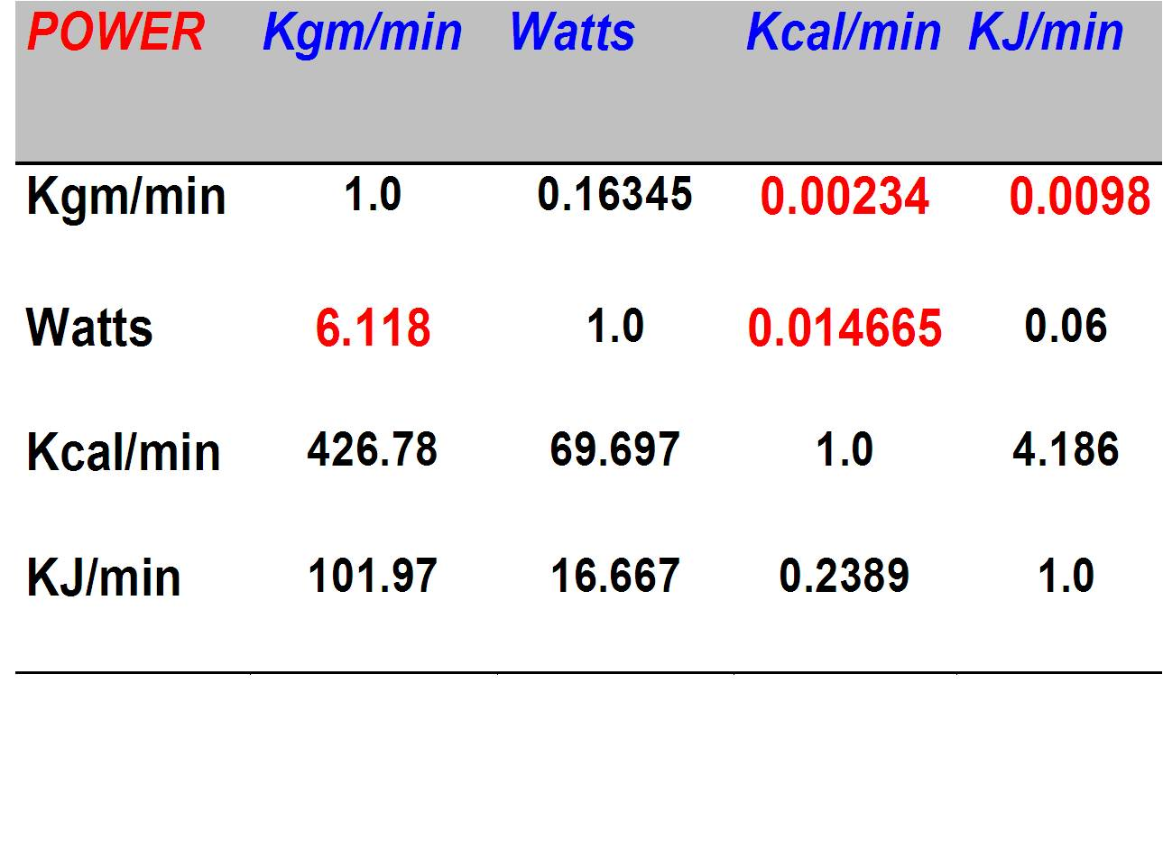

Temp (°C) | P_{H2O} (mmHg)
14 | 12.9
15 | 13.5
16 | 14.1
17 | 14.9
18 | 15.5
19 | 16.5
20 | 17.5
21 | 18.7
22 | 19.8
23 | 21.1
24 | 22.4
25 | 23.8
26 | 25.2
27 | 26.7
28 | 28.3
29 | 30.0
30 | 31.8
31 | 33.7
32 | 35.7
33 | 37.7
34 | 39.9
35 | 42.2
36 | 44.6
37 | 47.1
38 | 49.4
39 | 52.0
40 | 54.7

