Practice Exam #2b: PEP 426 Intermediate Exercise Physiology

Fall 2006

Write all answers on the answer sheet provided.

Section1: Multiple Choice
Select the response that best answers the following questions.

- How intense and often should adults exercise to prevent/retard cardiovascular and metabolic diseases?

- light to moderate intensity 3 times/week
- at least 30 min continuous moderate to vigorous intensity 5 times/week, preferably every day
- accumulate 30 min of light to moderate activity every day
- any activity at least once/week
- as little as possible to avoid over-use injuries

- Which is the most severe/detrimental?

- 2 % dehydration
- triacylglycerol de-esterification
- heat exhaustion
- postural hypotension
- heat stroke

- Normal body fluid osmolality (mmol/kg) is ……

- 260
- 280-290
- 300
- 275
- 305

- For air that is fully saturated with water vapor, and at 37 °C, the water vapor pressure is ….?

- 18 mmHg
- 28 mmHg
- 12 mmHg
- 47 mmHg
- 104 mmHg

- Which disease condition is benefited or prevented by increased physical activity?

- osteoporosis
- obesity
- hypertension
- hyperlipidemia
- all of the above

- Which of the following does not increase during acute exposure to an altitude of 4,000 m?

- plasma volume
- ventilation
- blood pH
- urine pH
- exercise heart rates

- For a person who weighs 80 kg prior to exercise, and has a post-exercise weight of 76.8 kg, what is the % dehydration?

- 4 %
- 1 %
- 6 %
- 3 %
- 2.5 %

- How much exercise should we be recommending to the public for optimal health and disease prevention?

- accumulate 30 min each day of any activity
- at least 3 days/week of moderate to intense exercise of any duration
- accumulate at least 2,000 steps/day
- at least 3 days/week of moderate to intense exercise lasting at least 30 min
- 5 days/week, preferably every day of at least 30 min moderate to vigorous exercise

- Excessive glycerol ingestion can cause …….

- headache
- blurred vision
- light headedness
- nausea
- all of the above

- In the US, and most other westernized countries, the greatest causes of death are in the large part influenced by?

- infection
- war
- inactivity and overeating
- accidents
- terrorists

- The proportion of the U.S. adult population that does not perform adequate daily physical activity approximates …..%.

- 30
- 22
- 90
- 70
- 60

- If you wanted to improve hydration before, during or after exercise, you should ingest.

- home brew beer
- gatorade
- orange juice
- a low concentration glycerol drink
- water

Section 2: True/False
Write either T (true) or F (false) on the answer sheet provided.

- Individuals should only drink a carbohydrate-electrolyte drink when performing exercise for longer than 90 min.

- Regular moderate to intense exercise can normalize mild hypertension.

- As we age we lose our ability to adapt to exercise training.

- Both adult and childhood obesity and overweight are no longer increasing in the U.S.

- Severe dehydration is associated with a decrease in skin blood flow, which compromises evaporative cooling.

- Air pressure increases with increasing altitude.

- The easiest body fluid compartment to rehydrate after dehydration is the cellular compartment.

- More vigorous/intense exercise, such as interval training, provides the greatest health benefits.

- Acute mountain sickness (AMS) can be life-threatening.

- As the body becomes dehydrated beyond 3%, there is an increased rate of sweating and evaporative cooling.

Section 3: Short Response
Write your answer on the lines provided for each question on the answer sheet.

- Why is it difficult to rapidly recover from a severe dehydration?

- List at least 5 diseases or debilitating conditions that physical activity prevents/retards.

- Does altitude training work? Explain.

Section 4: Figure Interpretation
Write your answers in the space provided for each question on the answer sheet.
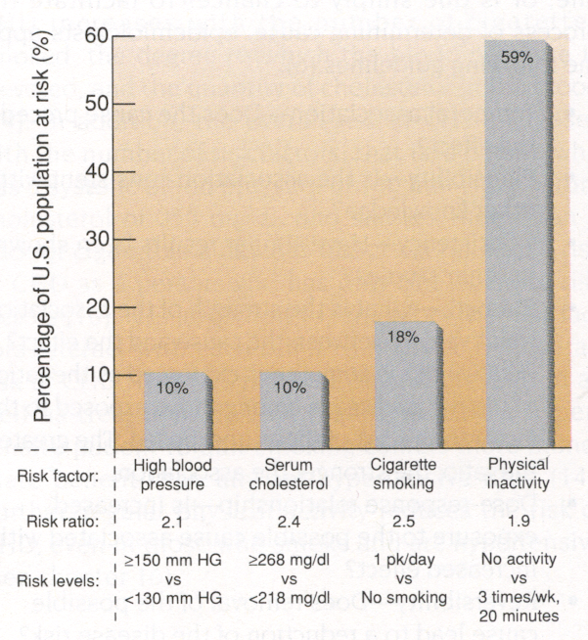
- Although having a lower risk than other conditions, physical inactivity is viewed by many to be the most important risk factor contributing to the high incidence of heart disease in the US. Why?

2. What is the main cause of type II diabetes and why is it a risk factor for heart disease?

3. Why is pictured in the above diagram, and what is it use for?

IMPORTANT

While not on this practice exam, make sure you can do the computations of altitude to pressure conversions, alveolar and arterial PO₂, as well as blood arterial O₂ content.

