Pulmonary Respiration and Blood Gas Transport Practice Questions

Oxy-hemoglobin Dissociation Curve
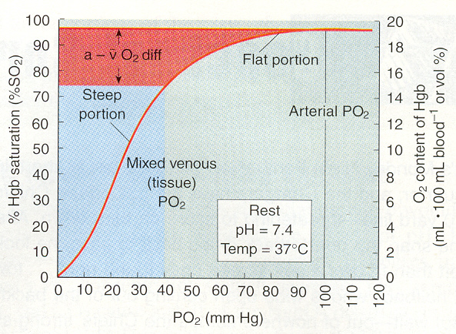

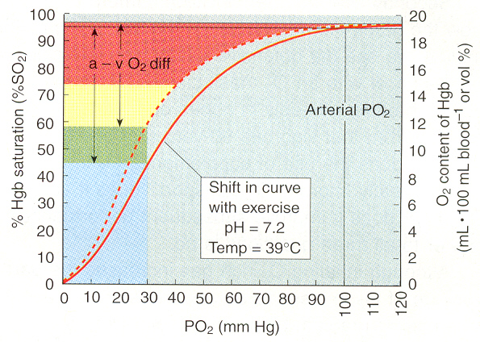

Facts and Equations

Maximal O₂ binding capacity of hemoglobin = 1.34 mL/g

CaO₂ = [Hb] x 1.34 x O₂-Hb saturation fraction

FAO₂ = 0.146; PAO₂ at sea level = 104 mmHg; PACO₂ at sea level = 40 mmHg

PH₂O at 37 °C for 100% saturated air = 47 mmHg

Questions

- Complete the calculation entries for the following table that allow you to finally calculated PaO₂. Assume complete equilibration of gases between alveolar air and blood.

Pressure (mmHg) | Calculations
Pressure (mmHg) | Corrected for PH₂O | PAO₂ | PACO₂ | % O₂-Hb Saturation | PaO₂
725
630
500
400
300

- For each condition of the table above, calculate the CaO₂ when [Hb] = 15 g/100 mL. I have duplicated the above table and formatted it for your answers below. Simply transfer over the % O2-Hb data and perform the necessary calculations.

Pressure (mmHg) | Calculations
Pressure (mmHg) | % O₂-Hb Saturation | O2-Hb  (mL/g) | [Hb] | CaO₂
725 |  | 1.34 | 15
630 |  | 1.34 | 15
500 |  | 1.34 | 15
400 |  | 1.34 | 15
300 |  | 1.34 | 15

ANSWERS

- Complete the calculation entries for the following table that allow you to finally calculate PaO₂. Assume complete equilibration of gases between alveolar air and blood.
Note: I used the Bohr effect curve (shifted down and to the right) of the bottom O2-hemoglobin dissociation curve.
 | Calculations
Pressure (mmHg) | Corrected for PH₂O | PAO₂ | PACO₂ | % O₂-Hb Saturation | PaO₂
725 | 678 | 99.0 | 38.0 | 98 | 99.0
630 | 583 | 85.1 | 32.7 | 96 | 85.1
500 | 453 | 66.1 | 25.4 | 85 | 66.1
400 | 353 | 51.5 | 19.8 | 72 | 51.5
300 | 253 | 36.9 | 14.2 | 54 | 36.9

- For each condition of the table above, calculate the CaO₂ when [Hb] = 15 g/100 mL. I have duplicated the above table and formatted it for your answers below. Simply transfer over the % O₂-Hb data and perform the necessary calculations.

 | Calculations
Pressure (mmHg) | % O₂-Hb Saturation | O₂-Hb  (mL/g) | [Hb] | CaO₂  (mL/100 mL)
725 | 98 | 1.34 | 15 | 19.7
630 | 96 | 1.34 | 15 | 19.3
500 | 85 | 1.34 | 15 | 17.1
400 | 72 | 1.34 | 15 | 14.5
300 | 54 | 1.34 | 15 | 10.9

