Practical Exam 2 Data Program Instructions
The program for Part 2 of the exam is relatively straight forward. The user interface of the program is presented below in Figure 1.
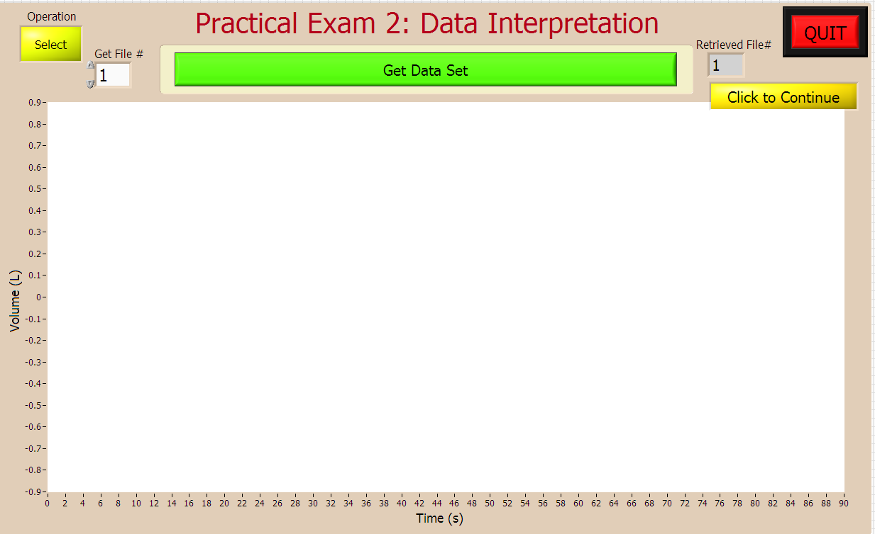
The program will open running, as per all the other programs.
You may need to resize the window to fit the screen. To fit the window to the screen, you will first need to stop the program by clicking the “QUIT” icon. Then click the usual Windows “fit to screen” icon (open square) in the top right corner of the window.
So that you can use the program to practice, I programmed to have the program run in two modes – “Select” vs. “Random” modes. This is controlled by the top left icon, which in the figure above is colored yellow in default “Select” mode. This mode allows you to select a number from 1 to 14 to retrieve a data file to be graphed.
The other mode is ‘random” mode, and it will then bring up a data set in random order.
To retrieve a data set, you click on the large “Get Data Set” icon. This will then disappear and the data set will appear in the graph. You have to get back to data set selection by then clicking the “Click to Continue” icon. The large green icon will then re-appear.
The “QUIT” icon only works when the green icon is visible. This will end the program.
Remember, you can re-start the program by clicking the open arrow (not seen in Figure 1) near the top left of the screen, or by selecting, “File”, then “Start” from the top menu.
The data files presented will occur in random order from the following.
- VEVO2 vs. time (s)
- VEVO2 vs. time (s)
- VEVO2 vs. time (s)
- VEVO2 vs. time (s)
- VEVO2 vs. time (s)
- VEVO2 vs. time (s)
- VEVO2 vs. time (s)
- VEVO2 vs. time (s) for incremental exercise to volitional exhaustion
- VO₂ (mL/kg/min) vs. time (s) for incremental exercise to volitional exhaustion
- RER vs. time (s) for incremental exercise to volitional exhaustion
- Breathing frequency (breaths/min) vs. time (s) for incremental exercise to volitional exhaustion
- Power output (Watts) vs. time (s) for the traditional Wingate Test
- Steady state VO2 vs. time (s) for a single rest – to – exercise bout.
- Steady state VO2 vs. time (s) for resting metabolic rate
Note that all data used in the Figure will have a presented y-axis and x-axis label and units. You job will be to answer the questions given to you about each data set presented. You will have to explain as many data sets as possible in the 10 min examination period. Sample question for each data set are provided in the Prac Exam 2 Details file.

