Using The EPL Indirect Calorimetry Systems

These systems are custom developed, and consist of several components.

- flow turbine(s) (either on the expired, inspired, or both sides).
- oxygen sensor/analyzer and display unit
- carbon dioxide sensor and display unit
- flow pump and related tubing
- expired gas mixing bag frame and bag
- expired gas sample tubing
- high performance computer
- cables from each component to a black junction box
- large shielded cable from the junction box to a computer acquisition card on the back of the computer

Make sure the analyzers have been on for at least 30 min (they are always left on during the semester), as the oxygen analyzer must operate at a high and stable temperature for it to produce valid results.

Operating Procedures
- Turn on the computer.
- Turn on the turbine processing unit.
- From the desktop, double click the icon called Adam. An executable file of the software will take several seconds to boot up.
- When the program is running, a large initial window appears, as indicated below.

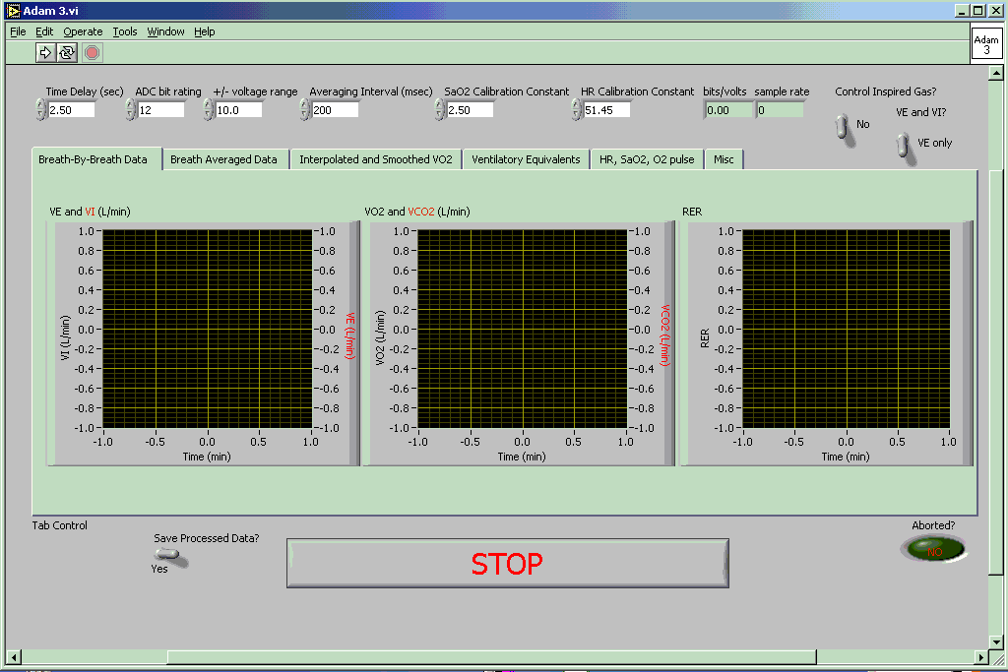

Make sure you change the Time Delay to the correct value (4 s for the South Room system). Also, make sure you select the correct ventilation condition – see the toggle switches in the right top corner.

- Before executing the program, make sure you are ready to perform the test. Do you know your protocol? If you are using the Load ergometer, is the bike and interface powered, and do you have the protocol programmed and ready? Is the ECG turned on? Is the subject prepared for ECG monitoring? Do you have a mouthpiece made? Are all components of the mouthpiece, turbine, and mixing bag prepared? Do not proceed until all of the above questions/items are prepared. Calibrating the VO2 system should be the last procedure performed prior to the start of the test.
- Start the program by clicking on the solid white arrow in the header margin (see above). The program also starts by clicking OPERATE, and then RUN in the header.
- A data entry window opens (below). The contents of this window are not essential, but if you want VO2 expressed in ml/kg/min within the text file, then make sure you enter an accurate body mass (kg). Other contents of this window do not appear in the text file.

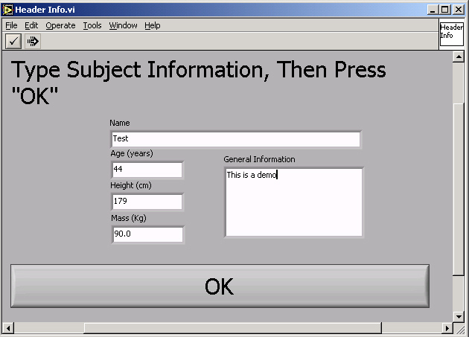

- When the program wants you to click “OK”, make sure you click with the mouse and not hit ENTER. The program needs the “OK” box to be registered to go to the next component.
- After clicking “OK”, a new window opens – for calibration gas and environmental constants. We use 100% nitrogen, a commercial calibration gas mix, and room air. You will need to make sure that the O2 and CO2 percentages for the calibration gas are entered correctly. These values change with every new gas tank we get, but will be close to 5% CO2, and 15% O2. You need to be accurate to 2 decimal places for these gas % values.
- For environmental conditions, the humidity and room temperature are only important for when you measure ventilation on the inspired side. However, it is recommended that you enter all values as if you need them. Obtain the room temperature and humidity values from the two radial dial (temperature and humidity) weather station on top of the gas analyzer shelves, near the pump (Figure 4). Barometric pressure is obtained from the wall barometer located on the north side of the EPL (Figure 5). When done, click “OK”.

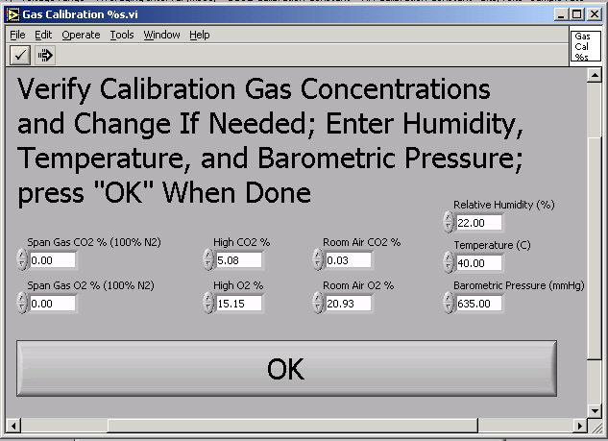

- The next window to appear is for turbine calibration. The next series explanations and Figures directs you how to calibrate the turbine.

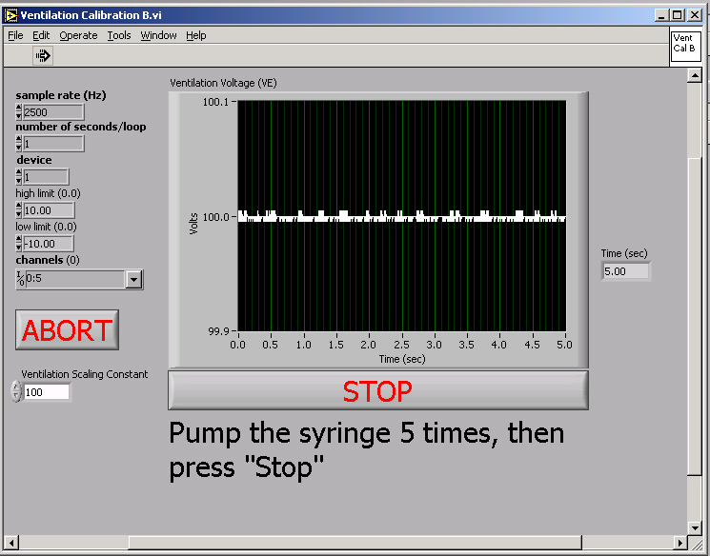

- The turbine has a white end and a black end. The white end is the one that receives air-flow. Thus, air should flow into this end, and thus, not out of it!!! This color-coded feature determines how you place the turbine on the mouthpiece during calibration, and during the test.
- The 3 L calibration syringe should already have a mouthpiece valve system on it. Place the turbine on which-ever end is needed (inspired or expired) to suit how you are measuring ventilation.
- After you click OK to the dialogue window that precedes the turbine calibration, wait until you see data on the displayed chart, and then start to complete at least 5 full strokes of the syringe.
- When stroking the syringe, make sure you do this in a controlled, and easy manner. Do not slam the syringe at either end of each maneuver. The voltage numbers that appear in the displayed figure can be interpreted. The turbine functions based on 0.1 volt for every liter of air-flow. Thus, as we use a 3 L calibration syringe, you should get results for each stroke that are close to 0.3 volts.

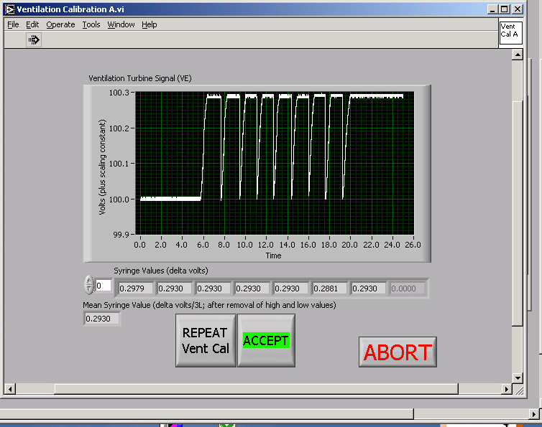

- When done with the appropriate number of maneuvers, click “STOP”, and then view your displayed results. If you average voltage for the 3 L calibration is less than 0.29, I would repeat the procedure by clicking “”. Otherwise, click “OK”.
- The next calibration procedure is for the gas analyzers. You will be prompted to first connect the calibration gas-bags to room air. At this prompt, you should evacuate the calibration bags using the vacuum pump, and fill each bag with the correct gas mixture. I recommend using the red capped bag for the calibration gas, and the black capped bag for the nitrogen gas.
- Once the calibration gas-bags are obtained, connect the gas bag tubing to the sample line, and arrange the stop-cocks so that room air is being pumped through the tubing to the analyzers. Make sure the pump is on!!!!!
- Click “OK”, and then watch as the displayed charts show the voltage for O2 and CO2 as gas is sampled into the analyzers. Remember there is about a 4 s delay time to start seeing voltage from the gas analyzers. Note, for room air, there will not be much change in the readings. After several seconds of stability, click “OK”, and then you will be prompted to connect the gas to Nitrogen. Repeat the procedure, and the repeat it again for the calibration gas.
- After the calibration gas has been sampled, and you click “OK”, the results of the gas analyzer calibration will be shown. There will be two charts beside each other – O2 on the left and CO2 on the right. The linear regression line that fits the calibration data for each analyzer should directly connect each data point. If the line does not do this, then you must have either sampled the calibration gas wrong, or entered the wrong gas constants during step 8. If your data look good, then continue. If not, click “”, and repeat the calibration gas procedure.

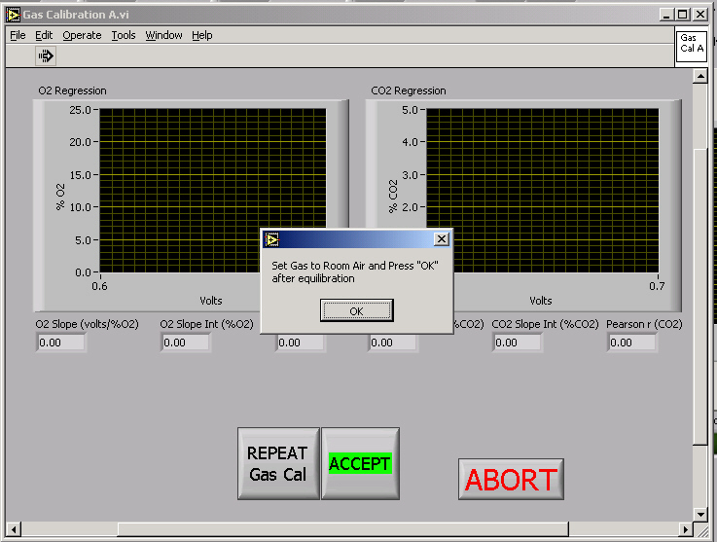

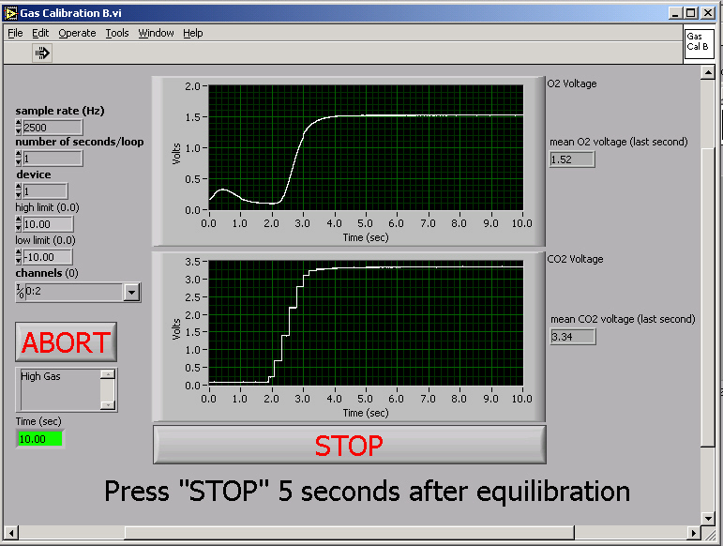

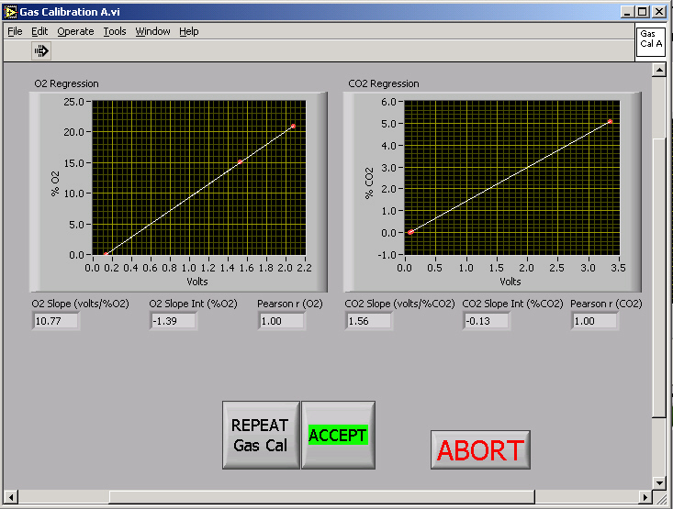

- After you complete the gas calibration, you will be prompted to connect the subject to the mouthpiece, and then to the system. To do this you need to place the mixing bag on the round frame, and then connect this to either the turbine of the mouthpiece, depending on where you are measuring ventilation. Make sure the sample tubing is connected to the mixing bag frame, and that you did not dislodge the turbine from its coupling.

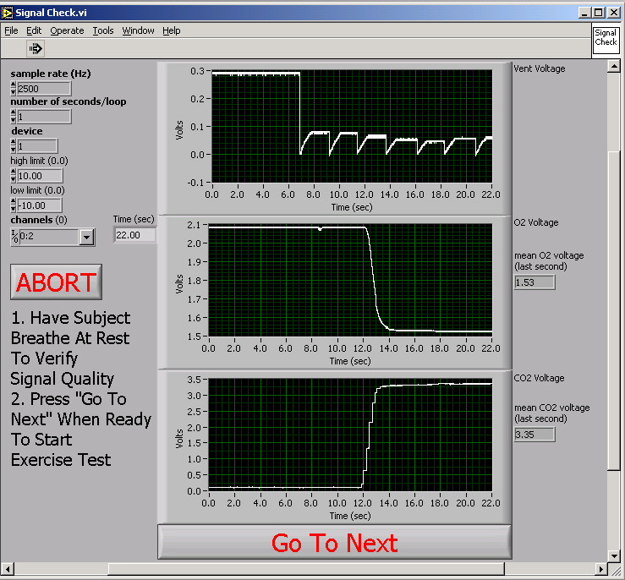

- Click “OK”, and than you will be in the check signals procedure (above). All you need to do here is look to make sure you get breath-by-breath signals from the turbine, and that the gas analyzers are responding to the expired air (higher in CO2 and lower in O2). You should see similar voltage changes for the turbine as you saw in the calibration procedure, and the O2 signal should decrease and the CO2 signal should increase. It is easier to also check the readings on the gas analyzers. These should be close to 15-16% for O2, and 3-4% for CO2.
- If everything look s good, click “OK”, and you will be prompted to name a file to save. This file is a binary file. Binary data is an efficient method of data storage for computers, and this file essentially enables another version of the software (Dane) to re-compute all the data from the test at a later date. As you will save the data to a text file at the end of the test, use a file name that has some clarifyer to it so you know it is the binary file. I recommend that you name it, “namea”, and then after the test when you save the text file, you can name it “nameb”.

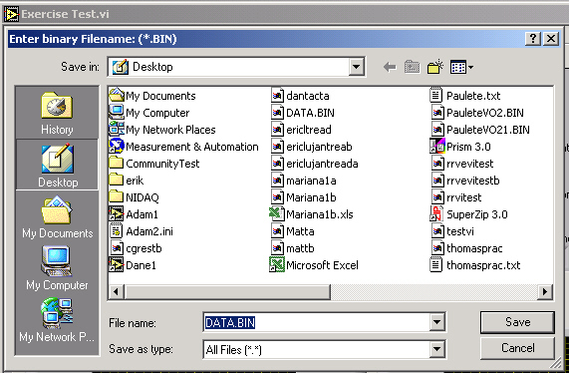

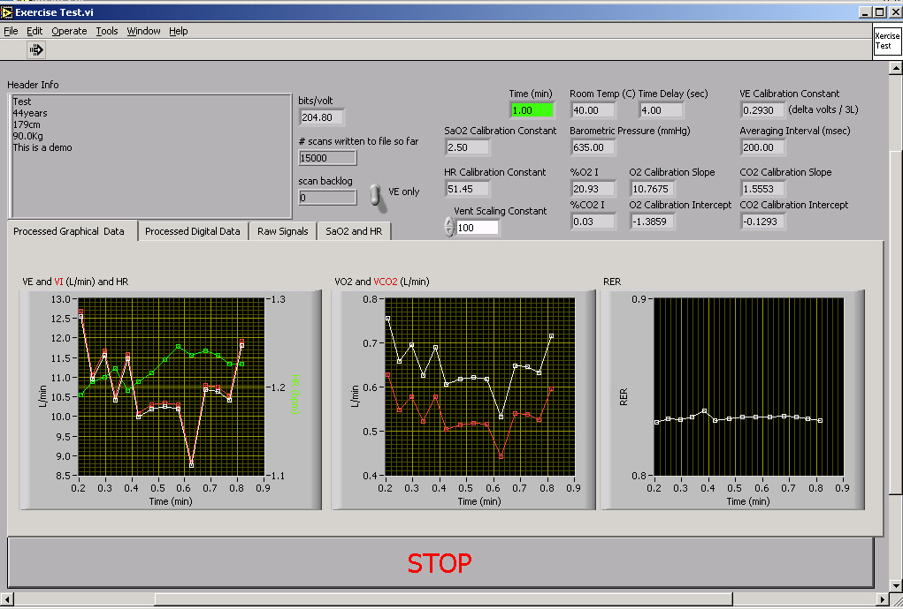

- Once you click “OK”, to save the binary file, you start the data collection. This is important to know. However, I recommend that you collect some rest data prior to exercise to verify a good calibration. I use a 2 min rest period and then have the subject start to exercise.
- Collect data throughout the test. You do not have to do anything except make sure the turbine stays connected, and ensure subject safety is maintained.
- During data collection you can look at graphic data, or you can look at tables data. Click on the “Processed Graphical Data” and “Processed Digital Data” labels to go to each method of data presentation. I like to use the graphic data to see trends during the test.
- When the test is over, immediately click the “STOP” button at the bottom of the page. This will bring up a new window that has another “STOP” button. You then need to click “STOP” once again – making sure that the toggle button is on the “YES, save file” option. It may take several seconds for the software to react, so be patient. Another “Save File As” dialogue box appears, and save the data by writing the name and add the “b” ending to the file name. This file is a text data file that can be copied to disk and imported into Excel.

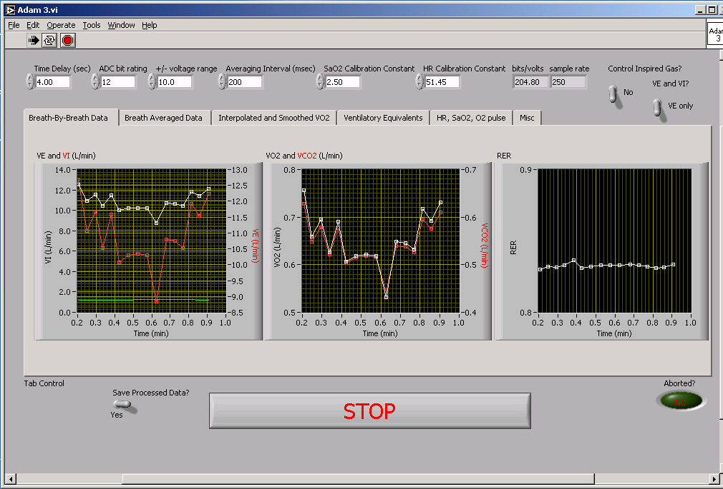

- You are now done. The final dialogue box prompts you to select options based on a new test, the need to re-calibrate, etc. I recommend that you just ignore this, as I am not totally confident in the programming connected to these options. Thus, close the program, even if you want to run another test. Start another test starting again at number 2.

Exporting the Text File
Once you saved the file “nameb”, then all you have to do is open it in Excel. It is tab delimited. The following are the column titles.

Time(min), VE(stpd), VI(stpd), VE(btps), VI(btps), VO2(L/min), VCO2(L/min), VO2(mL/kg/min), VCO2(ml/kg/min), FEO2, RER, VEVO2, VEVCO2, O2 Pulse, HR, FEO2, FECO2, SaO2

See the Example Data Excel file I have on the website.

