**Exam 2 Part B. Your Name:**

**Please TYPE your answers in an MS Word Document. When complete send your exam answers as an ATTACHMENT to an Email to Dr. Kravitz. Exam 2 Part B is due Friday February 26 by 12midnight. No late papers accepted. Also, academic honesty is totally active here. Please do your OWN work! Use AS MUCH SPACE as you wish in your answers!**

*This EXAM is open note. Please use the WEB LINK to guide your answers.*

**A. Please explain in steps the formation of lactate as described in the YOUTUBE video. Explain what happens at STEADY state and in STRENUOUS exercise. (40 pts)**

**B. Please answer the following questions (4pts each for a total of 56 pts)**

1. What professor authored the review article that changed our understanding of lactate?   
2. Where does lactate production occur in the cell?  
3. How much of lactate is converted back to pyruvate?

4. Where (what organ) does the conversion of lactate to pyruvate occur in the body?

5. What is the name of the cycle that converts lactate to pyruvate?   
6. Does lactate formation cause the burn or acidosis?   
7. What is the cause of the burn?  
8. Where do the protons come from that cause the acidosis?

9. What are the three irreversible reactions in glycolysis?

10. What enzyme facilitates the conversion of pyruvate to lactate?

11. The TCA begins and ends with what molecule?

12. From the Youtube video explanation, what are the implications of Step 1 of glycolysis in reference to endurance athletes?

13. Where in the mitochondrion does the conversion of pyruvate to ACoA occur?

14. In the YouTube video Dr. Kravitz states the TCA starts and ends with one molecule. What molecule is it?

**C. Please draw and write out the two steps for the Conversion of Pyruvate to Acetyl-coenzyme A. Take a PICTURE of your diagram and input into the MS Word document or attach to your email. (20 pts)**

**D. What is the net yield of the Conversion of Pyruvate to Acetyl-coenzyme A? (how many CO2, NADH+H+, ACoA) (10 pts)**

**E. Please draw and write out all of the steps of the TCA Cycle. Take a PICTURE of your diagram and input into the MS Word document or attach to your email. (50 pts)**

**F. What is the NET Yield of TCA (how many ATP, NADH+H, FADH2, CO2) (10 pts)**

**G. Please identify the areas of the mitochondrion from the illustration below. (21 pts)**

1.

2

3.

4.

5.

6.

7.

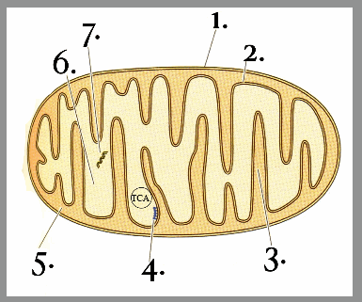

**END**